BIG HATE GANG!

On May 5, 2000 pop music group Bloodhound Gang performs at the Univ. of Maryland despite student protest against the group for their offensive lyrics perpetuating racism, homophobia, sexism, and offense towards the disabled. Various campus and other groups such as the Asian Student Union, Lesbian Gay Bisexual Transgender Alliance, the Women’s Circle, the Latino Student Union, the NAACP, the Jewish Student Union, and many others showed support for the cause. These groups led the support for the protest against the offensive music group and university administration for allowing them to perform on campus. The peaceful protest grew to as high as 200 students of all mixes of race, gender, religion, and sexual orientation.

May 24, 2000 also saw a protest against the BHG in San Francisco where they played at the Fillmore Nightclub. Mainly students from De Anza College as well as students from UC Berkeley scattered along Fillmore and Geary Streets to raise awareness of the BHG’s racist messages. Organized by TAR, protestors were met with much support from various community organizations, gay/lesbian groups, independent media, and many neighborhood residents of the extremely diverse Fillmore district. The purpose of the demonstration was to educate fans about prejudice today. They asked fans to be critical when listening to such prejudice music. Some fans disgusted by the BHG’s messages actually refunded their tickets.

The BHG’s song “Yellow Fever” is a clear-cut representation of racism and sexism today. The lyrics are a perpetuation of the Asian female fetish and are filled with racial stereotype upon stereotype. Those unaware of Asian/Asian American racism may wonder what the big deal is. If this song had targeted the African American community using the same type of language, responses would be quite different. This song reinforces racism but towards an easier target, Asian Americans.

The music group also targets gays/lesbians and promotes ignorance towards them. In their music video, “The Bad Touch,” it shows them beating two gay French men up. This not only condones gay bashing, but glorifies it. Their offensive lyrics and images may seem purely “humorous” to some, but their music continues the intolerance that is poisoning our society. “I just don't know how something like that could breed hate. It’s all in good humor,” says BHG member Jimmy Pop.

These kinds of messages are very influential to culture and especially to our youth. We know that pop-culture has a lot of influence on society and people’s views. All this racism, hate, and intolerance is being capitalized at the expense of those who are affected by it. The BHG targets minorities such as ethnic groups, gays/lesbians, women, and the disabled. While these groups still continue to encounter ignorance and discrimination, they still hold strong in fighting against intolerance. Sure there is freedom of speech, and we have the freedom to voice our concern. But by being silent, we are condoning their messages as acceptable. We need to continue in educating the public and creating awareness of all the hate that we as humans encounter and will not stand for.

TAR Organization - Together Against Racism
tarorg@yahoo.com

Online Petition: www.dragon5000.com
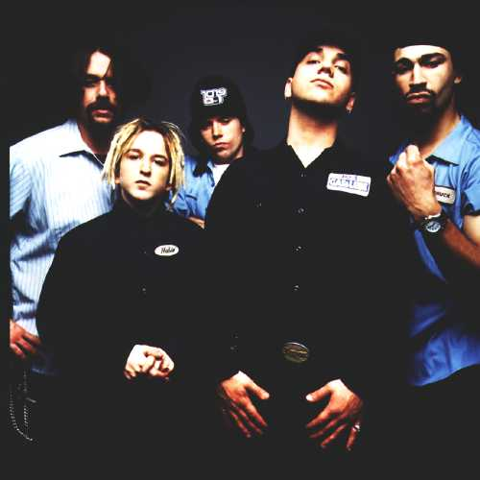

Lyrics from “Yellow Fever”
Are those numchucks in your pants or are you just happy to see me?
Let me take you back to the day that I met my China girl
When I landed a ‘Pam’ like on the San Fran Real World
I was sweating like a vegetable inside of a wok
I’d never been to Asia Minor but I was gonna Bangkok
Like Kristy Yamaguchi I had to break the ice
Should I talk about Mothra M*A*S*H or shrimp-fried rice?
I was sharp as a Chinese star but it’s a line I threw
Just thirty seconds over Tokyo and this Johnny would Woo
I took a shot like Jeanette Lee put on my moves like Bruce Lee
I told her every Soon Yi needs a little Woody
She said for all the tea in China my vagina’s not free
But my love will linger longer than the Ming Dynasty
I said I needed her to do and her to do my laundry
I knew she needed a way to stay legally within the country
She was made in Taiwan I said I’m O.K. with that
Just promise me you'll never try to eat my cat
In Japan the hand is used as a knife
In Japan a man’s wife’s hand job than can cost him his life
But now this Captain Kirk has his own Sulu
I’ll shampoo her Foo Man Chu with Lo Hung Wang Goo
Cause I ride my slant-eyed slope like a brand new Kawasaki
Oh me chinky she’s so kinky got me hot like Nagasaki
Burnin’ up like Napalm burstin’ like an A-bomb
I think I got that jungle fever but I caught it in ‘Nam
She’s like an oriental rug cause I lay her where I please
Then I blindfold her with dental floss and get her down on her knees
I’m a diving Kamikaze eating out Chinese
First I’ll have the poo-poo platter than some tuna sushi
She’ll be screaming like Godzilla and kickin’ like Jackie Chan
I’ll get her redder than China wetter than the Sea of Japan
Like the Chinese New Year she’s gonna see fireworks
Now be a good chinky and press Jimmy’s shirts
Chinky chinky bang bang I love you
Chinky chinky bang bang I know you love me too
Sing chinky sing
One more time

More words from BHG member Jimmy Pop:
“The whole song is about how I want to bang an Asian girl.”
“It would probably be an Asian-American that would hate a song about an Asian girl and me wanting to screw her.”
“We really don't care.”

