The Ultimate Turing Test

Nothing else to do while waiting for my Taiwanese partners to complete their reports for me to, um, translate. So, I took my Indonesian partner out for langauge lessons. We walked into a shop and did spontaneous vocabulary builders .
"Apa ita?" What's that?
"Ita gula gula." It's candy.
"Apa ini?" What's this?
"Ini telefon." It's a telefon.
After an hour of that, there was only the museum for some peace and quiet. After finding that the width of our 2 butts was greater than the width of the seat of a rickshaw (pedicab) we chose 2, got ripped off by the cabbies ( but who cares) and waited for the director of the museum for an interview.
More spontaneous language lessons with school kids.
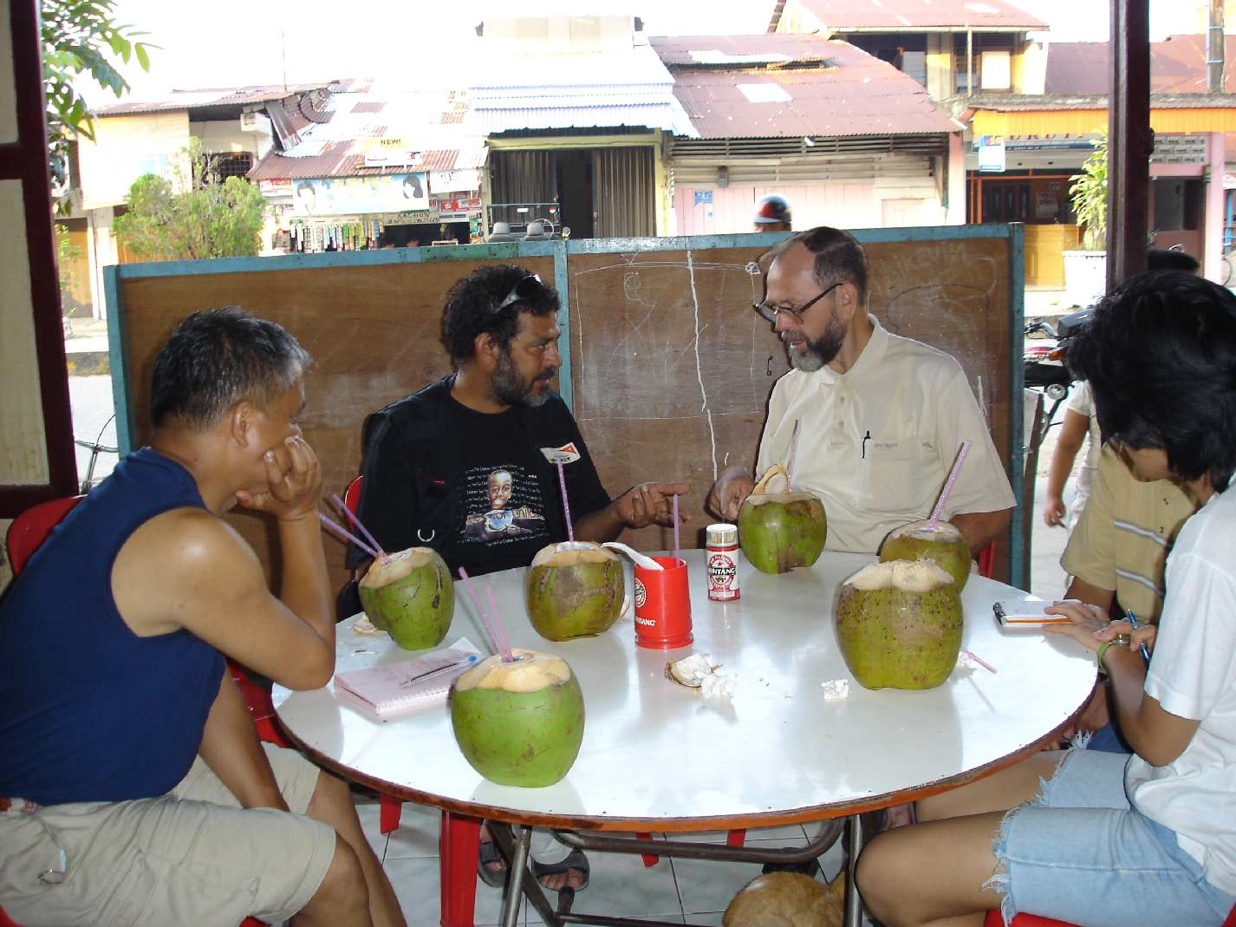
What started out to be a quiet afternoon in the museum turned into a aid assessment. The museum is being systematically denied funding by the local government. Father Johanes, Franciscan Order from Germany has been on Nias 33 years. His protégé, Natal, is the only one from his village to have graduated beyond high school.
We discussed various problems with infrastructure, government, health care, distribution of wealth and opportunity, … We invited Fr Johanes and Natal to dine with us at the soon- to- be- famous Bindang Dirang restaurant. ( Excellent fried rice, fried noodles, pork soup, .. Achhh! Anything on the menu is splendid. CRAB!) We ate and listened and pumped them for all the information we could get. You don’t everyday get the chance to get a history lesson from a museum director and curator.

Fr Johanes speaks Indonesian language and Nias language and German, which was little help to him at this round table meal. So through his broken English, he would turn to Natal to translate from either Nias or Indo. Natal would give us the English. Then, I would translate the English into Chinese for our Taiwan partner, who then elaborate in Taiwanese.

