Name_____________________________________ Group _______________
Escribe enunciados indicando los problemas de salud y dando un consejo.
 I have a sore throat. Advice: Take some honey with lemon juice.

____________________. Advice:__________________________________.

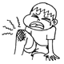___________________. Advice:__________________________________.

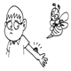___________________. Advice:__________________________________.

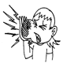__________________. Advice:____________________________________.

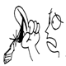_________________________. Advice:______________________________.

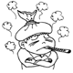__________________________. Advice:_____________________________.

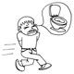__________________________. Advice:____________________________________________.

