Telling Time
Directions: Draw the hands of the clock as they should appear at the time indicated in each problem.
  1. | 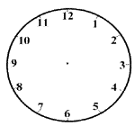
   | It’s six O’clock.
  2.
  It’s noon.
  3.
  It’s twenty to four.
  4.
  It’s three thirty.
  5.
  It’s midnight.
  6.
  It’s seven-oh-five
  7.
  It’s a quarter to eight.
  8.
  It’s a quarter after one.
  9.
  It’s four forty five.
  10.
  It’s nine O’clock.
  11.
  It’s twelve thirty.
  12.
  It’s ten before eleven.

Name ______________________ | Date ____________________

