Alpbach or Bust (and for some it was the latter!) – Feb 07

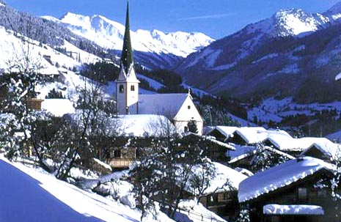

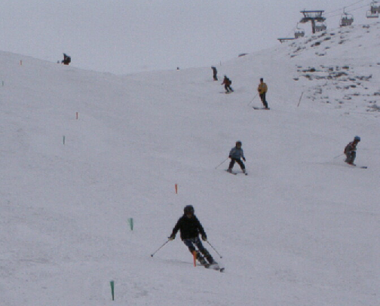
Oh the irony of it. With snow, or to be more precise, the lack of snow being a huge concern in the run up to Alpbach few of us could have expected the British weather system to play it’s winter joker 6 hours before we were due to leave Telford. Now personally I’d never had Stourport down as being Europe’s newest glacier but 3 ¾ hours after leaving home, patience was thinner than the layer of ice that my tyres were skating along and it was becoming increasing difficult accept the bloke on the radio telling me that global warming was a real danger to mankind.

After a strategic rethink on our meeting point we eventually all managed to make it to the same location and immediately hit the road. Now there isn’t much to do on a 27 hour minibus journey. With our three year olds calling the shots on the DVD player and the boys overdosing on PSP, the adults found it somewhat difficult to sleep. Well, all the adults did apart from Emma Ruston who managed to take sleep onto a new and somewhat impressive level. To be honest it resembled virtual hibernation. Indeed after a bit of research, I can now confirm that the brown bears of North America model their sleep pattern on Mrs Ruston.

The week itself was fantastic. Despite being absent from the village there was enough snow on the mountain to keep everyone happy. All of the racers worked incredibly hard and each and every one of them deserved the level of improvement they each managed. We must also note our gratitude to everyone at Alpbach Aktiv for their huge levels of help and assistance they provided throughout the week. Also it is important to note the huge amount of individual assistance we received from Hannes Hausberger. For a coach of Hannes’ standing to provide Telford Ski Club with his time and knowledge was a real scoop, for Hannes to do this at no cost was a truly wonderful gesture

Telford Skiers
training
on piste 13

for which we are all extremely grateful.
The highlight of the week for many was the annual Alpbach snow show. Not only was this an important event in the local calendar but Telford Ski Club were invited to take part. Less then one hour after the invite, after much scrambling around and fantastic help from the Hotel in pushing dinner forward we arrived at the piste without much of a plan of what we were required to do. Four practise runs later the kids were neither ready or nerve free, but they were duly introduced to the crowd as a ski team from England and went on to do both Telford and themselves proud with a fantastic show of synchronised skiing devised and worked out entirely on their own.

Unfortunately, the week wasn’t to pass without a fall or two (or three). Chris Brown, made the post of Team Doctor his very own, performing heroics for three consecutive days as we made the very most of the village medical facilities. All of the injured parties are on the way to recovery now, but I would like to thank Chris again for devoting much of his holiday to ferrying casualties to doctors, hospitals and hotels. Strange how he could be so compassionate for the ladies but saw nothing but humour in both Richard Breese & my hangovers.
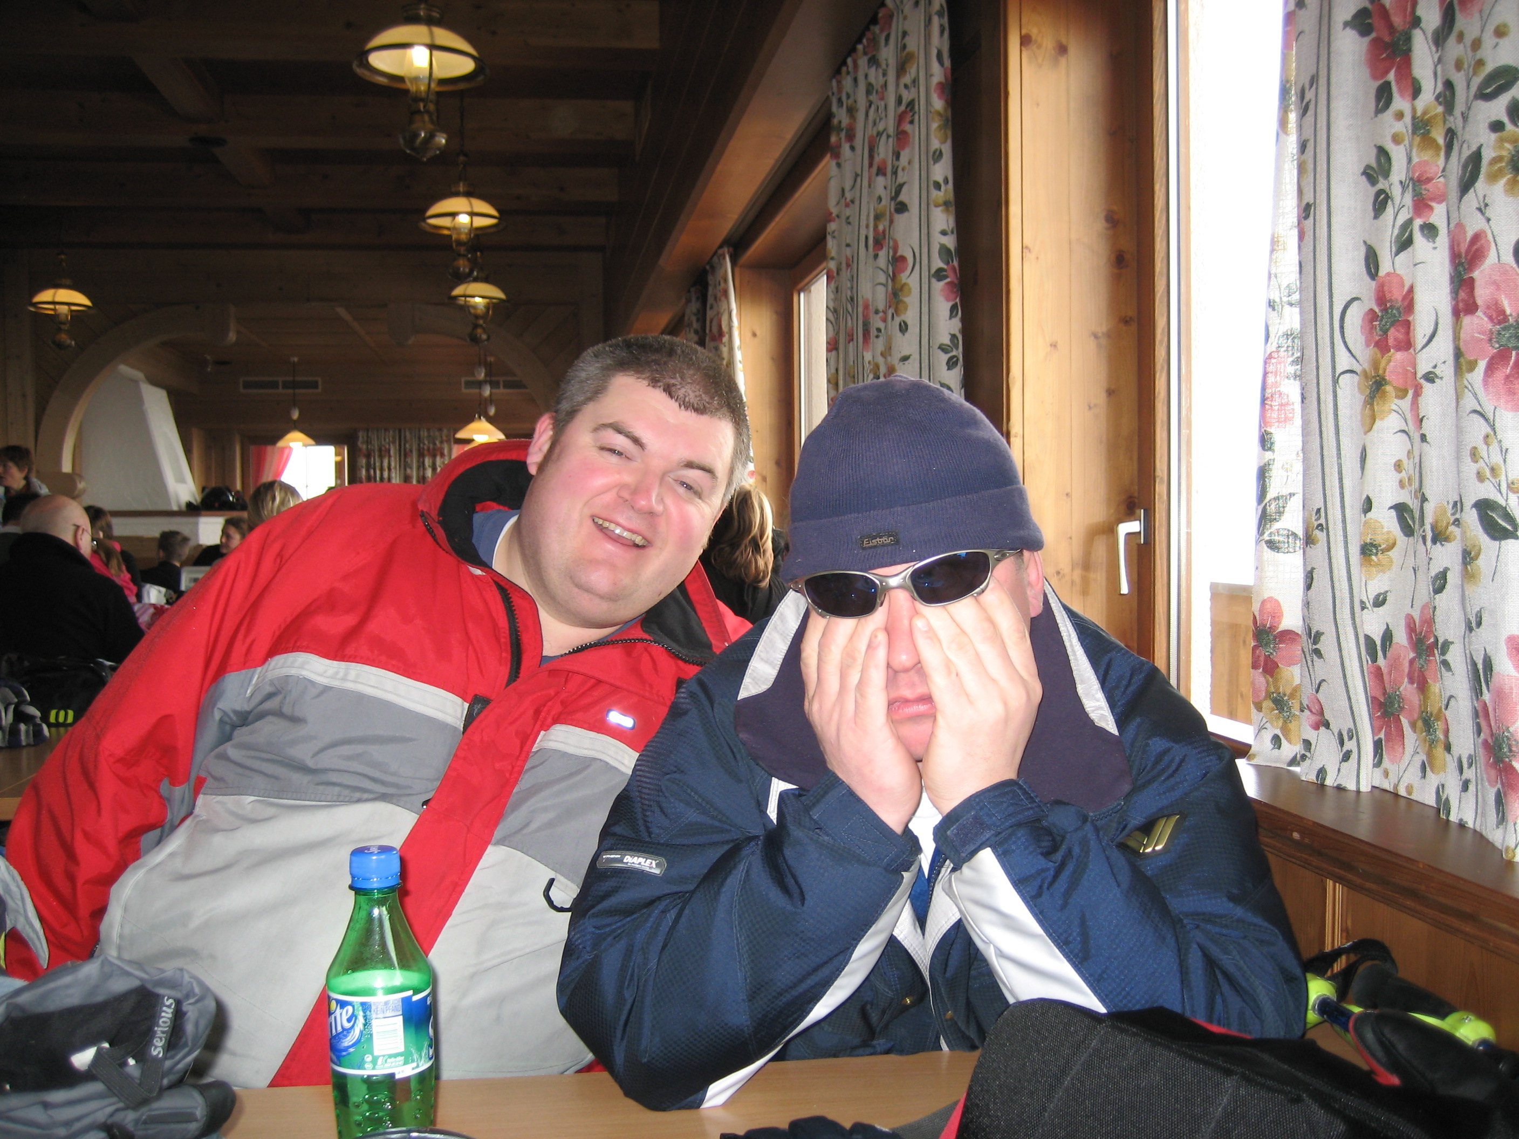
Such dedication! - Our team manager and chairman never missed an opportunity to get on the piste
Ah hangovers. Step forward young Mr Wrigglesworth. Now I have to admit I had my suspicions. I’d heard a lot of the talk but was yet to see Alex do the walk. Was he the party animal I’d been led to believe? Was he ever! The whole week was one magnificent nightly lap of alcohol based honour as he proved to be a true après heavyweight. I know he nudged tipsy to a new dimension on a couple of occasions but his post night-out resilience shone a whole new light on the lad. Indeed, when (or more to the point if) I ever grow up I now know that I want to be like Alex Wrigglesworth. Premiership quality, I tell ya. Good work fella.

Honourable mentions have also to go to Pete Shrimpton for the hat of the week - that 2 foot goofy special was so out of order, to my better half for falling over so many times in one morning it was untrue, to Sue Williams for her mobile crèche facilities, to Kirsty Thomas for impressively squeezing a whole night of après into just short of 2½ hours, Joseph Ruston for walking away unscathed from a monster double clicker induced cartwheel and finally to Chris Noble for sneaking so far off piste he had to go through passport control just to get back into Alpbach – I spotted you impressively cruising down from the heights of the gondola.

And so to the trip back. The pain in Emma’s hand limited her sleep to more acceptable proportions on the way home but the others on the bus did force her into the front seat thus ensuring that she had to endure listening to me wittering on for miles on end. Much to everyone’s relief we made it back in less than 20 hours and by the time the paperboy had been most of us we tucked up in bed dreaming of the fun we’re going to have next year.
By Darren

(Video of the Alpbach experience may be found at www.youtube.com/watch?v=q5z1Mm8X118)

DATES FOR YOUR DIARY

Salomon Xscape Race Series Dates
Castleford ** Milton Keynes ** Glasgow
Race 1 | Calendar…………….  Sat 12th May - Xscape, Milton Keynes
Race 2 | Sun 13th May - Xscape, Milton Keynes
Race 3 | Sat 7th July - Xscape, Braehead, Glasgow
Race 4 | Sun 8th July - Xscape, Braehead, Glasgow
Race 5 | Sat 18th August - Xscape, Castleford
Race 6 | Sun 19th August - Xscape, Castleford  British Indoor Snow Champs 2007
(To enter the Xscape races you have to be registered with Snowsport England.)

Local Race Dates
At Telford
Telford Club Race – 22nd April
(entry form attached to this letter)
WMSA Schools Race – 20th May

At Stoke
Fun Race Series
Race 1 21st April
Race 2 19th May
Race 3 9th June
Race 4 21st July (Afternoon start)

WMSA Race Series.
This will again be running for 2007. The dates for points to be accumulated are;
Telford Race - 20nd May
Stoke Fun Race 3 - 9th June
Midland Club Race – Date to be confirmed
(To enter schools races you do not have to be registered with Snowsport England)

A countrywide race calendar can be found on the Snowsport England website together registration details.
http://www.snowsportengland.org.uk

Has anyone got a used pair of race skis in good condition that they no longer need and wish to sell????

Size 140 to 145 cm

If so please contact Melissa Thomas (Kirsty’s mom) on 01902 337712
or speak to Kirsty /Melissa on Wednesday nights.
Wanted!

Summer Training Camp- 27th - 29th August
Rossendale Ski Slope has been booked for the use of Telford Club during the week prior to the All England Championships- (which take place at Rossendale on 1 & 2 Sept.)
Please see Richard for further details.

Due to the Easter training camp and subsequent races in France, there will be no timings on April 4th, instead the timings from the Telford Race on 22nd will be used.

Training Fees
All participants in the ½ term Alpbach trip are respectfully reminded that payments for the training undertaken are now due (£20.00 each full day) to Richard Breese.
Thanks to members who have already paid.

Return trips to Alpbach have already been planned and bookings are now being taken!
The dates are
- Christmas Training 22nd – 29th Dec.
- Feb ½ term 2008
Please speak to Richard if interested (£25.00 per head deposit)
Alpbach Return Trips

Donations

Donations are being sought for the Club Race raffle prizes – If you have anything you would like to donate please give them to Chris Brown.


A big thank you to Soccer Kings for supplying us with some new kit and donating a rather nice bag for the club race raffle

Please email me any bits and pieces that you would
like to have included in the next newsletter (round about mid/end of May) – Editor Chris Noble
Nobletz@aol.com

