3

DATES FOR YOUR DIARY
Events At
Telford Ski Slope

Presentation Evening
Join the fun on Wednesday 20th December. There will be the traditional Dual Slalom followed by our Annual Presentation Evening Awards, including your voting results for the Skiers' Skier Trophy. Then party afterwards - buffet and drinks provided.

Wed. November 29th @ 6.45 pm.

Richard Breese will be “waxing lyrically”
to his audience, when he demonstrates
basic ski preparation for racers.
Come and watch him “iron out” a few
lost and damaged “soles”.

A Reminder.......
Skis - Race Preparation


Over the past few months the club has been trying to launch the Snowsport England “Snow Life Awards”. The awards are nationally recognised for both skiing and snowboarding and have been developed by BASI (British Association of Snowsport Instructors) and all the UK Governing Bodies for skiing participation, awareness and safety.
The awards begin at Level 1 and go right up to Level 9. Badges are awarded for passes at each Level. However, as a club we are particularly targeting our younger members who are coming from the “Saturday White Tiger” sessions who are already on, or working towards a level 3.
As you may be aware, Sophie Yates is running this scheme and is presently trying to establish the most productive way of bringing the young skier’s on through the levels. Each Level takes at least 2/3 sessions to complete. Assessment is not just skiing ability but also researching and learning for example, “The Ski Way Code” (The criteria for levels 4, 5 & 6 are on the club notice board in the lodge)
If you would like to be involved in this scheme, or seek further information please contact Sophie on 07921121542 or speak to her in person on Wed. nights.
Training Evenings Arranged to date:
Level 4 – 6th December
Levels 5 & 6 - TBC.
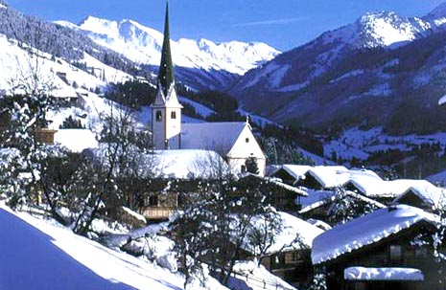
Just a reminder to members signed up for the Alpbach holiday/training trip – Balances to be paid to Richard by 30th Nov. Cheques to “Telford Ski Club”
At other establishments

at the Shakespeare Inn, Castle Street, Bridgnorth.
on Saturday 13th January 2007 at 7.30pm.
Great Fun - Bring the Family!

Menu Available
Minute Steak & Chips or Jacket Potato | £7.00
Cod & Chips or Jacket Potato | £7.00
Chicken & Chips or Jacket Potato | £7.00
Sausage & Chips or Jacket Potato | £6.00
Ploughman’s (Ham, Cheddar or Stilton) | £6.00
Veggie Lasagne | £6.50

Children’s Meals
Sausage & Chips | £4.00
Chicken & Chips | £4.00
Chicken Nuggets & Chips | £4.00
Julia will collect orders and money during club nights 6th & 13th December – please make cheques payable to “Telford Ski Club”.

Who’s been racing recently?

British Championship - Sunderland
Congratulations to Abby on a brace of 3rd places at the British Championships

European Dry Slope Championship - Hillend
Again, Abby was our only representative and despite the disappointment of missing out in the slalom Abby blasted her way to victory in the Giant Slalom.

Sheffield Frostbite Series - Race 1
A small turnout from Telford saw Ben and Joe as our sole representatives. Results are still not published but I understand that both lads did very well in a competitive category.

Stoke Fun Race 4
A fantastic morning of racing on a rather windy slope saw a great set of results for a generally inexperienced Telford team. Man of the day was William Lucas who, in only his second race, produced two super runs to claim an excellent 3rd place in the U8’s. Congratulations also go to Claire Ainsworth who also produced two fine runs to win in the U10 girls. Thomas McLaughlin and Charlotte Shrimpton claimed a Telford double with wins in the U12’s, and Charlotte Gould followed suit in the U14’s. Georgina Gould impressed with a fine 4th place in a very competitive U12 girls and Ben Cooper took his first podium with a 2nd place in the U14’s with Joe Humfress claiming a fine 3rd.

Racing Update.
After the final event in the Stoke Fun Race series the results for this year’s inaugural WMSA Club competition are now complete. Telford came second overall despite fielding easily the most inexperienced teams in all three races.

Stoke 224 pts
Telford 216 pts
Midland 199 pts

Congratulations to the children who represented Telford this year, many of them in only their first or second race. Well done to Rachael Ratledge, William Lucas, Nathan Breese, Joseph Ruston, Claire Ainsworth, Ashley Breese, Kirran Singh-Khalsa, Georgina Gould, Charlotte Gould, Charlotte Shrimpton, Joe Humfress, Ben Cooper.

By Darren

Becky and Claire who have been selected for the Eiskia Senior Norway team in February next year and to Charlotte who has been selected for the Junior team to race in Austria.

Abby who has been selected to race in the World School’s Championships in Andorra in February next year.

Thomas Telford School’s Ski Team in the English finals and who are now going on to represent the school in the British Finals.

and finally...........


Trophy Recall - if you were lucky enough to win a trophy at last year's presentation please return it ASAP. (They are needed for this year's ceremony)

Injury Update

Kirran was due to visit the hospital on Tuesday 14th Nov with the hope of having his plaster removed. Hopefully this has happened and he’ll be on the road to recovery. We all miss the smile Kirran!

A lesson for us all in concentration!

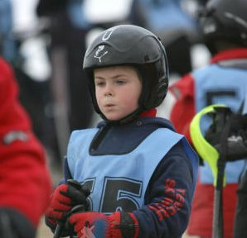

William, 6 years old, 2nd race, focussed like Bode.

Future Newsletter Contributions
If you have any items for the next newsletter (February time 2007), please email them to me at:-
nobletz@aol.com

