CURRICULUM VITAE
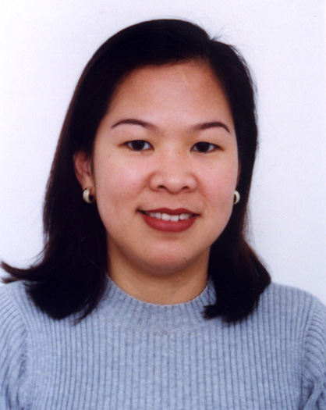

CAREER SKILLS/KNOWLEDGE

- Ability to interact in a fast paced working environment
- Strong Customer Relations Skills
- Excellent organization skills
- Ability to handle pressure
- Ability to handle different people of different cultural background
- Customer service/direct sales
- Develops marketing presentations, brochures & promotional materials
- Plans & implements advertising and promotional campaign to create product awareness to existing and prospective clients
- Solid Computer Skills in MS Word, Excel, Powerpoint, Publisher, Adobe Photoshop
- Knowledge in Frontpage Extension, HTML, Flash, Dreamweaver, Corel Draw, PC Assembly/Troubleshooting
CAREER EXPERIENCE

- Over 15 years experience in administrative, personnel & marketing
- Presently supports the Marketing Department in the development and implementation of the company's advertising & promotion strategies
- Ensures that company brochures, books, materials are readily available and regularly updated
- Develops & maintains the company’s website
- Locally promotes and market the company’s products and services
EDUCATION

Bachelor of Science in Commerce - Marketing Major (1986)
University of St. La Salle
Bacolod City, Negros Occidental, Philippines

EXTRA CURRICULAR ACTIVITIES
Assistant Secretary, Parents Teachers Council, SY2001-2002
The New Filipino Private School
Sharjah, United Arab Emirates
PERSONAL

Flexible, easy to get along with, friendly and possess excellent organization skills. A quick learner and possess the ability to attain new skills with ease. An optimistic person and look for the best in every situation. A team player and can interact with different types of people in any organization.

Contact information
Office Tel : +971-4-883-8589
Residence Tel : +971-6-574-6382
Mobile No : +971-50-656-9749
E-mail Ad : tenvalencia@hotmail.com

Mailing Address
P.O. Box 17365, Jebel Ali Free Zone, Dubai, United Arab Emirates

