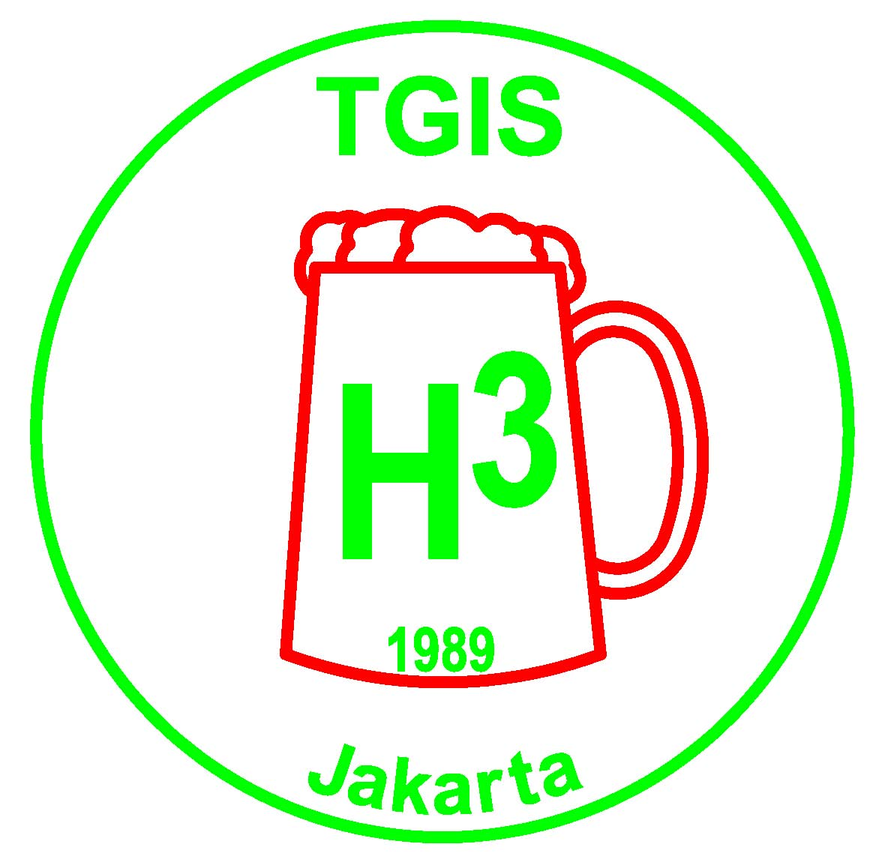 | TGIS Hash House Harriers  Jakarta  TGIS runs on the 2nd and 4th Saturday of every month

TGIS HASH SHEET No. 486

Next Run: Run No. 487 Saturday 8th September 2007 at 4:00 pm.

Hares: Wimbo & Juicy Teaser

Location: Pabuaran

Directions:

Exit Jagorawi toll at Citereup and turn left after paying toll. Turn left again following one way system to T junction then turn right. Stay in left lane and turn left at small road with police post at corner toward Tajur. Follow this road approximately 12.5 km to T junction at small school in village of Pabuaran. Turn left and proceed to run site before soccer field on left. Park along left side of road leaving room for other vehicles to pass. Allow 40 mins from the toll exit.

Map for TGIS Run
8 September 2007 4:00 pm
Soccer
Field
School
To Pabuaran
To Jonggol
12.5 km
Tajur
Large Bridges
Jakarta
Citereup Exit
Jogorawi Toll
Police Post
Market
HHH

TGIS Hash Car:
Pick up point is in front of Crown Plaza Hotel on Jl Gatot Subroto. Car will leave at 2.00pm sharp. Fee is Rp50,000 per person, return. Please book early in advance by contacting On-Sec on 0811-843846 or lozlee@cbn.net.id .

TGIS Committee 2007 – 2008 :

Grand Lady: Sarah “$100 Skidmark” Maurer
Grand Master: Agus “Fak Fak” Sjafrudin
Hash Cash: Paul “Katoy Fcuker” Nontasak
Hash Cash: Benny “Fibreman” Chau
Hash Music: Ramesh “ Fcuk U2” Bachani
RA: John “Sheepskin” Toomey
Scribe: Herbert “Herpes” Motz
Hash Trash: Netti “Juicy Beaver” Hempell
On Sec: Lawrence “Container” Lee
Hash Flash: Nini “Juicy Teaser” Rohmani
Trail Master: Kosidin “Sodomy”

Receding Hare Line;

Run No 488 Sep 22 W Anker Joint run with Krakatau HHH
Run No 489 Oct 13 KK, Woody Pecker Idul Fitri
Run No 490 Oct 27 ?
Run No 491 Nov 10 ?
Run No 492 Nov 24 Wimbo, Sadist, Go Round 18th Anniversary
Run No 493 Dec 8 ?
Run No 494 Dec 22 ?
Run No 495 Jan 12 ? Chinese New Year
Run No 496 Jan 26 ?
Run No 497 Feb 9 Old Committee – Erection Run
Run No 498 Feb 23 Incoming Committee
Run No 499 Mar 8 ?
Run No 500 Mar 23 ? 500th Run – Special Occasion
Run No 501 Apr 12 ?

Announcements:

* Please note all the available dates in the above hare line. Please choose the date that suits you best to be a hare, then contact Trail Master or On Sec at lozlee@cbn.net.id to reserve it.

* Visit the TGIS Website: http://geocities.com/tgish3/ A copy of the permission letter is available at the website, or ask On Sec to email you a copy.

* Please notify us if you want to be added to or removed from the mailing list for this newsletter. It is sent out by email and by sms. Contact On Sec at lozlee@cbn.net.id or 0811 843 846

Upcoming Events:

2nd SOUTH ASIAN INTERHASH 29 Sept to 1 Oct’2007 See web site http:saih.colombohash.com.

Bali Mini Trihashlon , 19 October: alunphillips@gmail.com The main BTH VI will take place next June.

INTERHASH 2008 – PERTH WESTERN AUSTRALIA Easter weekend 21-23 Mar 2008. HERB BOLTONG is on the Interhash Committee as the Visa Coordinator/Advisor www.interhash2008.com/webregistration/ Herb & Yeti: herbyeti@bigpond.com

Other Hash events: http://www.cix.co.uk/~bicesterh3/uk/events/wwevents.htm
Also look at: http://www.gthhh.com/

Scribe Report:

TGIS Run 484
Date: August 25, 2007
Location: The Police Kennels in Cikeas Uduk
Hares: Juicy Teaser and Katoy Fcuker
Theme: “What is a long check?”

The Run:
We have got used to the –not so new anymore-police kennels of Cikeas Udik, occupying a formerly beautiful countryside location known as the dog kennels. The place is now adorned with a huge concrete plane fit for a Jumbo Jet to land amidst palace like buildings and lots of kennels of a police husbandry, where they are said to raise the finest cops of the nation.
So, as the hashers gathered before the run start in one of the corners of the concrete plain they were hardly visible, firstly for the sheer size of the area, secondly for the pitiful small numbers assembled here. One of the reasons for the small numbers at the time of the run start might have been that a lot of Hashers arrived late. The Hash signs had been partly blamed for the late arrivals. A number of hashers with impaired eyesight said they could not see the hash signs, and indeed the hares, obviously keen environmentalists as they did not want to disturb the nature by obtrusive colors produced signs which matched perfectly the background. They were made if paper from grey brown coconut fiber and the letters TGIS in a very decent grey color shade to guarantee perfect invisibility.
As it happened we were only an extremely small number when the run started , not much more than you count on the fingers at one hand.
Like a miracle it seemed there is still life beyond the police kennels and very good countryside too. And moreover the hares had designed a very good run, at least in the general layout. At the same time they managed to build in a few glitches to fuck up the whole thing, well not entirely but at least slightly.
The run consisted of two versions, a medium with slightly more than 1 hour and a long one with 2 hours plus. Shortly after the split between medium and long the hares felt an itch to add a lengthy check back on the medium version towards the long run. About a 100 m away , on the long run they felt the necessity to make a check around . The result was as expected. Notable front runners like Hello Sailor and Helmut Hole picked up the wrong paper and found themselves unknowingly transferred from the long run to the medium one.
The run excelled in remarkable long checks of 200m plus , it excelled in never ending huge loops into all available swamps and kampongs and last not least instead of finishing with a short in trail after 2 hours of running we were guided back on a 3 km kampong stone and gravel road, but the rest was ok!! Coming back from the long run the moon was already shining bright and the number of participants had multiplied , all of the late comers had chosen the short version of the run.

The circle
Where the fuck was the majority of the committee? At least we spotted the G-Lady our 100 $Skid mark, cursing and swearing that she was late because of the camouflaged signs. Who else was there from the committee? Katoy Fcuker of course was there and Herpes, who writes this shit. No Fak2 was seen, not even his TV crew.
Sadist stepped in as GM , Helmut Hole as Music and MGM as RA.
There were finally about 15 or more in the circle including lots of newcomers and visitors.
We had visitors from Singapore, Australia and Jowhore Baru and fuck knows from which other locations. MGM even suspected Indians in the circle but Sybil, that’s her name defended herself and claimed to be an Aborigine from Ozzie. Unfortunately I can’t read my scribbles but the visitors from Johor seemed to have the names Cane and Cobra. Together this means they told us: fuck the Cobra (Good luck) Cane showed us the Planet Mars in the distance, however it turned out only to be the red light of the police whorehouse.
The Johor people tried to impress us with a self (de)composed song of which I only remember the unique and intelligent refrain. It was something like: him, him , fuck him. Moreover Cane told us more than we wanted to know; while he broke the winds on the run he said his girlfriend broke the checks.
Interesting facts came to light during the run discussion held by MGM: Katoy Fcuker showed us his torn and stinking sandals in which he laid the run, obviously to impress us. Cane (again him, him f… him) was winging that he missed the sight of coconut plantations on the run, otherwise he was satisfied.
Okama bin Sama did not see much of the run as he was so impressed by the bums of the ladies running in front of him.
A discussion about the proper length of a check started and it was MGM the expert on international hashing who finally gave as some clarification. He read in the books that international Hash requires checks not shorter than 300m; he however conceded that for Indonesia 100 m is enough. (Probably because Indonesians have shorter legs?)
GL was the only one who sternly demanded Hash shit still grumbling over invisible Hash signs. And the well deserved verdict was: GOOD RUN.
The OnOnOn was declared by the hares in a guaranteed alcohol free “Halal Restaurant” in Cibubur. At the end Katoy Fcuker however felt that something was not right with the drinks and vanished for half an hour in this dry neighborhood. He finally arrived back with a plastic bag full of warm Guinness Black Bitter, my favorite brand. As a compensation for this less enjoyable thirst quencher it was further onon to EP, where due to a celabration free beers were dished out.

