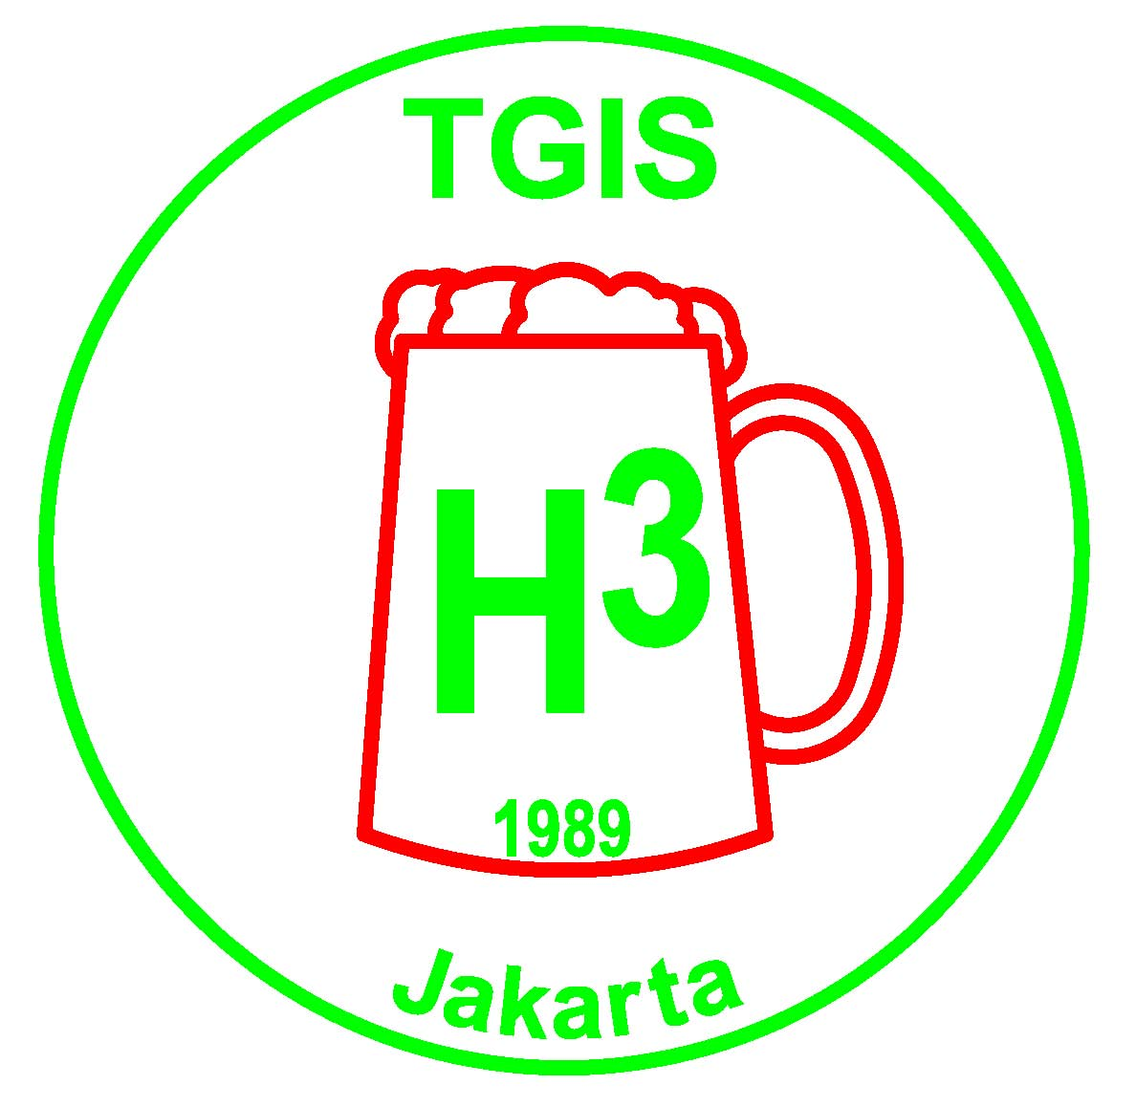 | TGIS Hash House Harriers  Jakarta  TGIS runs on the 2nd and 4th Saturday of every month

TGIS HASH SHEET No. 491

Next Run
TGIS 18th Anniversary “International Relay Run”
Date: 24 November 2007,

Relay Team Briefing Start Time is 1000 AM. Individual Start Time is 12:00.

Location: Curug Panjang Waterfall Park, Puncak.

Hares: Moham, O'Fornicator, Shirley Temple, Wimbo

Run Directions: Take the Jagorawi Toll past Bogor and set your trip meter to zero at the Ciawi toll gate. Take the left hand fork toward Puncak. At 8.9 km turn left at large blue sign for Unilever Learning Center. At 11.7 km you will see the entrance to Mega Inda Housing Estate to your front and a Police Training center to your right. Turn sharp right going around the police center. At 12.4 km turn right at the Unilever Learning Center. At 15.6 km turn right into the Curug Panjang parking area. You will see signs for Curug Panjang along the way. Hash signs will also be posted from the main road going to Puncak. Traffic will be heavy because it is Saturday although we may get the benefit of Puncak's one way traffic system at that time of the morning. Allow at least one hour to reach the site from the Ciawi toll gate.

TGIS Hash Car:
Pick up points are in front of Crown Plaza Hotel on Jl Gatot Subroto and at CITOS on Jl. Simatupang. Cars will leave at 8.00am sharp. Fee is Rp50,000 per person, return. Please book early in advance by contacting On-Sec on 0811-843846 or lozlee@cbn.net.id .

Scribe Report:
TGIS Run #491 on Saturday 10th November 2007
Location: Sore Rail’s House, Sentul Selatan
Emergency hares: Thunder & Live Wire

There were a couple of reasons for the small turnout for this run. Pissing it down with rain was one, admitted by Hello Sailor as he missed his turn off at the Sentul roundabout and found himself heading back to Jakarta . The other being the Saturday Night Fever party for the Harriettes 30th Anniversary bash in town. I can only imagine the likes of Whoremoan missing the run to fix his afro several hours before the party. At least we had the GM and GL back.

The run
By 4pm, the hares came back soaking wet to send the 15 or so hashers on the out trail. Clever checks and crossings kept the small pack pretty much together until the split for S and L. Most opted for the short as they were desperate to get to the party. Short was an understatement, because soon after the spilt was the on-in. 10 minutes or so was wasted looking for paper only to find the long trail, so a gentle jog up the road back to Sore Rail’s residence was decided.

The circle
“Let’s start the circle early so we can get to the party” was on everyone’s mind. So at 5.30, GM called the circle. Returners were Rubherturd, Auditurd, GM Fak Fak and GL $100 Skidmark. Sorry if I missed out anyone else, but as stand in scribe, stand in hash cash, and regular duty as on sec, I had my hands full to remember everything.

One beaver drinks, all beavers drink was the motto for the day, giving more than enough share of the barrel to Juicy Beaver and Beaver Kecil for the never ending charges against them.

New names were given to Ade from Global TV and Melly. Ade was named Butthead which quicky prompted Auditurd (I think) for calling in the trio of Beavers and Butthead for more beer. Melly, being Katoey Fcuker’s other half, was recently named on the Thursday hash with the name of KFC, KF standing for Katoey Fcuker and C standing for a person you don’t like. Being (slightly) less crude than Thursday, TGIS gave the same name of KFC, but 1 swear word was sufficient and the C on TGIS stands for Cewek.
The shortest run discussion in history was about to be made, when Rubherturd blurted out “Good Run”. The truth was he was desperate to get back to Jakarta to join the party.
6.15….swing low….and ononon to Everest

On On….
Container

TGIS Committee 2007 – 2008 :

Grand Lady: Sarah “$100 Skidmark” Maurer
Grand Master: Agus “Fak Fak” Sjafrudin
Hash Cash: Paul “Katoy Fcuker” Nontasak
Hash Cash: Benny “Fibreman” Chau
Hash Music: Ramesh “ Fcuk U2” Bachani
RA: John “Sheepskin” Toomey
Scribe: Herbert “Herpes” Motz
Hash Trash: Netti “Juicy Beaver” Hempell
On Sec: Lawrence “Container” Lee
Hash Flash: Nini “Juicy Teaser” Rohmani
Trail Master: Kosidin “Sodomy”

Receding Hare Line;

Run No 493 Dec 8 Hello Sailor
Run No 494 Dec 22 Herpes
Uni Run Dec 29 Hosted by TGIS
Run No 495 Jan 12 Sheep Dip, Sheeps Kin - Chinese New Year
Run No 496 Jan 26 Container - Birthday Run
Run No 497 Feb 9 Old Committee – Erection Run
Run No 498 Feb 23 Incoming Committee
Run No 499 Mar 8 ?
Run No 500 Mar 23 ? 500th Run – Special Occasion
Run No 501 Apr 12 ?

Announcements:

* Please note all the available dates in the above hare line. Please choose the date that suits you best to be a hare, then contact Trail Master or On Sec at lozlee@cbn.net.id to reserve it.

* Visit the TGIS Website: http://geocities.com/tgish3/ A copy of the permission letter is available at the website, or ask On Sec to email you a copy.

* Please notify us if you want to be added to or removed from the mailing list for this newsletter. It is sent out by email and by sms. Contact On Sec at lozlee@cbn.net.id or 0811 843 846

Upcoming Events:

INTERHASH 2008 – PERTH WESTERN AUSTRALIA Easter weekend 21-23 Mar 2008. HERB BOLTONG is on the Interhash Committee as the Visa Coordinator/Advisor www.interhash2008.com/webregistration/ Herb & Yeti: herbyeti@bigpond.com

Other Hash events: http://www.cix.co.uk/~bicesterh3/uk/events/wwevents.htm
Also look at: http://www.gthhh.com/

