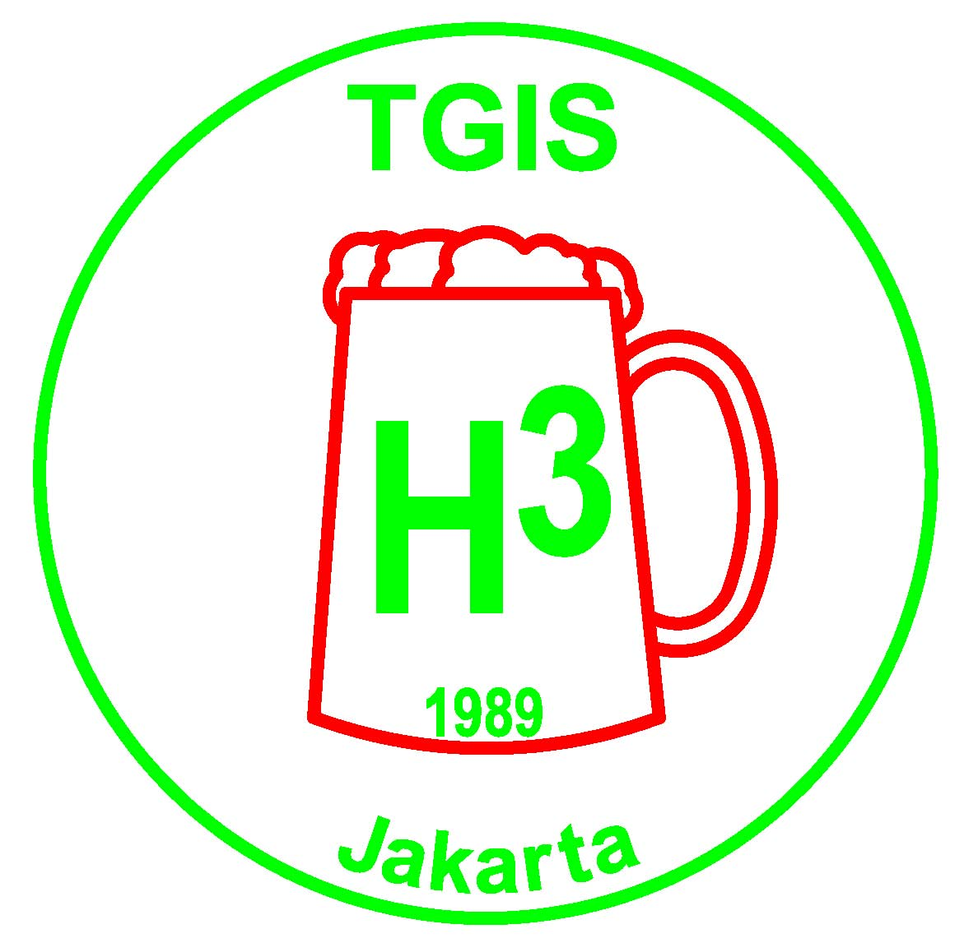 | TGIS Hash House Harriers  Jakarta  TGIS runs on the 2nd and 4th Saturday of every month

TGIS HASH SHEET No. 492

Next Run # 493

Date: Saturday 8 December 2007

Start Time: 4:00pm.

Location: Ciawi Service Area

Hares: Short Change & Whoremoan

Run Directions: Take the Jagorawi Toll to the Ciawi Service Area at the end of the toll road.

TGIS Hash Car:
Pick up point is in front of Crown Plaza Hotel on Jl Gatot Subroto. Car will leave at 2.00pm sharp. Fee is Rp50,000 per person, return. Please book early in advance by contacting On-Sec on 0811-843846 or lozlee@cbn.net.id .

Scribe Report:
TGIS RUN 492
18. Anniversary Run
Date : Nov. 24. 2007
Hares : Quite a lot ( Wimbo, Moham, Shirley Temple, O’Furnicator)
Location: Puncak area , out in the jungles, high above Mega Mendung

Basics and general observations
Miracles sometimes happen just in time and the long lost GL and GM popped up again out of the woods for this ominous event. Together with them long lost TGIS hash paraphernalia appeared again like the toilet seats for the hashshit holders, the old shit on the seats carefully removed and cleaned away by GM himself. We also had a happy reunion with TGIS’s greatest treasure, the Queen Fred look alike piece of fine arts, the “where the fuck are we” award. Many guests of the Saturday run (and there was a fucking lot of them) who saw this artistic masterpiece for the first time were absolutely left speechless, overtaken by the sheer beauty of it.
So far so good, paraphernalia back, GL and GM back - double reason to rejoice on this anniversary Saturday. If the truth would be known - we did not miss the GL and GM too much in the months before and it looks like we will get rid of them anyhow in a few weeks time. The usurper to the throne, Powderballs was seen with a hopeful grin on his face already.
The hares, Wimbo and his accomplices in crime did not spare any effort to make this anniversary Saturday a special event. First they lined up 20 sponsors and sucked their pockets empty. Then they went endlessly out into the most far away rainforests , where no human beings have ever set their eyes upon. Then they where so carried away by the potential the area offered ( I guess especially Wimbo) , that after the recce it turned out – oops – it was 27 km long with elevations up and down of at least 1500 m Who would run such a triple ball breaker, except Wimbo himself may be . So, what the fuck to do? The good idea was fast at hand, let us split it up into three sections and call it a relay run, splitting up the distance between three runners, called a team. To make the thing complete each team was given a baton made of an aluminum pipe and last not least the hares tried to instill some competitive team spirit into the teams.
Each team ideally – according to the plans of Wimbo, had to consist of three different farts an old fart, a young fart and a lady fart. Well, everything smacked like competitive running (which baton comes back first?) but as we are the hash it was predictable that this relay idea and the competitive component would be fucked up in no time.
And indeed: There were about 25 batons distributed at the start- I think about two or three came back the prescribed way. The rest went missing in action for various reasons. One reason was that the runners of the second and third stage were so eager to run that they did not wait for the batons to come and pissed off right away, whenever they reached their respective starting point. Other batons got lost as they were use as a kind of ice pick on the slimy, slippery and steep climbs.
Anyhow, with or without batons all participants had a great time to run on one of the three sectors, definitely a good workout an in lovely countryside.
Phantastic efforts were seen by true hash sportsmen. Some teams, which looked unbeatable at the begin of the run saw the valuable first price – a sweaty running shoe formerly used by O’Fornicator and nailed to a piece of wood, slip away right before their eyes. Why? The reason, as usual in sports was bad coaching. Pouff for instance, who was supposed to run the third leg went too fast up to the run start. Instead of the 15 minutes planned for this walk he did in incredible fast 30 minutes and thereby exhausted himself so badly that he had to give up before the start of the run. MIA his teammate also tackled the first 500 m of the first leg in too fast speed, as a consequence he jumped, dehydrated and exhausted on an ojek. (Actually on two, the first one broke down under the load)
Another promising team lead by Gay Gurkoff saw victory vanishing already shortly after arrival. Gay Gurkoff undergoes at the moment the steep part of a difficult learning curve. It was only until recently that it was engraved in his brain that a hash run starts at 5 pm. After a few weeks of learning he got smart and now he understands that TGIS starts usually at 4pm. However life is a bitch and not all hash runs are equal. When he arrived at 4pm he learned that this run started at 10:30. So it is true, we never stop learning during our whole lifetime.
The run
As if the aforementioned monster undertaking was not enough, it was laid as a life run. The first set of hares set out paper throwing 15 Minutes before the start of the run. Actually Wimbo was a hare for all the 27 km, changing his auxiliary hare at the begin of each leg.
Although in the middle of the rainy season this was a day without the slightest cloud, at the run start it was already boiling hot and not getting better. The hares, afraid that the runners would catch them (which runner by the way) made the most incredible long and difficult checks ever seen on a hash run. Up and down these steep and slippery slopes of the first leg, lost paper on the checks finding it again after 10 minutes we finally arrived on an asphalt road leading downwards. Great, I thought, that’s it. Bullshit, all of a sudden arrows pointing up on a almost invisible steep trail, of course no mercy until the top was reached, including nasty checks on virtual trails.
At this point it was clear that the run had already taken his toll on the brains of some runners. While running through the woods a Betawi runner came all of a sudden against me (fuck knows from where, he had no idea himself) He insisted that the correct run direction was backward and tried to persuade me to do the same. I refused and he vanished like ghost into the out trail. Finally at the endpoint I learned that the young fart of my team Cocopops had already fucked off, so the only thing I could do with my baton was to shove it up my ass and take the car back to the Onon place.
Relaxing by some beers I watched the whole afternoon hashers coming back from various places, most on paper some not, some fucked up beyond recognition and some others seemingly fit. Having nothing else to do the first leggers, the second leggers the short cutters and ojek riders got slowly pissed in the shade of the pine trees and having occasional another helping from Sheep- Dips soup kettle .

The circle
A great place for a circle, amidst pine trees and meadows. A tent had been set up, in case of rain it would have been big enough to accommodate at least 5% of the assembled hashers, some rental chairs and of course Sheep Dips Super kitchen cum barbecue. Even a waterfall with ice cold water was provided nearby. Some diehards dared to dive into the pools below the falls . They were easily recognizable by the blue/red appearance upon return.
Over the whole evening, until late, lost hashes dropped into the circle from the woods, some winging but most of them too tired to.
Rubher Turd was quite upbeat at the start of the circle –Spermaid seemed to have been vanished in the jungle. There was great disappointment on his side when she finally showed up, “another wasted day, I want my money back” he was heard murmuring.
There had been obviously two teams who really run the prescribed rout including baton- and the winning teams were: The Bogor Buggers closely followed by Nini and the Fuckups. Witless also had to do something with the teams, surely not with winners. Anyhow they were all seen happily drinking out beer from the sweaty award shoes. The rest of the teams had somehow dissolved in space and the only award for the many losers was plenty of booze. By the way, statistics had it, that 7 kegs of Carlsberg were annihilated that evening, a new TGIS record.
Some people are loved by leeches, some more some less. Head job got the band AIDS leech award for having been sucked empty by numerous leeches and other vampires.
Time for naming some 5 timers. Two Fuk2’s Global TV girls were due for the ceremony. The first girl says she sells everything but did not further specify. For strange reasons she was named Cheese pot. (May be you can also sell a cheese pot, even I would not buy one). The next girls name was Lulu, like Come Rounds dog but with two legs.
Noteworthy proposals: MBP (Menado Botak Pussy) and Fak2’sFak or Fak 3. For somebody with the name Lulu there is however only one possibility and this is Gangbang, as it is prescribed in the folk song “Gangbang Lulu, Lulu’s gone away, who is going to gangbang, when Lulu’s gone away”.
GL finally came up with something funny: To the tune of Do toot do toot do doot or similar some selected individuals had to show sexy behavior. The crowd wanted to see the moon, but Cocopops and Auditurd luckily spared us from this horrible sight.
GM, still alive by that time gave us a sex report, not from the book of his own experiences but from Guinness book of records. A 110 year old Arab, according to Fak2, was looking for a 20 year old one to fuck, complaining that he could not “explode” in his 105 year old wife because of the combined stink of pussy and garlic. Moreover we learned, Fak2 has it on good authority,
That Greeks fuck 365 times a year closely followed by the Japanese who do it twice a year. Such is the fucking wisdom of our GM.
In between we had a food break- Steaks, chicken and sausages masterly prepared by Sheep Dip and driven to the site by Sheep Dip.
Run discussion:
Whoremoan said he was surprised as he never had heard of the bad concept of a relay hash, Rubher Turd considered it a Fuck up, W-Anker thought it was excellent because due a lucky twist of fate he got separated from his nagging wife, so he could enjoy the run while his wife was lost on the other side of dead mans gulch. Liberarsey requested that the run will be repeated next week; he will have some training meanwhile. Many, many voices however for excellent run, and an outstanding effort by the run organizers, excellent makan done by Sheepdip.
Finally the awarding of the “Where the fuck are we“was a short issue. Nobody could compete with GM and GL, which got lost for many months and they themselves had no fucking idea where they have been. The much deserved honor went rightfully to the top mismanagement.
A very well done anniversary!

TGIS Committee 2007 – 2008 :

Grand Lady: Sarah “$100 Skidmark” Maurer
Grand Master: Agus “Fak Fak” Sjafrudin
Hash Cash: Paul “Katoy Fcuker” Nontasak
Hash Cash: Benny “Fibreman” Chau
Hash Music: Ramesh “ Fcuk U2” Bachani
RA: John “Sheepskin” Toomey
Scribe: Herbert “Herpes” Motz
Hash Trash: Netti “Juicy Beaver” Hempell
On Sec: Lawrence “Container” Lee
Hash Flash: Nini “Juicy Teaser” Rohmani
Trail Master: Kosidin “Sodomy”

Receding Hare Line;

Run No 494 Dec 22 Herpes
Uni Run Dec 29 Hosted by TGIS
Run No 495 Jan 12 Sheep Dip, Sheeps Kin - Chinese New Year
Run No 496 Jan 26 Container - Birthday Run
Run No 497 Feb 9 Old Committee – Erection Run
Run No 498 Feb 23 Incoming Committee
Run No 499 Mar 8 ?
Run No 500 Mar 23 ? 500th Run – Special Occasion
Run No 501 Apr 12 ?

Announcements:

* Please note all the available dates in the above hare line. Please choose the date that suits you best to be a hare, then contact Trail Master or On Sec at lozlee@cbn.net.id to reserve it.

* Visit the TGIS Website: http://geocities.com/tgish3/ A copy of the permission letter is available at the website, or ask On Sec to email you a copy.

* Please notify us if you want to be added to or removed from the mailing list for this newsletter. It is sent out by email and by sms. Contact On Sec at lozlee@cbn.net.id or 0811 843 846

Upcoming Events:

INTERHASH 2008 – PERTH WESTERN AUSTRALIA Easter weekend 21-23 Mar 2008. HERB BOLTONG is on the Interhash Committee as the Visa Coordinator/Advisor www.interhash2008.com/webregistration/ Herb & Yeti: herbyeti@bigpond.com

Other Hash events: http://www.cix.co.uk/~bicesterh3/uk/events/wwevents.htm
Also look at: http://www.gthhh.com/

