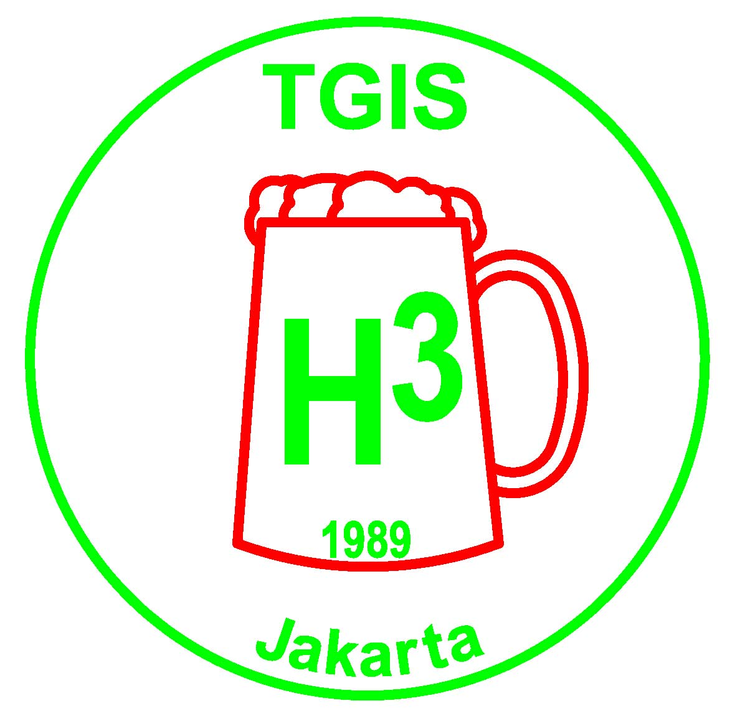 | TGIS Hash House Harriers  Jakarta  TGIS runs on the 2nd and 4th Saturday of every month

TGIS HASH SHEET No. 493

Next Run # 494

Date: Saturday 22 December 2007

Start Time: 4:00pm.

Location: Rainbow Hill

Hares: Herpes & Chlamydia

Run Directions: Take the Jagorwi toll road and exit at Sentul Selatan/Sentul City, go left after toll booth towards the arches ,but do not pass them . Go three times left instead and drive up the hill. At T-junction go left for another 5 km followings signs to rainbow hill golf. Enter rainbow hill golf course on the right hand side and follow signs up the mountain. Pass the huge hotel ruin and find the run site in the rear. Follow the HHH signs.

UniHash Run # 14 – Hosted by TGIS HHH

Date: Saturday 29 December 2007

Start Time: 4:00pm.

Location: Rancamaya Golf & Country Club

Hares: Powderballs, Juicy Teaser, Gay Ghurkoff

Run Directions: Take the Jagorawi Toll to the end. After the toll booth continue on and take the right fork towards Ciawi/Sukabumi. Straight on at the traffic lights, after 800 metres, turn right to Rancamaya Golf Estate. Follow the HHH signs.

TGIS Hash Car:
Pick up point is in front of Crown Plaza Hotel on Jl Gatot Subroto. Car will leave at 2.00pm sharp. Fee is Rp50,000 per person, return. Please book early in advance by contacting Maryati on 0815 6657105 (alternatively contact On-Sec on 0811-843846 or lozlee@cbn.net.id)

Scribe Report:
Run #493
Date : Dec. 8, 2007
Location: Ciawi service station
Hares: Whoremoan and Headjob

General observations:
The old proverb – go hashing a day and you keep the doctor away –seems to hold still a lot of truth. Our GM, newly recycled two weeks ago gave a shit about this ancient wisdom –and was duly punished. Due to a lack of hashing recently and an exuberant lavish lifestyle he caught a dose of the gout, accumulating huge quantities of ureic acid in his joints. To see him walking in pain you even feel some pity with him, nevertheless it seems that this time he had a good excuse for not showing up. GL, without the benefit of having gout did not show up either. So, TGIS is back to square one and without top management. Usurper to the throne Powderballs’s dirty smile getting bigger and bigger every week.
This run coincided somewhat with another important event, namely to a wedding invitation to MGM’s daughter. Some noted hashers like Sheeps’kin and Sheepdip stayed away at all fearing that if they would not come early enough the best bites from the buffet might been gone already. Others, attending the run showed some degree of nervousness in the circle, would there be enough food? Would the beer last in the Nikko Hotel? These questions were visibly wandering around their minds. As a result some hashers pissed off at various stages of the circle, only cold blooded core hashers and uninvited bastards showed no unduly haste. The hares have cleverly divided their responsibilities, Whoremoan pissed off immediately after laying the paper whereas Head job stayed on, representing the hares. A hint from the hares for those , who want to use the Ciawi site in future: Go to the backside of the restaurant and the site management will charge you 250 000 peraks, stay in front and promise the restaurant owner you will come and eat in his restaurant later on and you pay nothing. Food, which used to be awful in this place has improved a lot as it later turned out.
The Run
TGIS it is lucky these days, always good weather in an otherwise very wet season. So, what did we get, lovely sunshine, great views, dry trails, already 50 % of the requisitions of a good run fulfilled.
This time the hares had obviously done a reccie so not unexpected figure of eight appeared as it happened in the area in the past, intrail and out trail kept well apart this time. The countryside east of the toll road, being used many time, does not hold big surprises anymore. Nevertheless we got good hare craftsmanship a well designed and executed run. The only question, would it finally swing left or right and what kind of additional loops would be provided. After climbing up the third ridge it became clear to lead into a rightie , passing the Gunung Geuliss adventure camp and back with a couple of loops over three ridges.
A satisfying run, that’s at least what I felt, a good length for the average hasher of slightly over 1,5 hours , just what is needed for a Saturday.

The circle
It is now crystal clear who will be our next leaders. Beside the usual usurper another usurper stepped out of the twilight, indeed Moham looks exactly like an incoming GL. At least none of them will come up with gout. Who will fill into the other jobs? The crowds requested beaver kecil to play an important role in the new committee moreover Helmut Hole was requested to make himself available. Even Liberarsey is expectet to get leading function as residential pisspourer on the committee. As we were told the picture of TGIS finances seemed to be very bright, at least until two days ago. A major committee meeting, attended by at least 15 people however put TGIS financial future in jeopardy. GM Fukfuk in hi usual spendthrift lifestyle had food and drinks in abundance ordered for all. Now, party over, our future looks bleak and Powderballs is already secretly pondering the idea to increase taxes. Hashers watch out!
Just having had the 18 th anniversary celebrations another great event is looming on the horizon, TGIS 500 run. Forceful recruitment of sponsors has started already. The latest hasher victimized in public was Woody Pecker, who set up a happy face when he heard that he was allowed to be a sponsor.
Stand in GL, in a moment of mental disturbance called in Helmut Hole for a downdown for being the most handsome hasher in the circle. Rubher Turd and Spermaid, already anxious not to miss the wedding party had already redressed into their most beautiful shorts and t-shirts and were ready to piss off any moment to hotel Nikko.
Juicy Beaver, as everybody knows equipped with the most unstoppable piece of mouth, was totally quiet, sometimes we could hear some snoring from her corner. She had been on the piss until the morning hours the day before, obviously led astray by Juicy Teaser. This made her pleasantly calm. Juicy Teaser, please have another night out with her Friday in two weeks!
Katoy Fcuker was awarded the price for the gayest haircut. Juicy Teaser accused him of inappropriate calling. Instead of showing her the paper and calling on on he only said psst psst and showed her his private parts. (Tzs, tzs...)
Hello Sailor was investigated and found to be alive. To keep it that way he was entrusted to pour the amber piss. Beaver kecil had two white strings hanging out and after some guessing it was concluded she was double tamponized. The question, who had the best shaved armpits in the circle, could not be clarified totally but it was suspected that Powderballs was the winner. Helmut hole, instead of becoming next years hash cash announced that he will piss off for good in two weeks time. To celebrate this event he has rented the Cazbar on Dec 18 and all the piss you can drink is on his account. Okama bin Sama, who did not say much before, now was even more speechless by hearing about such a piece of generosity.
Hash cash had not much to say so he downdowned the hares, sponsors and look-alikes, who contributed to the event two weeks ago.
Run discussion:
Nobody could really remember the last hashit holder on TGIS, I strongly suspected it was Mr. Run-discusser Sukapussy himself, so the toilet seats were symbolically given out to guaranteed innocent people as stand ins. Liberersey is for sure innocent, I cannot even remember that he ever laid a run.
Difficult to say something bad about the run, some desperately tried and came up with “too boring, too short and too long” and things like this. Nobody was able to come up with an explanation that the run was not that what he finally was declared to be: an excellent run.
Hello Sailor unexpectedly and all of a sudden kick started himself and he made a 15 minute speech who should and who not get the Fuckawi.
Katoy Fcuker was a candidate as he could not explain why he was all of sudden for 10 seconds leader of the running pack; a couple of other unworthy figures, like Woody Pecker and Liberarsey were singled out. Finally it was given to Juicy Beaver. Already fast asleep and mumbling, “where the fuck is my bed”
On on was at the restaurant on the spot, which kindly sponsored our parking. Food was surprisingly good, thanks to Head Job, who personally supervised the actions in the kitchen.

TGIS Committee 2007 – 2008 :

Grand Lady: Sarah “$100 Skidmark” Maurer
Grand Master: Agus “Fak Fak” Sjafrudin
Hash Cash: Paul “Katoy Fcuker” Nontasak
Hash Cash: Benny “Fibreman” Chau
Hash Music: Ramesh “ Fcuk U2” Bachani
RA: John “Sheepskin” Toomey
Scribe: Herbert “Herpes” Motz
Hash Trash: Netti “Juicy Beaver” Hempell
On Sec: Lawrence “Container” Lee
Hash Flash: Nini “Juicy Teaser” Rohmani
Trail Master: Kosidin “Sodomy”

Receding Hare Line;

UniHash Run Dec 29 Hosted by TGIS
Run No 495 Jan 12 Sheep Dip, Sheeps Kin - Chinese New Year
Run No 496 Jan 26 Container - Birthday Run
Run No 497 Feb 9 Old Committee – Erection Run
Run No 498 Feb 23 Incoming Committee
Run No 499 Mar 8 500th Run – Special Weekend
Run No 500 Mar 9 500th Run – Special Weekend
Run No 501 Mar 23 ?

Announcements:

* Please note all the available dates in the above hare line. Please choose the date that suits you best to be a hare, then contact Trail Master or On Sec at lozlee@cbn.net.id to reserve it.

* Visit the TGIS Website: http://geocities.com/tgish3/ A copy of the permission letter is available at the website, or ask On Sec to email you a copy.

* Please notify us if you want to be added to or removed from the mailing list for this newsletter. It is sent out by email and by sms. Contact On Sec at lozlee@cbn.net.id or 0811 843 846

Upcoming Events:

INTERHASH 2008 – PERTH WESTERN AUSTRALIA Easter weekend 21-23 Mar 2008. HERB BOLTONG is on the Interhash Committee as the Visa Coordinator/Advisor www.interhash2008.com/webregistration/ Herb & Yeti: herbyeti@bigpond.com

Other Hash events: http://www.cix.co.uk/~bicesterh3/uk/events/wwevents.htm
Also look at: http://www.gthhh.com/

TGIS 500th Run Weekend 8th & 9th March 2008……details to be announced

