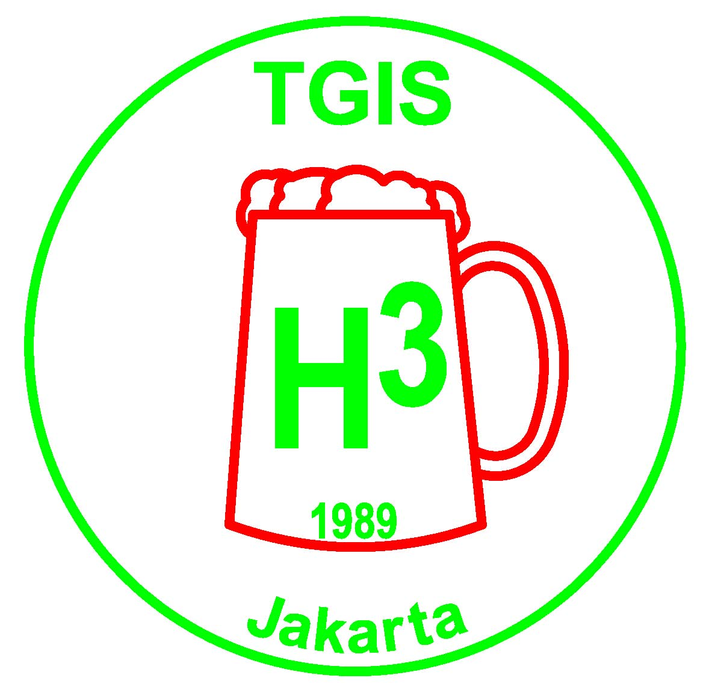 | TGIS Hash House Harriers  Jakarta  TGIS runs on the 2nd and 4th Saturday of every month

TGIS HASH SHEET No. 498

Next Run # 499 – New GL and GM’s Run
This Saturday's run will be by The Novotel, Bogor, with the New Committee as hares. Two runs will be set, long and medium.

Date: Saturday 23 February 2008
Start Time: 4:00pm.
Location: Novotel, Bogor
Hares: Moham and Powderballs

Run Directions:
Take the Jagorawi toll, exit at BOGOR. 50mtr after toll booth, make a U-turn on the left and enter Bogor Raya. Follow this road back over the tollroad. There will be signs to the site near the Novotel.

TGIS Hash Car:
Pick up point is in front of Crown Plaza Hotel on Jl Gatot Subroto. Car will leave at 2.00pm sharp. Fee is Rp50,000 per person, return. Please book early in advance by contacting On-Sec on 0811-843846 or lozlee@cbn.net.id

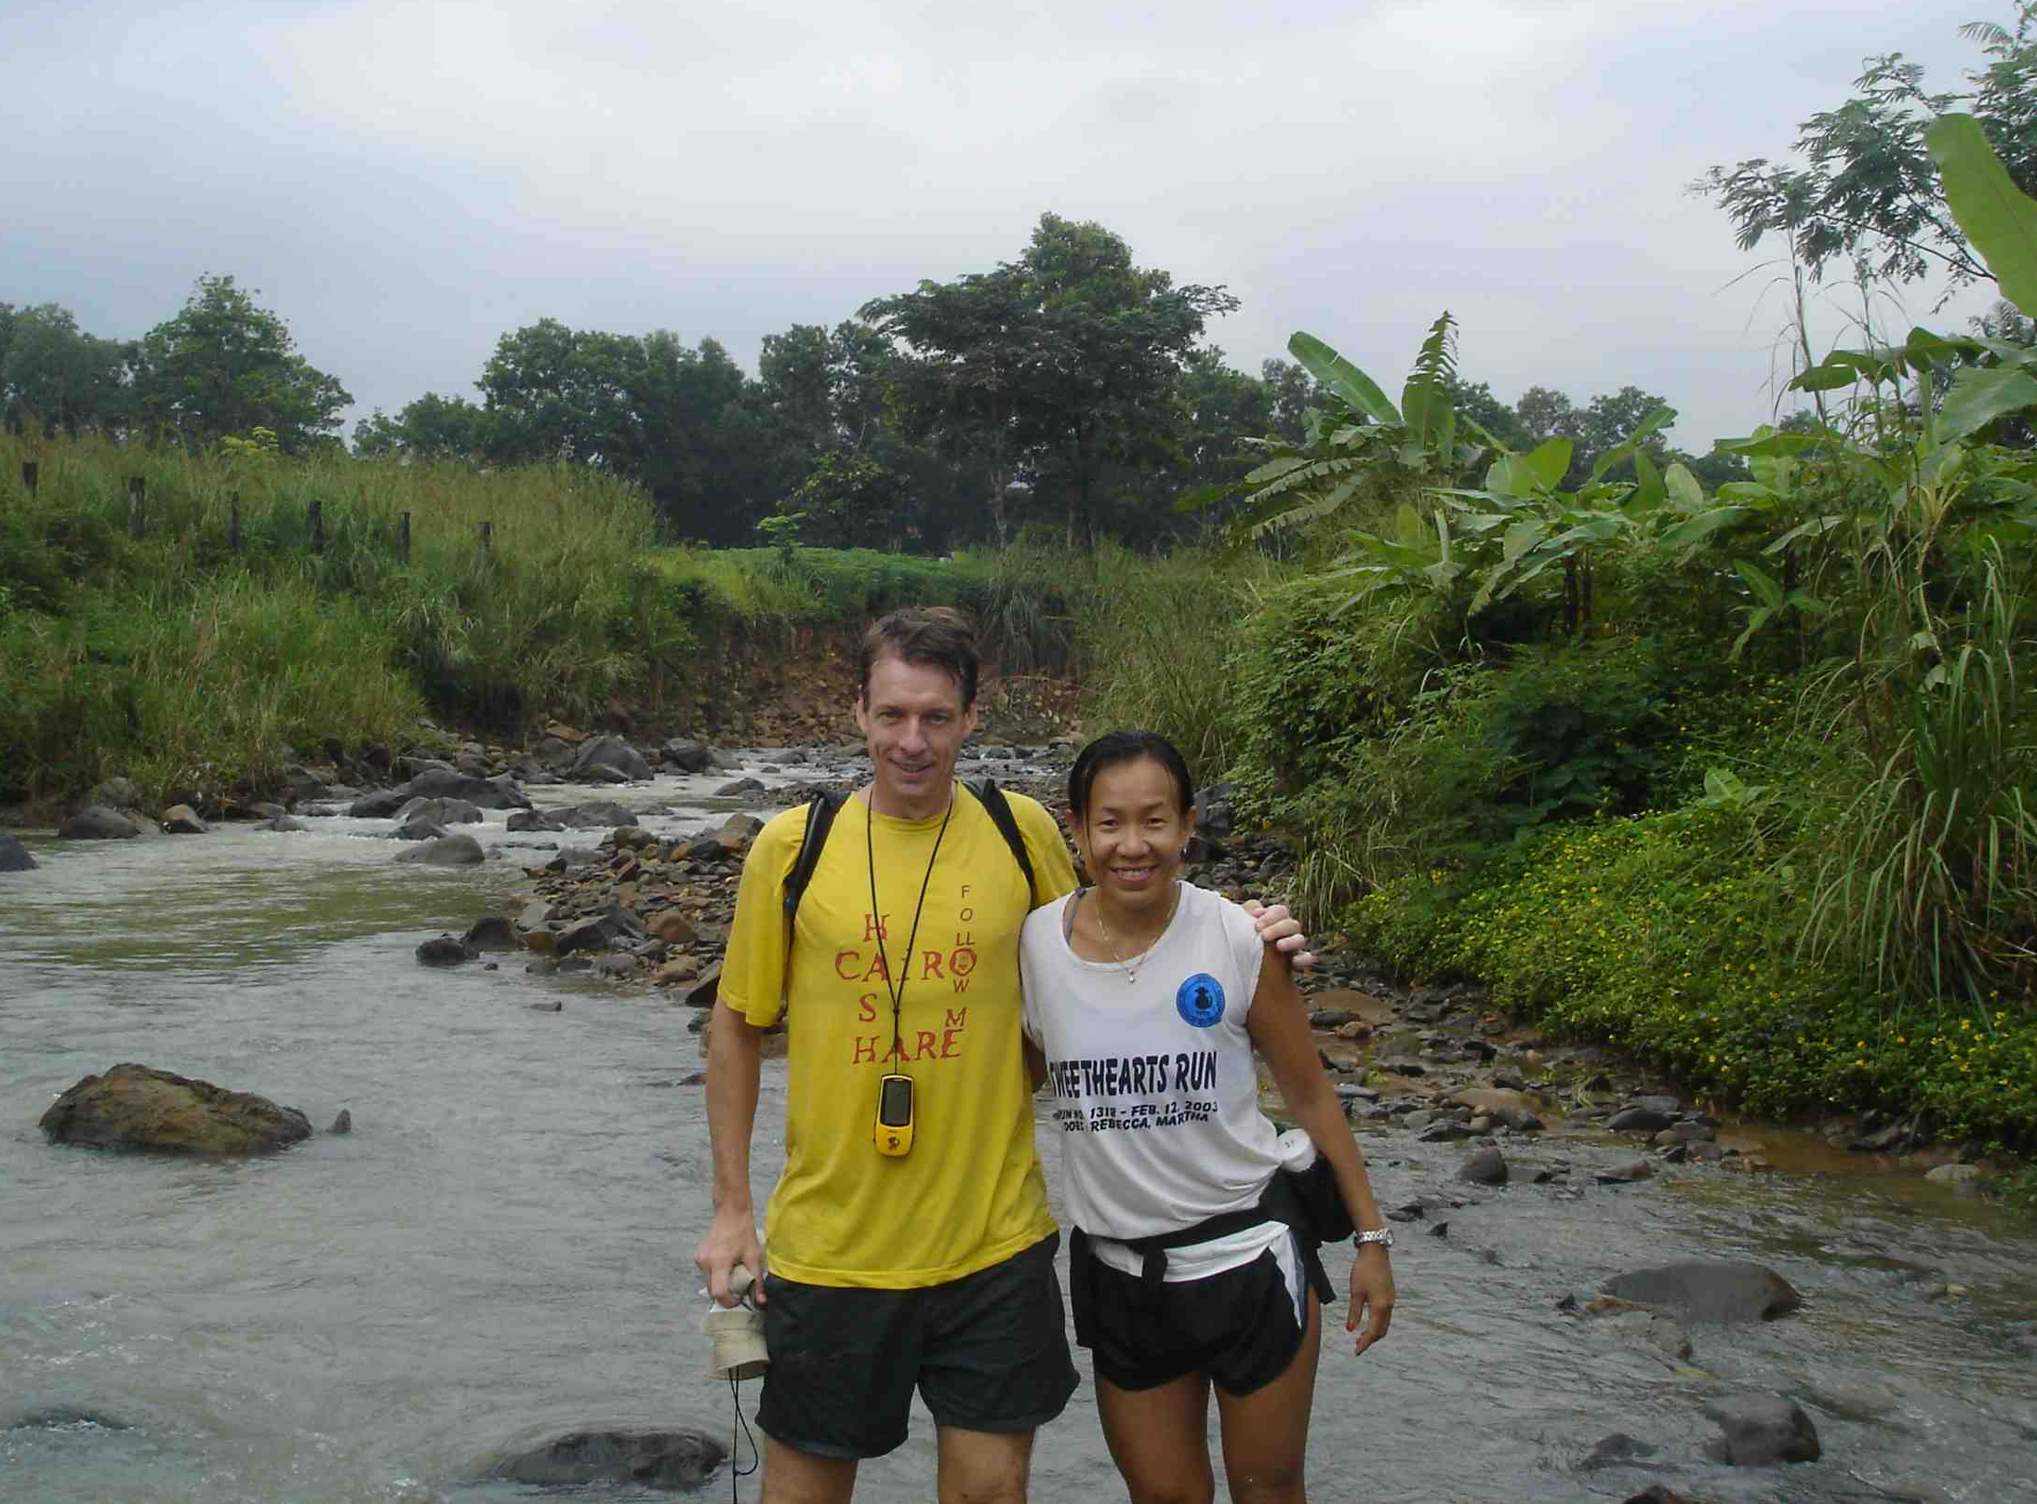

Scribe Report:
Erection Run # 498 at Gunung Pancar by stand-in scribe Auditurd.

40 hashers showed up for this Erection Run at Gunung Pancar. Several new faces were present while some old faces stayed away preferring to find themselves in warmer and drier places such as Anyer. Two hares (Fak-Fak & Juicy Teaser) called the pack to gather round, and, as has become routine these days, announced that there would be a long-ish Medium run a super-long-ish Long run. The third hare (Katoy Fcker) was “still out there”. Why do hares feel compelled to lay these super-ridiculous long runs? And so we were set off and right on time.

The trail headed out the back of a football pitch, meandered down the hill in a generally sweeping big (real big) rightie. As one would expect, rain came down as we got started. This made for some wonderful slipping and sliding and two unfortunates (Novi & Gay Gurkoff) reported twisted ankles & were spotted limping along. Rivers were swollen beyond the hares expectations, causing several to abandon the hash trail and find their way back when refusing to cross the swollen river. Several hashers later reported having near-death experiences during several river crossings. This scribe managed to get back to the bir truck in 1:45 and considered himself damn lucky as most hashers took 2-3 hrs.

While we waited an eternity for the GM to start the circle, an evil Mother Nature started brewing up a night that would be colder than a witches tit. The sky darkened, cold wind gusts started blowing in, almost knocking down the hash umbrella, bringing cold sheets of rain that caused much trembling and looking for cover. This would be the start of a very cold and miserable evening. Meanwhile, the hares, under several umbrellas, helped to barbecue a small heard of tasty goats – a virtual feast including sate kambing, sop kambing, nasi kambing, lontong kambing accompanied by kilos & kilos of chopped cabe.

Fak-Fak finally started the circle and this only because restless hashers started singing “Why are we waiting? Slowly masturbating…” He brought in his outgoing committee, including a bunch of stand-ins, as most of the real committee had apparently made other plans for the evening.

GM handed out down-downs: to Leaky Tits, the self-appointed Hash Flash for out of control private partying; to the Vodka & Bacardi man for helping to expedite the drunken condition of the circle with his generous offerings of Bacardi-Cokes and Vodka-7Ups; to Rotan Prick’s Mrs. whose hash fashion made her look like the wife of the Kenyan Ambassador; to a Dallas sex tourist who managed to amass a multitude of wives in the circle; to RubHerTurd for wearing ridiculous body-sized condom to protect from the rain (RHT admitted he wouldn’t dare wear the puffy condom at a men-only hash); to GM for having us wallow in the mud like pigs; down-downs to a whole corner of the circle that was infested with private partyers which included Gay Gurkoff, Wimbo & Moham; down-down to Jeffrey the Englishman for wanking but pretended to have his left hand in his pant pocket because he was cold; to Woody Pecker for low profile; to Beaver Kecil for pouring piss with a big smile; and of course the usual down-downs to returners, first and last to pay, etc. Gay Gurkoff announced something, but thanks to the Bacardi & Vodka Man, his words were so slurred that only a little could be understood: “Everest. Party. Thurs. After Batavia Hash. For men.”

At some point in the drunken madness, our highly esteemed and loved GM handed over cuntrol of the circle to the new GM, whose name to this point had been kept secret. To the shock & horror of everyone present, it was none other than the mad Dutchman PowderBalls (and GL Moham.) Could tonight’s shitty conditions be a sign that the hash gods disagree with the choice of this Dutchman as GM? – this man of contrary points of view – a real cuntrarian – to take over the reins of this hash? This really was turning out to be a shitty night all the way around.

The new RA (Juicy Beaver) couldn’t wait for the 3rd hare to arrive, so she started the Run Discussion with the other two hares. The RA did a good job picking good commentators such as RubHerTurd who said the Medium Run was a very good run … that had, unfortunately, been fcked up by the hares, so, by definition, was a Hash Shit. This comment was met with applause and jubilation from the other hashers. Other comments followed: too long, too cold, too wet, too muddy, too slippery and did I mention too long & muddy? SUDDENLY KATOY MYSTERIOUSLY APPEARED IN THE CIRCLE, coming in out of the dark, looking like a ghost, but sunburned and like he lost 10 kilos during the day. He himself immediately proclaimed the run a HASH SHIT! The hares were given several DD’s for talking during the Run Discussion. In the end, the RA agreed this run deserved a Hash Shit, which elicited cheers from the crowd. Good job, RA. Nevertheless, we do give a BIG THANK YOU to the hares for cooking up the small herd of goats and for a very nice hash shirt sponsored by Global TV. And thx to the Bacardi & Vodka man too.

So let’s hope that future hares keep runs to a max hour-and-a-half. Don’t follow the bad example of certain hashers (whose hash name might start with a W and might end with an O) to lay super-long runs.

Where the fck are we? Spermaid & MGM nominated Auditurd for using a GPS device that was “off by 200 meters” and this caused them to get lost near the end of their run. Auditurd tried to defend himself (unsuccessfully), saying he had bought the device in Pakistan at a sizeable discount. But, in the end, the WTFRW award went to the deserving Katoy Fcker, the hare who got lost on his own trail and came in hours after the pack.

On this cold night, the only thing that was heated was the debate about what to do about 2 hashers who were still lost on the trail (two young and sexy Indonesian harriettes). Wimbo said that TGIS rules require hares to go out and find lost hashers, but most agreed there was little chance of that. And so it remains a mystery to this scribe what became of the two lost hashers. Perhaps a local goat herder will get lucky and offer them a place in his bed until sunrise.

The last surprise of the evening came when it became obvious that the exit to the car park had become muddy, swampy & was not letting some cars out. Spermaid’s car made several high-RPM attempts to muscle its way through the swamp, finally successing. This hasher was lucky to be stand-in driver of Juicy Beaver’s Terrano which made short order of the muddy swamp with its four wheel drive. But some Kijang drivers were lining up to give it a go and had the look of dread on their faces. The End. See you next TGIS.

TGIS Committee 2008 – 2009 :

Grand Lady: Kim “Moham” Kleppe
Grand Master: Frank “Powderballs” Wijnands
Hash Cash: Paul “Katoy Fcuker” Nontasak
Hash Cash: Maryati “Beaver Kecil”
Hash Music: Don “Wimbo” Reeves
RA: Netti “Juicy Beaver” Hempell
Scribe: Colin “SheepThrills” Ingram
Hash Trash: Melly “KFC”
On Sec: On Sec: Lawrence “Container” Lee
Hash Flash: Netti “Juicy Beaver” Hempell
Trail Master: Nini “Juicy Teaser” Rohmani

Receding Hare Line;

Run No 500 Mar 8 500th Run – Special Weekend
Run No 501 Mar 9 500th Run – Special Weekend
Run No 502 Mar 23 ?
Run No 503
Run No 504
Run No 505

Announcements:

* Please note all the available dates in the above hare line. Please choose the date that suits you best to be a hare, then contact Trail Master or On Sec at lozlee@cbn.net.id to reserve it.

* Visit the TGIS Website: http://geocities.com/tgish3/ A copy of the permission letter is available at the website, or ask On Sec to email you a copy.

* Please notify us if you want to be added to or removed from the mailing list for this newsletter. It is sent out by email and by sms. Contact On Sec at lozlee@cbn.net.id or 0811 843 846

Upcoming Events:

TGIS 500th Run Weekend at Ciater Spa Resort 8th & 9th March 2008……click here for further details

INTERHASH 2008 – PERTH WESTERN AUSTRALIA Easter weekend 21-23 Mar 2008. HERB BOLTONG is on the Interhash Committee as the Visa Coordinator/Advisor www.interhash2008.com/webregistration/ Herb & Yeti: herbyeti@bigpond.com
Special Run organized on Thursday prior to the INTERHASH bash for ex JKT in exile and flown in JKT Hashers.

