AIR ALERT III: THE COMPLETE VERTICAL JUMP PROGRAM

Introduction
For the past 11 years TMT Sports has sold the most popular jump training program on the market, Air Alert II: The Complete Vertical Jump Program - Revised. Although Air Alert II has become a favorite around the world, we have worked to improve it. The Air Alert III upgrade is the improved Air Alert. We changed the number of sets and reps, and, most importantly, we changed the number of days per week that the program will be completed which will help with overall muscle recovery and strength development. We also added one new exercise, Squat Hops™ to greatly benefit your vertical. Any topic that you see on the Air Alert III upgrade MUST BE READ and followed as written. When you see a word "CHANGE" beside of a heading, this means that a change has been made from Air Alert II to Air Alert III.

Air Alert II verses Air Alert III
The exercises for Air Alert III are exactly the same with the exception of one. The technique of each exercise will not change for Air Alert III.

Frequency (changed)
Air Alert III is designed to be done 3 days per week with the exception of week 15 which is designed to be done 4 days. The 3 days workout schedule alternates from week to week which allows for ample muscle and strength recovery for your legs. This is extremely important in building the strength required for giving you the lift you need.

WORKOUT CHART (CHANGE)
The Air Alert III workout chart will provide you with 2 charts. You will notice that the odd numbered weeks and the even numbered weeks instrict the same order sequence for each exercise, but that the actual days of the week are different. Do the workout exactly as prescribed on the days designed for the respective week. The odd weeks are to be done on Monday-Wednesday-Friday and the even weeks are to be done on Tuesday-Wednesday-Thursday. Week 13 is designed as a complete muscle recovery week. Air Alert III should not be completed at all during week 13. Week 15, the final week, is designed to completely break down the muscles, shock them and prepare them for the final recovery. This last week will help to add an additional 1-2 inches on your jumping ability. You are required to do week 15 four (4) days that week. You will do Air Alert III on Monday-Tuesday-Thursday-Friday of the week.

RESTING BETWEEN SETS (CHANGE)
The Air Alert III workout consists of multiple sets and repetitions for each exercise. After completing 1st set of an exercise, do not rest anymore than 2 minutes before completing the second or third set for the respective exercise. During the 2 minute resting period, it is important to massage the muscle that you are currently working on. If you are doing Leap ups, be sure to massage your thighs while resting. When moving from 1 exercise to a new exercise (for example, from Leap ups to Calf raises), do not rest at all. Move immediately to the next exercise.

AIR ALERT III EXERCISES
The Air Alert III exercises are identical to the Air Alert II exercises with the exception of a new exercise, Squat Hops™ (see below). See Air Alert II for instructions regarding the first 5 exercises. Be sure to follow all warm up and cool down instructions identified in the Air Alert II.

SQUAT HOPS - NEW EXERCISE
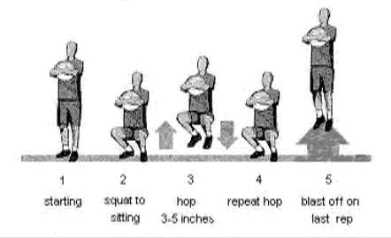
Step 1 - For balance, hold a basketball or volleyball at chest level. You can hold the ball with your hands at each side of the ball or hug the ball.
Step 2 - Squat down into a sitting position while holding the ball. Make sure that you are looking straight ahead, with your back straight and that you are elevated on the balls of your feet (half tiptoed). And most importantly, make sure that your thighs are parallel to the ground.
Step 3 - Hop or bounce in the seated position between 3-5 inches per hop. Keep your thighs parallel. When you land, that completes 1 repetition.
Step 4 - After you complete each repetition (each landing), you land back in the original, seated position. Jump up again for the next repetition.
Step 5 - At the completion (the last rep) of the required set, blast off as high as you possibly can. For example, if you are required to do 1 set of 15 repetitions, you will do 14 Squat Hops (3-5 inches per jump) and on the 15th Squat Hop, you will blast off as high as you possibly can.

Leap ups (with/without rope)
This exercise can be done without the use of a jump rope if you desire. When jumping, keep your hands by your side or in front of you for assistance in jumping and follow the same procedures just described.
Step1: When beginning, bend down to a 1/4 squat position
Step2: Turn the rope and jump back into the air to a minimum of 8 to 10 inches. (You may jump 10 to 12 inches if this is too easy). When you land this completes 1 repetition.
Step3: Continue repeating this motion for each repetition.
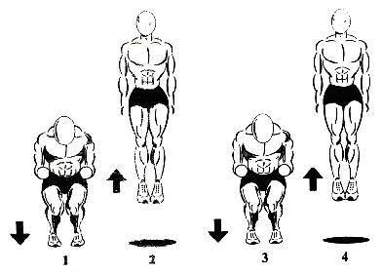
Step1: When beginning, bend down to a 1/4 squat position with your hands out in front of you and jump up
Step2: Jump up into the air to a minimum of 8 to 10 inches. (You may jump 10 to 12 inches if this is too easy) When in the air, your hands should be back by your side. When you land, this completes 1 repetition.
Step3: Same as step 1. Step 3 begins repetition 2
Step4: Same as step 2

Calf raises
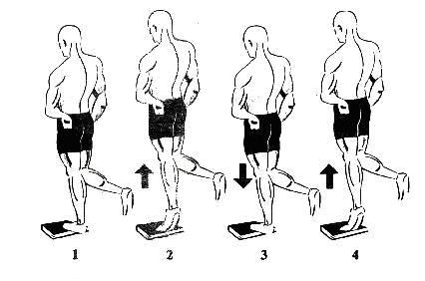
Step1: Your starting position will be with the heel below the book or stair step rested on by your entire body.
Step2: Raise yourself as high up as you can with only the one calf
Step3: Lower your body back to the original, starting position. This completes 1 repetition. Step4: begin second repetition.

Stepups
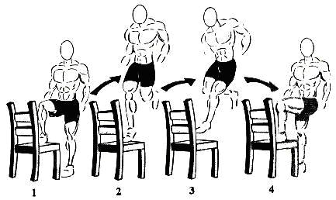
Step1: Begin with one thigh on the chair parallel to the ground.
Step2: With all of your strength, push off of the elevated leg and leap off of the chair as high as you can.
Step3: Crisscross or switch your legs in the air.
Step4: Land with the opposite leg elevated in the chair as in step 1. Repeat the procedure until you are back to step 1. This completes 1 repetition.

Thrust ups
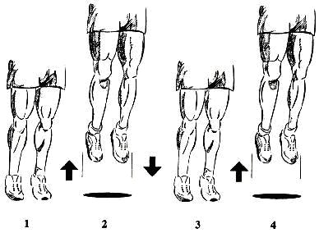
Step1: Begin with your legs straight.
Step2: Thrust (or bounce) yourself up as high as you possibly can.
Step3: The split second and you hit the ground, thrust back up as high as you can trying not to bend your legs. It is helpful to use your arms to throw yourself back up into the air.

Burnouts
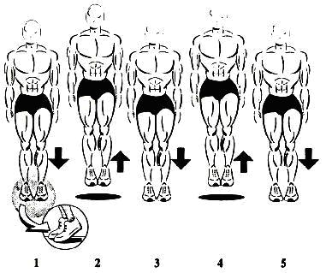
Step1: Elevated as high as you possible can on your tiptoes to assure that you work the high end of your claves.
Step2: As quickly as you possibly can, jump repeatedly no more than 1/2 to1 inch off of the ground making sure to keep yourself elevated as high on your tiptoes as possible ensuring that you are working the upper calf muscles.

Rest 1-2 minutes between sets.
GET OUT AND PLAY AND WORK THOSE LEGS
During the days that you are not doing Air Alert III, it is important that you help your legs get used to normal jumping situations. Air Alert III will increase your vertical, but you will need to train your legs to actual jumping situations. On your days off from Air Alert III, go out and play. And, practice jumping aggressively when you play. This helps to develop muscle memory.

AIR ALERT III PROGRESS CHART
WEEK 1 2 3 4 5 6 7 8 9 10 11 12 13 14 15
DATE
HEIGHT

AIR ALERT III WORKOUT CHART (ODD WEEKS)

ODD NUMBERED WEEKS ARE TO BE DONE ON MONDAY-WEDNESDAY-FRIDAY ONLY
Week | Leap Ups | Calf Raises | Step Ups | Thrust Ups | Burnouts | Squat Hops (wed)

 | sets | reps | sets | reps | sets | reps | sets | reps | sets | reps | sets | reps
1 | 2 | 20 | 2 | 10 | 2 | 10 | 2 | 15 | 1 | 100 | 4 | 15
3 | 3 | 25 | 2 | 20 | 2 | 15 | 2 | 25 | 1 | 300 | 4 | 20
5 | 4 | 25 | 2 | 30 | 2 | 20 | 2 | 35 | 2 | 250 | 4 | 25
7 | 4 | 30 | 2 | 40 | 2 | 25 | 2 | 50 | 2 | 350 | 5 | 25
9 | 4 | 50 | 2 | 50 | 2 | 30 | 2 | 70 | 3 | 300 | 5 | 30
11 | 6 | 50 | 4 | 30 | 2 | 35 | 2 | 90 | 4 | 275 | 5 | 30
13 | DO NOT DO AIR ALERT 3 IT IS IMPORTANT THAT YOU REST YOUR LEGS DURING WEEK 13!!!!!!!
15 | 4 | 100 | 4 | 50 | 2 | 50 | 2 | 100 | 4 | 500 | 5 | 50

AIR ALERT III WORKOUT CHART (EVEN WEEKS)

EVEN NUMBERED WEEKS ARE TO BE DONE ON TUESDAY-WEDNESDAY-THURSDAY ONLY
Week | Leap Ups | Calf Raises | Step Ups | Thrust Ups | Burnouts | Squat Hops (wed)

 | sets | reps | sets | reps | sets | reps | sets | reps | sets | reps | sets | reps
2 | 3 | 20 | 2 | 15 | 2 | 15 | 2 | 20 | 1 | 200 | 4 | 20
4 | 3 | 30 | 2 | 25 | 2 | 20 | 2 | 30 | 2 | 200 | 4 | 20
6 | 2 | 50 | 2 | 35 | 2 | 25 | 2 | 40 | 2 | 300 | 4 | 30
8 | 3 | 50 | 2 | 45 | 2 | 30 | 2 | 60 | 4 | 200 | 5 | 25
10 | 5 | 40 | 2 | 55 | 2 | 35 | 2 | 80 | 4 | 250 | 5 | 30
12 | 4 | 75 | 4 | 35 | 2 | 40 | 2 | 100 | 4 | 300 | 6 | 30
14 | 3 | 30 | 2 | 30 | 2 | 20 | 2 | 30 | 1 | 250 | 4 | 20
* Week 14 is designed to prepare your legs for the final week. The repetitions have been reduced for this reason. Do not exceed what is prescribed.
* Week 15 must be completed on Monday-Tuesday-Thursday-Friday.
The final week is designed to completely exhaust and breakdown the jumping muscles and prepare them for final recovery. That is the reason the repetitions are higher and 4 days required instead of 3. You will notice that your jumping ability will be the highest 4-7 days after completion of the program. MAINTENANCE At the completion of Air Alert III, you can maintain your new vertical simply by aggressively playing a jumping sport 2-3 times per week. You may also repeat week 8 on the alternating, 3 day per week routine. If you wish to redo the program entirely for additional gains, you should wait at least 1 full month before restarting. It is important to rest your legs from this type of workout if you wish to add additional inches. Your gains will not be as significant each time that you do the program.

