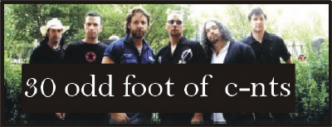

October 2001

Sun Mon Tue Wed Thu Fri Sat
 | 1 Voting begins for Sail Those Same Oceans on Fresh Oven: www.mmusa.tv/  Ray Martin show airs ~ Oz | 2 | 3 | 4  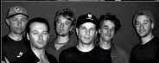  Cracksquad  Rozelle 9:30pm  Voting ends for Sail Those Same Oceans on Fresh Oven | 5  Cracksquad  Rozelle 9:30pm | 6
7 | 8  Columbus Day (US) | 9 | 10 | 11 | 12 | 13
14 | 15 | 16 | 17 | 18 | 19 TOFOG 8pm ~ Sydney's Metro Theatre with special guests Russell Gilbert, Danielle Spencer & band, and Burnum Burnum. | 20 TOFOG 8pm ~ Sydney's Metro Theatre with special guests Russell Gilbert, Danielle Spencer & band, and Burnum Burnum.
21 | 22 | 23 | 24 | 25 | 26 | 27
28 | 29 | 30 | 31  Halloween (US) | 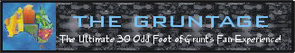  http://www.geocities.com/thegruntage/welcome.html  © Moonrose, 2001


