
The Howling Pig
Issue I Vol I thehowlingpig@yahoo.com

Mirror – a polished surface for reflecting images
~Webster

The UNC Mirror has won many awards for excellence in journalism from some college newspaper organization. I wonder if that organization sees the same papers we see or if the state of college journalism is really that pathetic. Neither polished nor reflective, our mirror doesn’t really deserve its name. From grammatical errors galore to a phobia of actual investigative reporting, our campus newspaper is hardly worth the time to skim through. SRC violating some law that no one understands or cares about is getting a lot of attention. Great, I love reading quotes from x-council members who have no idea about what is going on anymore. How about the story that many of the SRC vice presidents represented the student body by showing up drunk to the homecoming parade.
Or the one about the constant harassment and drinking violations by the Greeks who only receive warning after warning from an administration that seems it could care less about any real punitive action. Why don’t you look into the number of students who have been sexually assaulted at Greek events.
This is not a statement advocating the elimination of the Mirror, after all in the world of corporate media brainwashing, it is nice to have an independent news source on campus. To all of you “journalists” who spend your time and sweat putting the mirror out three times a week, journalism is not about playing nice and making friends, it is about exposing bull shit and affecting change. Get your hands dirty and give us something to read.

How UNC got its groove back
In a recent move, the University of No Color managed to eliminate its token nod towards diversity when it dropped Tony Montoya and his position as Vice President of Multicultural Affairs. Granted, Montoya managed to underperform in a token position with little real power and a relatively meaningless place in the University hierarchy, but the fact that the administration dropped his ass and got rid of even the idea of representing minority students on the administrative level in one step is a new kind of clusterfuck, even for them.
The next step is the long-awaited consolidation of the cultural centers into a single entity known as the "no whitey zone" on the mezzanine of the new student services center in Bishop-Lehr. A great advance for minority students on campus, it means that they can be underserved and underrepresented all in the same place.
So "Charting the Future" means that in ten years we can have a championship football team, a thriving business school, a solid fraternity contingent with the accompanying sororities, a record number of serial rapists and a commitment to white supremacy. Way to go UNC.


If You Build it They Will Come

So what the hell is with all the new stuff everywhere on campus? Where are they getting the money for this shit? Unprecedented budget cuts, a threatened reduction in force for tenured faculty and we have a new honor code posted in every classroom, a good portion of which are “smart.” I’m so grateful that the University finally got its priorities straight and got classrooms smarter than its students. Now we just have to raise tuition, suck off as much from the student fees as we can and we really can be Colorado’s Best University Experience for whoever happens to get the next construction contract.


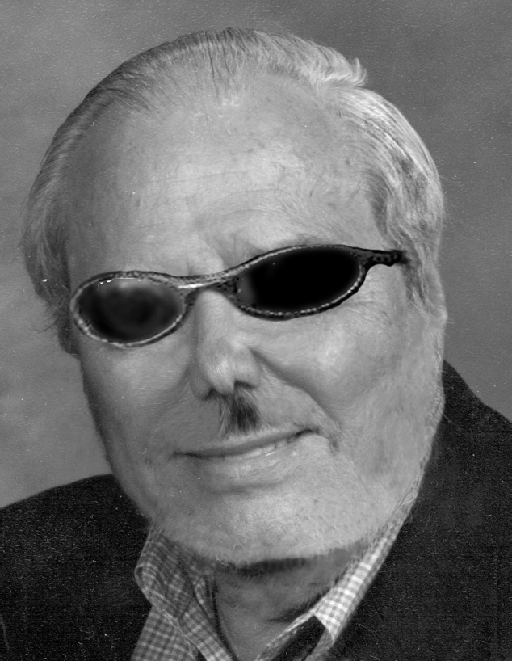

Note from the editor

I’d like to introduce you to the first edition of The Howling Pig. This will be a regular bitch sheet that will speak truth to power, obscenities to clergy, and advice to all the stoners sitting around watching Scooby Doo. This will be a forum for the pissed off and disenfranchised in Northern Colorado, basically everybody.
I am the editor in chief of The Howling Pig and my name is Junius Puke. Since I intend to maintain a long tenure at the helm of the journalistic behemoth, here’s a little about me. I was born in New York City and attended high school there. After school, I started in the mailroom at a large finance firm and worked my way up to be a broker on Wall Street. In the 90s I gambled and made a bundle in tech stocks. Now, I’m a well-paid, tenured professor at a small western university paid through an endowment from one of my business partners. I made it to where I am through hard work, luck, and connections all without a college degree. Dissatisfaction with a cushy, do-nothing, ornamental position led me to found this subversive little paper. I hope you enjoy it. ~Jay

