
The Howling Pig
Issue III Vol I thehowlingpig@yahoo.com

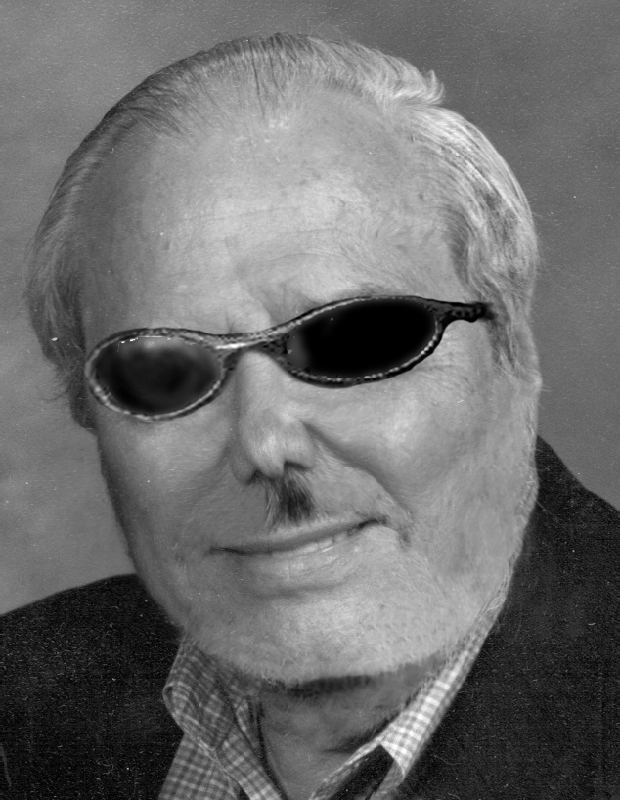

Allen Huang, Faster Than a Speeding Bullet
The administration seems to have made it a point lately to cut away all of the middle management jobs in an attempt to streamline the university. Some have noticed too that many of those that have been fired were people of color. Of course the first thing that leaps to mind is some sinister Aryan plot to eliminate minorities from campus. Alas, no luck. The reason for the disparity in firing is more likely the current system of awarding the cushiest jobs to friends, relatives, and business partners and surprisingly all those folks seem to be white and upper class. Upper middle management is about the highest someone can expect to rise on their own merits without some handy connection with the brass.
Allen Huang must be the best friend the movers and shakers have ever had. Right now he’s doing the job of eight close relatives with more duties being heaped on by the minute. In addition to being the Dean of the Graduate School, Dr. Huang is also the Interim Provost and Vice President for Academic Affairs, as well as taking over the duties of the director of the Center for Professional Development and the Vice President of Multicultural Affairs. All this in spite of the apparent racial cleansing going on lately.
The standard attack on affirmative action is that the person who can best do the job is the one who should be allowed to do it, no matter their race. In that light, it seems that Huang should start moving his stuff into the fourth floor of Carter Hall now.


Colorado’s Hottest University
Like a supermodel in an in-depth interview, UNC may look nice but it has little else to offer. Thanks to the administration’s obsession with campus beautification, our scarce financial resources are being wasted on projects to make UNC look “aesthetically pleasing” (nicer). I’ve got a great idea, instead of laying new sod on the central campus dorm lawns (in November?!?), re-carpeting and remodeling offices in the university center, and redoing parking lot lighting because it isn’t uniform, try spending money on something that students care about. Saving our academic programs from being starved and slashed again this year is one suggestion. Another would be supporting student programs by letting them advertise in ways other than putting a stupid flyer among all the other stupid flyers that no one reads. Student should be able to chalk and shout and post anything they want. Whose school is this anyway? “Students first” my ass. Did you know that we have a campus radio station? We do, but you can’t hear it because the administration wouldn’t allow a broadcast antenna the size of the one on your car to be put on top of the University Center. Why? It’s not “aesthetically pleasing.” If a University has outstanding academics and thriving student life in and out of the classroom, people won’t care how ugly it is. Carter Hall, please stop reading “Cosmo.” You look fine the way you are. Not all universities can look like that. Those that do are probably fake anyway. Seriously, it’s what’s on the inside that counts.


Speak Freely
In a country founded on the concept of the free exchange of ideas, one would expect a university to be all for free speech, on the forefront even. Not so much. In their commitment to free speech on campus, UNC has designated free speech zones in which anything may be discussed freely. Anywhere else on the roughly ninety percent of campus and you say something particularly nasty about some UNC crony like Wells Fargo and you can expect the police to show up and possibly some jail time or a fine. So shut your mouth.
This Just Makes Me Wanna…
By Junius Puke

In 2001, at the spring Board of Trustees meeting, a student asked Board Chair Dick Monfort if he and the board were going to take a position on federal legislation that would slash funding for the Pell grant. Mr. Monfort responded saying “what’s the Pell grant?” Dick, let’s face it. You are on the Board of Trustees because you are too stupid and irresponsible for the “Party” to give you any real power. Appointment to the Board by the governor is the lowest grade of political quid pro quo available for wealthy campaign contributors such as yourself. In fact, the only thing you know about higher education is how best to get your rich dad to bail your brother out of yet another drunk driving charge. Do us a favor. Resign and take up permanent residence at the Greeley Country Club where your ignorance will only hurt the women that you and your friends objectify and sexually harass as they put up with your shit, serve you drink after drink and then watch you stumble out and drive away. Grow up Dick.
~Jay

