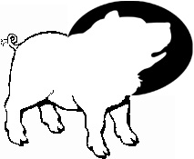
The Howling Pig
Issue IV Vol I thehowlingpig@yahoo.com

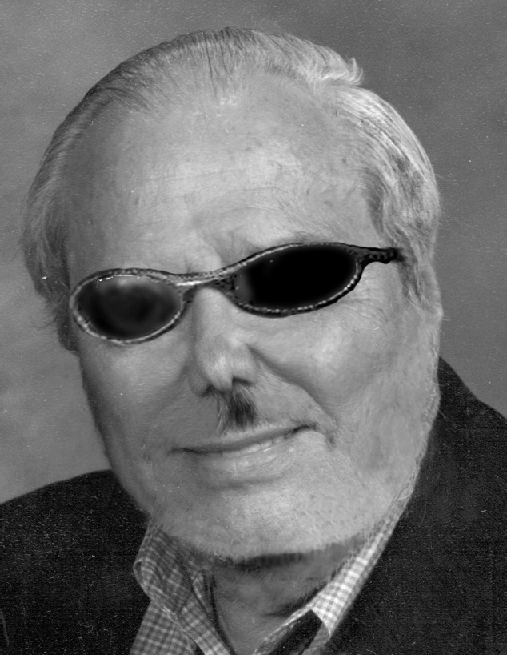

PVA Saved?
Kathleen Roundtree is leaving the deanship of the Performing/Visual Arts College. With her at the head of the College the dance, directing, and guitar programs disappeared. All of the departments were starved for money while any effort by students or faculty within these departments to raise extra money was immediately stopped because they were “overstepping their bounds.”
Roundtree was offended by the material covered in Checkov’s “The Seagull” (the best playwright since Shakespeare) and by the language used in Neil Simon’s “Biloxi Blues” (racy by standards in the 1950s.) Who made this woman Dean of a performing arts college in the first place?
The question at hand is this: will the administration use the opportunity of a Dean-less PVA to combine it with Arts and Sciences so that PVA can slowly be starved to death? Or will they recognize the fact that PVA boasts more nationally recognized excellent programs than any other College in the University. It is arguably one of our best recruiters as people from all over the country come to Greeley, Colorado to learn the art of acting, dance, visual art, and vocal and instrumental performance. The productions of PVA are one of the best links we have to the Greeley community. Hundreds of Greeley residents plan their schedules around the PVA calendar. Yet under Roundtree, PVA suffered.
If there is to be a new Dean of PVA, it should be a person who will fight for the college and who will not stand by to see it reduced to irrelevance by an administration working for a Board of Trustees appointed by a Governor who has already cut all of the funding for the Colorado Council for the Arts. We see what is going on. If you think PVA will go quietly, you’ve never been in the class where they teach theatre majors to project (translation for non-theatre majors: they’re LOUD).

Sen Andrews-McCarthy
In his noble quest to drive all those damn liberals out of higher education, Sen. Andrews plans to introduce a bill that could force universities to take political affiliation into account in the hiring of professors. Andrews believes that an obscene majority of college profs are liberals. On the one hand, no shit, and on the other hand did we learn nothing from Joe McCarthy? I'll tell you how to get more conservatives in higher education. Pay faculty at least as well as their counterparts in the business world. Andrews, you’re a Republican, this should make sense to you. There is no money to be made in higher education in Colorado, so of course the only people who would want to teach are those that care about their work more than their paychecks. While many conservatives care about their work, they tend to find work that also makes them rich. If Andrews actually succeeds in selling his idea to the legislature, the conservatives that will be brought into our universities will be the truly incompetent ones that couldn't find any other way to make money. Ironically, this man is also leading the charge to eliminate affirmative action in Colorado. How does this figure? Simple. Affirmative action hurts white conservatives, while Andrews’ bill would help white conservatives.


An All-America City
People wonder what student activists do in Greeley. The image that comes to mind is of a group of shabbily dressed kids sitting around that weird kid with the orange mohawk and bitching about the war, the environment, the President, and getting heartily stoned. That’s maybe not that far off, but there’s a big hulking injustice squatting on the north end of town that they should be working on. The house that Kenny built is still squirting out beef and beef accessories at a high rate of speed because of the hazardous work done by its dangerously overworked and underpaid employees.
Back in a kinder and gentler time, Warren Monfort started a family business that treated its workers well and produced a quality product- dead cows. Over time, his little enterprise became more successful and by the time his son Kenneth had taken over, things were pretty big. Kenny was well-liked in the community and things were peachy until the mid-70s when there was a strike by the meatpacking workers and Kenny did the right thing (financially speaking) and fired them all, shut down the plant and restarted again slashing wages, benefits and safety precautions.
That’s the source of the Monfort family fortune that UNC is so enamored of. That pile of money that helped garner Greeley the All-America City award in ’89 through contributions to the civic center, hospital and university is built on the backs of the workers. So a graduate of the Kenneth W. Monfort School of Business can be expected to follow in Kenny’s footsteps and exploit their overworked, underpaid, and undereducated workers for as much quick profit and political clout as possible. Next time you walk past Kenny’s smiling statue by Kepner Hall, give him a kick for the workers that paid for it. Smile when you do it, because you’re on camera.


Puke Pounces on Pounds
Weapons of Mass Consumption (WMC)-i.e. things that make people fat- represent the most dangerous threat to national security today. WMCs are eating away at our nation's strength, patriotism, and democratic system. One-third of North America is overweight. Since the Sept. 11 attack, it is clear that such Cold War strategies as multi-laterialism are outdated. The Cold War strategy of the food pyramid must also be abandoned if we are to remain strong in post-9/11 America. In fact, the "food pyramid" strategy actually embraces what is now recognized as the greatest threat to America: carbs.
The most sinister aspect of the food pyramid is that it actually encourages Americans to consume carbs. The pyramid places carbs at its base, referring to it as the "Bread, Cereal, Rice and Pasta Group", or what I like to refer to as the Axis of Making You Fat. This strategy suggests that carbs should take up the largest part of our diets, and that we should consume as many as 11 servings per day.
Now, I understand our interests abroad. But my grandpa always said “before you try to clean up the neighborhood, take care of your own back yard.” Our greatest threat lies not in the Middle East or East Asia, but on our plates, and at the drive-thru window.
The time calls for an all out war on cabs, complete with inclusion in the Office of Homeland Security, and a nice federal budget that detracts from higher education. Our diets have been hijacked by a liberal conspiracy to make this country weak. As a proud patriot, I won't stand for it. Do your part, and order that hamburger without the bun. ~J

