The Downward Spiral
The entrance to this dungeon is a huge spiraling funnel, easily 500 meters across and 300 meters deep. It looks like it has a circular path running along the edge of the funnel when there in fact are more than two spiraling paths running down. This makes reaching the bottom of the funnel very difficult. The builders of the Spiral created an illusory effect using colors and angles to make it look as if there is only on path going down. However once someone starts descending, the trick of the Spiral does its work. It is namely impossible to descent the spiral. Halfway down, the deluded traveler stops looses all sense of direction and doesn’t stop descending. While she thinks that she’s still going down the Spiral, she is following the same path over and over again. To notice this, you either need to succeed at a direction sense check (DC: 15) or you’ll probably notice it when the sun sets and you still haven’t reached the bottom. There is a way down and in order to find you have to change direction several times and follow cleverly concealed paths that will finally bring you to the entrance of the dungeon. The dungeon is a tomb, containing a few burial chambers and such (like the Egyptian pyramids). Before entering though the adventurers first have to fight a huge mantrap that has grown in the center of the funnel. It has long tentacles that can easily reach out and grab a person. It mainly feeds of the hapless desert animal that stumbles down the spiral and on a huge underground basin that used to be filled with water, but is now almost completely dry.
In the dungeon the Heart of the Fearless or the Dreadnought can be found: A huge ruby the size of a fist.

Through research in old books the party can find out about its existence and whereabouts. It is actually a pretty infamous place of which a few drawings exist.

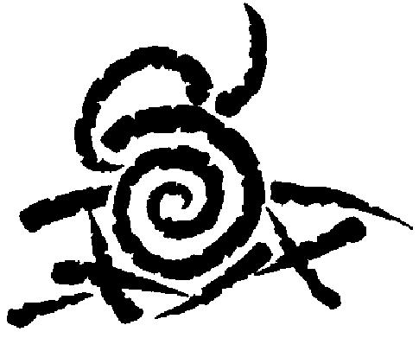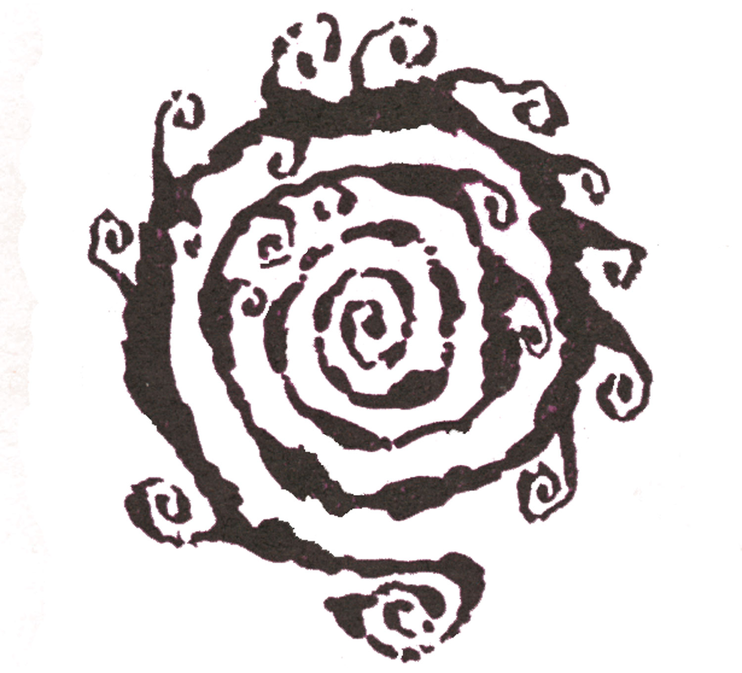

The main chamber of the dungeon is the mazelike combination lock that opens the way to the burial chamber of Lord Tuskin, a paladin from the Great War (although they were then called Knights of the Goddess). The entire complex is powered with steam energy.

Spiral

E
Top of the pyramid is glass, it can turn into a pillar that acts as a solar panel and provides the power for the spiral maze

Four spiraling staircases

E = elevator
This room is filled with Chainworms (appendix)

Burial chamber of Tuskin’s wife

This door leads to a hallway with four statues of the Goddess. Each statue has a riddle written on it. The heroes must solve this riddle to pass the statues. The hallway ends in the spiral maze. (next page)

1
2
3
4
4
1
1
2
3
4
1
1
moves
1
moves
w

3
3
4

1
2
2

The Spiral Maze
entrance

G
1
G
w
G
gong
w
w
water
w
Lord Tuskin’s Tomb
G

G

Gong: vibrations break glass, water flows (shoots) out into the water room (marked ‘w’) bringing with it some shards of its crystal container (clue for players to know what happened.) The water gathers in a hole in the ground, fills another container to become a counterweight that unlocks the doors.
C
W

C
w
w
W
w

C = Counterweight
W = container for water

Top view
Side view

CHAINWORM
Large Vermin
Hit Dice: 3d8 (13 hp)
Initiative: +3 (Dex)
Speed: 30 ft, climb 20 ft
AC: 15 (-1 size, +3 Dex, +3 natural)
Attacks: Bite +2 melee; or sting +2 melee
Damage: Bite 1d6+1; or sting 1d8+1 and poison
Face/Reach: 5 ft by 10 ft/5 ft
Special Attacks: Poison
Special Qualities: Vermin, web, light blindness, darkvision 60 ft
Saves: Fort +3, Ref +4, Will +1
Abilities: Str 13, Dex 16, Con 10, Int –, Wis 10, Cha 2
Skills: Climb +8, Hide +1, Listen +2, Spot +3

Climate/Terrain: Underground
Organization: Solitary, gang (2-4), or nest (5-10)
Challenge Rating: 2
Treasure: None
Alignment: Always neutral
Advancement: 4-7 HD (Large); 8-9 HD (Large)

A chainworm appears as a silver-scaled centipede 8’-10’ long with a razor sharp barb on its tail.
A chainworm can spin a web that covers an area of 5 ft. by 5 ft. in one round. Chainworms do not spin these webs at victims, rather they cover an area and wait for prey to become trapped in the near metal strength strands. Once trapped, a chainworm moves in and attacks its prey.

COMBAT
A chainworm attacks by biting or stinging its prey. The sting of a chainworm is poisonous. It usually prefers to wait until a victim is caught in its web before engaging in combat, but if threatened a chainworm will not cower.
Poison (Ex): Tail sting, Fortitude save (DC 15), initial and secondary damage 1d6 temporary Strength.
Web (Ex): A chainworm’s web is strong enough to support the chainworm and one creature of the same size. An approaching creature must succeed at a Spot check (DC 20) to notice a web. If caught, Strength check (DC 26) or Escape Artist check (DC 20) to free a stuck creature. Each 5-foot section has damage reduction 5/fire and 6 hit points.
A chainworm may move across its web at its normal climb rate, and can sense the exact location of any creature caught in its web.
Light Blindness (Ex): Abrupt exposure to bright light (such as sunlight or a daylight spell) blinds the chainworm for 1 round. In addition, they suffer a –1 circumstance penalty to all attack rolls, saves, and checks while operating in bright light.
Vermin: Immune to all mind-influencing effects (charms, compulsions, phantasms, and morale effects).
Skills: The chainworm has a +8 racial bonus to all Climb checks.

