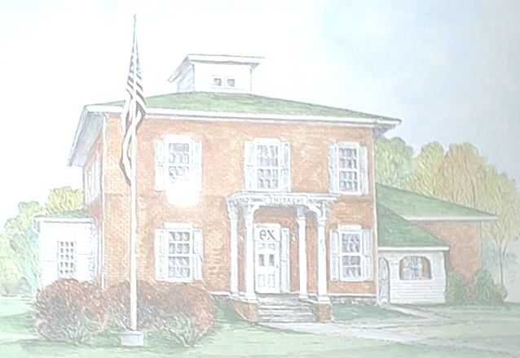
The History of Zeta Beta

The history of Zeta Beta has a long and proud record. While the charter of Zeta Beta is only thirty-five years old, history at 315 South Madison goes back well into the nineteenth century.
The organization that preceded Theta Chi at Adrian College was known as the American Commons Club. The ACC, as it was referred to, was founded at Adrian College in 1934. This proud organization would meet downtown and other locations where they could rent out meeting rooms. In 1959, the ACC with help of local industrialist and businessman Ray W. Herrick, Adrian College President John Dawson, and Professor Ed Peelle purchased the house at 315 for $30,000. Dr. Alexander, a dentist, originally built this house in 1871. It is rumored to be the oldest standing brick house in Adrian. This house was named the Ruth E. Cargo house until 1964.
In 1963, the ACC was a dying organization. It had only three sites nationally, one at Adrian and two in Ohio. Later that year one of the chapters in Ohio folded. Knowing that the same fate awaited them, the ACC at Adrian College decided to disband and absorb into Theta Chi national Fraternity. Thus on October 24, 1964 Theta Chi founded its Zeta Beta chapter at Adrian College from the remaining members of the ACC.
Since then, over 600 members have been initiated into the Zeta Beta Chapter of Theta Chi Fraternity. The house has under gone two additions in 1967 and in 1985. Zeta Beta has had three house fathers/mothers over its history. Marge Root was the first housemother serving the ACC. She only stayed one year. In 1962, Pearl M. Jones became the housemother. She guided the men through 10 years including the transition from ACC to Theta Chi. By far the most notable one though, was Eric Sullivan.
In 1972, Eric took over as housefather from Jones upon her death. Eric Sullivan was a graduate of Adrian College and also a charter member of Zeta Beta. Eric was a man of many talents. He was a teacher, a principle, a mayor, but more importantly he was mentor to over 300 initiates he guided during his tenure as housefather. After 26 wonderful years of service to the community and more importantly to Zeta Beta, Eric retired in 1998. In 1999, Theta Chi National organization bestowed upon Eric the Theta Chi Lifetime Achievement Award. He was the first Theta Chi that did not hold a national office to receive this award.
Since Eric Sullivan’s retirement, members at Zeta Beta have had to face new challenges and goals without the advisement of a housefather. These challenges and goals have been meet successfully. In the summer of 1998, the undergraduates of Theta Chi nation wide adopted a policy to have all chapter houses be alcohol free by 2003. In this spirit, Zeta Beta with other Greek organizations, set a policy forth that would eliminate alcohol at Greek parties and functions by the year 2000.
Membership has rose dramatically. Since 1994, Zeta Beta has initiated 100 new members into the fraternity. Zeta Beta’s current membership is forty-five men; this on a campus of under 1000 students. Zeta Beta is not only the largest male fraternity on Adrian College campus, it also was recently honored with the highest grade point average of any Greek organization with a 3.21 on a 4.0 scale.
Throughout Zeta Beta’s history, we have achieved many goals and have endured times of hardship. Since then, we have established ourselves as a strong fraternity with great ties to other organizations, faculty and administrators on campus. We look forward to having many more wonderful years of brotherhood at Zeta Beta.

