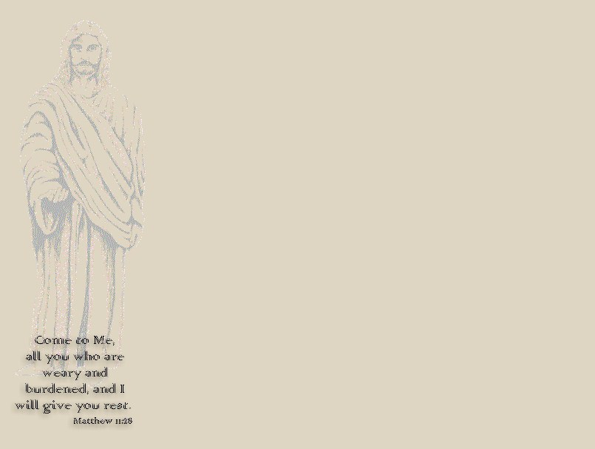
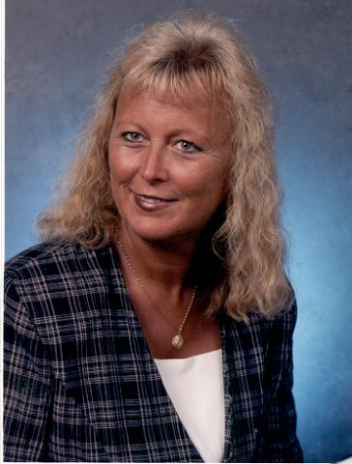

This is Judy Wine; she has been diagnosed with carcinoid cancer. Please pray that she will be totally healed. Please call her name in your daily prayer time.
HOME
Healing

III John 2
Beloved, I pray that in all things thou may prosper
and be in health, even as thy soul prospers.

Matthew 9:35
And Jesus went about all the cities and the villages,
teaching in their synagogues, and preaching the gospel
of the kingdom, and healing all manner of disease and
all manner of sickness.

Hebrews 13:8
Jesus Christ is the same yesterday and today, yea
and forever.

I Peter 2:24
Who his own self bare our sins in his body upon the
tree, that we, having died unto sins, might live unto
righteousness; by whose stripes ye were healed.

Psalms 103:3
Who forgives all thine iniquities; who heals all thy
diseases;

Isaiah 53:5
But he was wounded for our transgressions, he was
bruised for our iniquities; the chastisement of our
peace was upon him; and with his stripes we are healed.

All Is Well
II Kings 4:18-37

