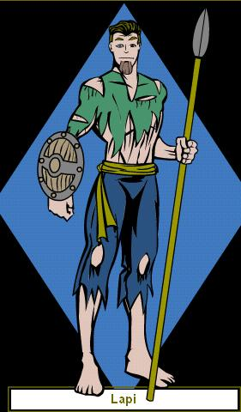Lapi, a slave who is entering the challenge to earn money for his family

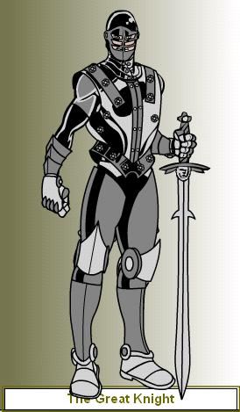The Great Knight, one of Lapi's many challengers, he has been the champion of the challenge for 4 years now!!

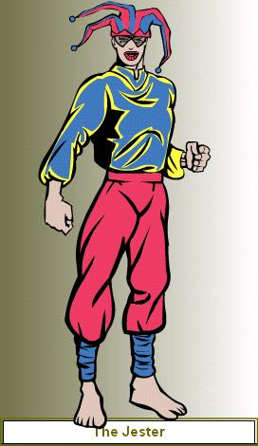 The Jester warms up the crowd before every challenge, he loves a good laugh, even when something bad happens, he can gladden your day!

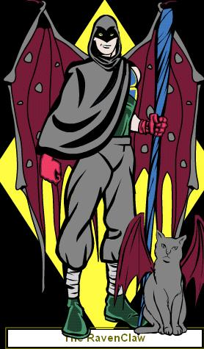 RavenClaw is a dark magician, he has been known to strike at any random time!

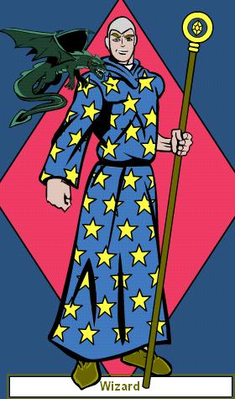The Wizard is a master of magic, he always is there when you least expect him!

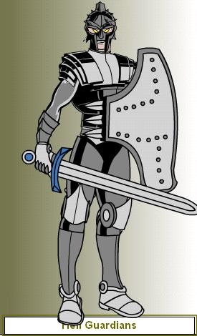 These guys are said to be at the gate of hell, making sure no outsiders get in!!!

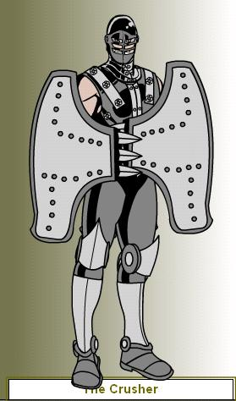The Crusher is said to have outrageous power, he crushes his victims between his 2 shields! Believe it or not it works!!!

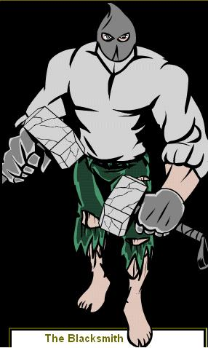The Blacksmith is a cruel hearted guy, he masters in the molding of iron and other metals!

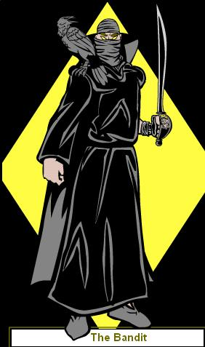The Bandit is a thieving fellow who spends all his time taking from others to make up for what he doesn’t have!

