M6528 MIRV Assignment #1
Name: Yeoh Wee Soon, Matrix No.: G0201890F

Objective: The idea is to understand different data representations currently used for medical images.

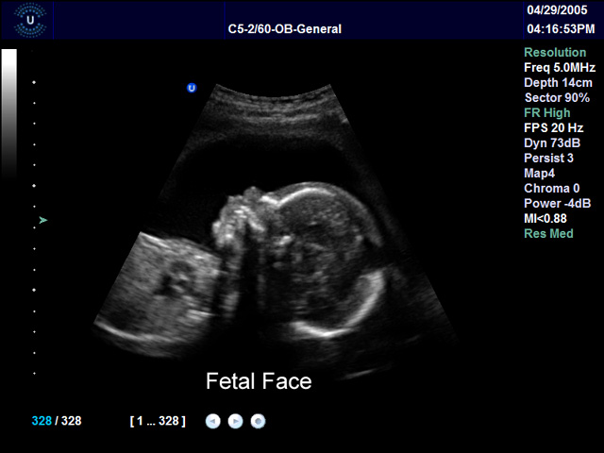  Cost: Exact cost is not known as it usually goes along with a screening package probably above $200 (Last link reveals cost of ultrasound scanning varying from $53~$116). Logically speaking, it is the simplest mode of medical imaging that does not require complex system. If simply scanning is concerned, the cost should be much less than that of X-ray.  Source:  Image:  http://www.ultrasonix.com/clinicalimages.html  Research RF test data:  http://kolonia.keteu.org/~haunma/work/  http://bul.eecs.umich.edu/  http://www.mountelizabeth.com.sg/pmc_packages_women.jsp  http://www.sgh.com.sg/ForPatientsnVisitors/ServicesGuide/HealthScreening/fees.htm | Ultrasound:  Ultrasound imaging is based on pulse-echo technique whereby an ultrasonic pulse-wavelet is transmitted from the transducer into the body and the formation of the image is via the reception of echoes from the same transducer. This fetal profile shows superior soft tissue and frontal bone definition can be appreciated in this image of a fetal profile scanned with a transducer array type curved array C 5-2/60.  System Used: Sonix  Resolution:  Frequency 5MHz, depth 14cm  Sector angle 85° FOV  JPEG Image: 640x480 pixels, 12-bit true color  Frame rate: 20Hz  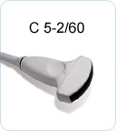  Array ultrasound transducer
Resolution is defined by how well two objects are discriminated by the imaging modalities. While image presented in the monitor is specified by the resolution of the monitor and the capabilities of the video card used, it should not be used to specify the capability of the imaging modality in resolving fine details. Indeed, it may be specified in terms of spatial resolution which is a metric of distance such as that specified in mm. Thus, in ultrasound imaging the resolution is not appropriate to specify in terms n x m pixels. It is determined by the scheme of imaging (e.g., coded excitation, fundamental or harmonic imaging), imaging frequency and pulse width, number of scanning lines and the characteristics of the ultrasonic transducer (type of transducers, dimensions of the array elements, array elements spacing, etc). Please see the characteristics of a typical ultrasound scanner for additional information on ultrasound in the following page.
Characteristics of a Typical Ultrasound Scanner

Table 1.Typical system operating parameters.
System operating parameters | Typical values
Transducer frequencies | 2 – 15 MHz
Typical depth of penetration | 18 cm (abdominal imaging)  16 cm (cardiac imaging)  4 cm (small parts and peripheral vascular imaging)
Time to acquire one 20cm acoustic ray | 260 μsec
Pulse repetition frequency (PRF) | 4 kHz
Typical number of rays in an image | 128 – 400
Data acquisition frame rates | 10 – 80 frames/sec

In the context of imaging of the human body, frequency and wavelength (and therefore resolution) are inversely related with a constant trend toward higher frequencies in order to obtain better resolution. However attenuation of the ultrasonic signals increases with frequency in soft tissues, and so a tradeoff must be made between the depth of penetration that must be achieved for a particular clinical application and the highest frequency can be used. Given the compromises that have to be made, resolution of the scanner is limited. Table 2 gives a rough estimate of the range of resolution and the depth of penetration at which these resolutions are achievable.

Table 2.Operating frequency, resolution & depth of penetration.
Operating frequency (MHz) | Resolution (mm) | Penetration (cm)
2.5 – 3.5 | 2 – 4 | 15 or more
7 – 10 | 0.5 | 3

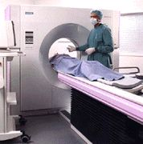  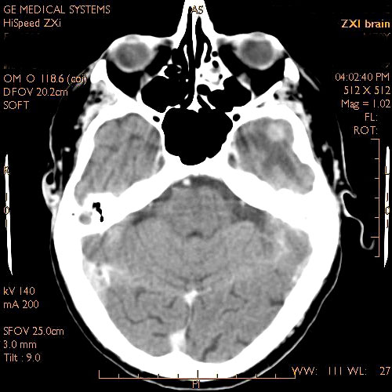 | Computed Tomography (CT):  CT scanning is a method which produces an image of a 'slice' of the body, using a computer program to reconstruct a picture from data derived from a series of precision X-ray exposures.  This scanning use a series of X-ray beams passed through the head taken from many different directions. Typically used for quickly viewing brain injuries. The harder a material is, the whiter it will appear on the scan. Modern CT scanning exposes the subject to about as much radiation as a single x-ray and can provide reasonably good images in a matter of minutes.  This method creates cross-sectional images of the brain and shows the structure of the brain, but not its function.  System used: GE HiSpeed  Resolution:  Brain axial image of 512 x 512 pixels  GE HiSpeed CT 60 Hz  Tube: 25,000 slices, 4.5 second reconstruction.  Detecting energy: 140kv, 200mA  Gantry tilting: 9 degree  Slice thickness: 3mm  JPEG Image: 500 x 500 pixels, 12-bit true color  Cost: approximately $1000/scan.  Source:  Images:  http://www.gehealthcare.com/usen/ct/case_studies/products/brainimg.html  Detail procedure & summary:  http://imaginis.com/ct-scan/  More on scanning parameters:  http://www.ctisus.org/mdct64/index.html  Cost:  http://www.raffleshospital.com/special_fixed_price_packages.html

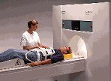  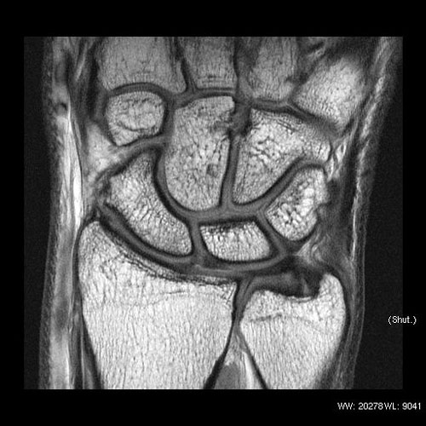 | Magnetic Resonance Imaging (MRI):  It relies on the atomic properties (nuclear resonance) of protons in tissues when they are scanned with RF (radio frequency) radiation. The protons in the tissues, which resonate at slightly different frequencies, produce a signal that a computer uses to tell one tissue from another. MRI provides detailed 3-dimensional soft tissue images. It provides an anatomical view of the brain. Advantages include safe, painless, noninvasive, no radioactive material is used, it provides detailed view of the brain in different dimensions.  MRI images provide greater detail than CT images.  System used: Signa EXCITE HD 3.0T  Resolution:  Image: Coronal Wrist  Obtained with the small extremity T/R coil 10 cm of internal aperature Ultra-high SNR.  JPEG Image: 500 x 500 pixels, 12-bit true color  Cost: part body > $400/scan, whole body > $900/scan.  Source:  Image:  http://www.gehealthcare.com/usen/mr/s_excite3/products/hdmrorth_imggal.html  Detail procedure & summary:  http://www.imaginis.com/breasthealth/mri.asp  Cost:  http://www.raffleshospital.com/special_fixed_price_packages.html

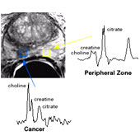  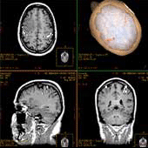  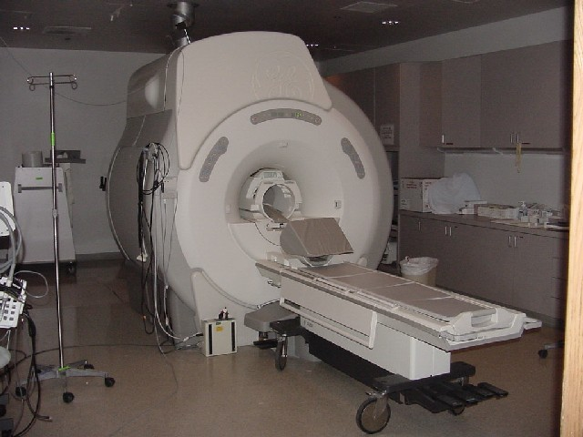 | Functional MRI (fMRI):  It relies on the paramagnetic properties of oxygenated and deoxygenated hemoglobin to see images of changing blood flow in the brain associated with neural activity. This allows images to be generated that reflect which structures are activated (and how) during performance of different tasks. Most fMRI scanners allow subjects to be presented with different visual images, sounds and touch stimuli, and to make different actions such as pressing a button or moving a joystick. Consequently fMRI can be used to reveal brain structures and processes associated with perception, thought and action. The resolution of fMRI is about two or three millimeters at present, limited by the spatial spread of the hemodynamic response to neural activity. It has largely superseded PET for the study of brain activation patterns.  System used: GE MRI scanner 1.5T Signa LX with Octane and Signa LX Version 9.0 Software.  Resolution:  2~3 mm  Cost: approximately $1000/scan.  Source:  Image:  http://www.gehealthcare.com/usen/community/mr/products/mr_lx_v9_0_software/products/eflex.html  Equipment:  http://www.fmri.wfubmc.edu/photos.htm  Brief introduction:  http://www.fmrib.ox.ac.uk/

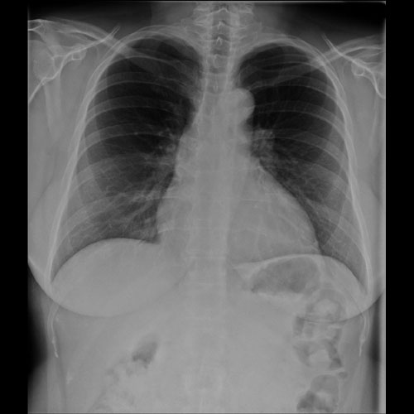  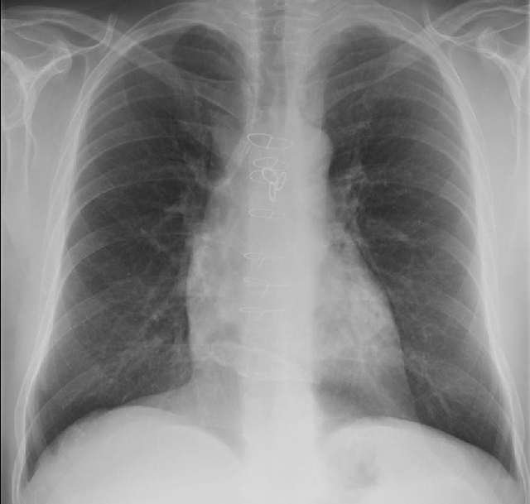 | X-ray:  X-ray high-energy electron beams, which are absorbed by bone, foreign, metal objects, and lungs, emit x-rays that are captured on a 2 - dimensional film. Soft tissue anatomy is not distinct.  System used: GE XR/d systems with tissue equalization.  Resolution:  Image:  (Top) Lung: JPEG Image 500 x 500 pixels, 12-bit true color  (Bottom) Chest: 640 x 609 pixels, 8-bit gray  Cost: <$45/scan.  Source:  Images:  http://www.gehealthcare.com/usen/xr/radio/products/digital_xray/adv_apps/tissue_equal.html  http://www.gehealthcare.com/usen/xr/radio/products/digital_xray/products/clinicalimages.html  Cost:  http://www.nuh.com.sg/patientvisitor.html

