M6528 MIRV Assignment #2
Name: Yeoh Wee Soon, Matrix No.: G0201890F

Objective: The idea is to understand surface extraction from volume data.

1. Marching Squares: Draw the marching squares and where the contour line would go for the following data (x,y,c), for the scalar value c=11:
(i) 0,0,0 (ii) 1,0,5 (iii) 2,0,9 (iv) 0,1,4 (v) 0,2,20 (vi) 1,1,13 (vii) 1,2,8 (viii) 2,1,25 (ix) 2,2,5

For clarify, we use the coordinate (x,y)[c] to represent (x,y,c). The procedure used to compute the contour line for the scalar value c=11 are elaborated as follows:
Steps:
- Fist, we let C(t)=11 and we interpolate the interception point t having the scalar value based on the linear interpolation formula:
- Then using the same interpolation formula, the coordinate of x and y at the point t are computed:
and

Point, i | Coord 1 |  |  | Coord 2 |  |  | C(t)=11 | Point, t
Point, i | X1 | Y1 | C1 | X2 | Y2 | C2 | t = C(t) - C1  C2 - C1 | X(t) | Y(t)
1 | 1 | 0 | 5 | 1 | 1 | 13 | 0.75 | 1 | 0.75
2 | 2 | 0 | 9 | 2 | 1 | 25 | 0.125 | 2 | 0.125
3 | 2 | 1 | 25 | 2 | 2 | 5 | 0.7 | 2 | 1.7
4 | 1 | 1 | 13 | 1 | 2 | 8 | 0.4 | 1 | 1.4
5 | 0 | 2 | 20 | 1 | 2 | 8 | 0.75 | 0.75 | 2
6 | 0 | 2 | 20 | 0 | 1 | 4 | 0.5625 | 0 | 1.4375
7 | 0 | 1 | 4 | 1 | 1 | 13 | 0.7778 | 0.7778 | 1

2. Marching Cube: Draw the triangle in a marching cube to indicate the surface for the following data (x, y, z, c), for the scalar value c=12:
(i) 0,0,0,0 (ii) 1,0,0,15 (iii) 1,1,0,19 (iv) 0,1,0,14 (v) 0,0,1,20 (vi) 1,0,1, 25 (vii) 1,1,1, 19
(viii) 0, 1,1,14
For clarify, we use the coordinate (x,y,z)[c] to represent (x,y,z,c). The procedure used to compute the contour line for the scalar value c=12 are elaborated as follows:
Steps:
- Fist, we let C(t)=12 and we interpolate the interception point t having the scalar value based on the linear interpolation formula:
- Then using the same interpolation formula, the coordinate of x, y and z at the point t are computed:
, and

Point, i | Coord 1 |  |  |  | Coord 2 |  |  |  | C(t)=12 | Point, t
Point, i | X1 | Y1 | Z1 | C1 | X2 | Y2 | Z2 | C2 | t = C(t) - C1  C2 - C1 | X(t) | Y(t) | Z(t)
1 | 0 | 0 | 0 | 0 | 1 | 0 | 0 | 15 | 0.8 | 0.8 | 0 | 0
2 | 0 | 0 | 0 | 0 | 0 | 0 | 1 | 20 | 0.6 | 0 | 0 | 0.6
3 | 0 | 0 | 0 | 0 | 0 | 1 | 0 | 14 | 0.857 | 0 | 0.857 | 0

3. Marching Cubes – Application
Source: “High-performance medical visualization tools to aid in kidney assessment”, Ning Tang (Dept. of Comput. Sci., Alabama Univ., Huntsville, AL, USA); Newman, T.S. Source: Proceedings of the SPIE - The International Society for Optical Engineering, v 3031, 1997, p 619-30.
Another interesting attends of volume rendering using Cray T3D is found at:
http://www.sdsc.edu/~johnson/papers/CUG_1995/cug_1995spring.html,
http://www.sdsc.edu/~johnson/papers/CUG_1994/cug_1994fall.html.
The second attend is controlled via a graphical user interface created in AVS (Application Visualization System), and runs on an X client that is attached to the T3D's host via HIPPI, FDDI or ethernet. The current system provides display rates of up to 1 frame per second over ethernet and up to 5 frames per second over FDDI. The website describes the size of the volume data, the number of triangles extracted from the object, computational time, and approximate surface normal is calculated by central different method. However, it does not reveal much information on the isosurface.

Introduction:
This application makes use of high performance medical visualization tools implemented using a networked computing configuration. The tools are designed to supply interactive and near-real-time visualization capability for volumetric data (especially computerized tomography (CT) data) to assist in diagnosis, monitoring, and surgical planning for kidney disorders, especially the Von Hippel Lindau (VHL) Syndrome.
The networked configuration combines the computing power of a vector-parallel supercomputer (Cray C94A) with the interactive graphics capability of a high-end workstation (SGI Indigo2 Extreme). One computationally intensive feature extraction and (two) image rendering function(s)—including the Marching Cubes , volume ray casting, and surface ray tracing—have been vectorized. The interactive exploration tools for viewing arbitrary orthogonal sets of planes (e.g., the surgical planes) and a probing tool for 3D measurements were implemented on the workstation.

Networked Visualization System:
As shown in Figure 3.1, the network configuration consists of a high-end workstation and supercomputer that are connected by a high-speed network. In this project, the supercomputer is Cray C94 and the workstation used is an SGI Indigo 2 Extreme.
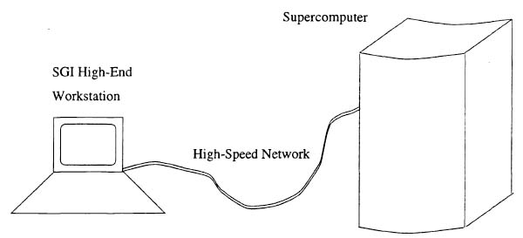
Figure 3.1. Networked Visualization System.

The visualization system of the data flow is decomposed as shown in Figure 3.2. This diagram illustrates the visualization process in a general visualization system. Based on this diagram, the visualization system can be partitioned into feature extraction (geometric model construction), image rendering, and interactive tool components. The components for feature extraction and image rendering—such as Marching Cubes, surface ray tracing, and volume ray casting—are normally computationally intensive and should be optimized on the supercomputer. Other tools need extensive user interaction and should be implemented where there is the most flexible graphic capability, which is usually the workstation platform.
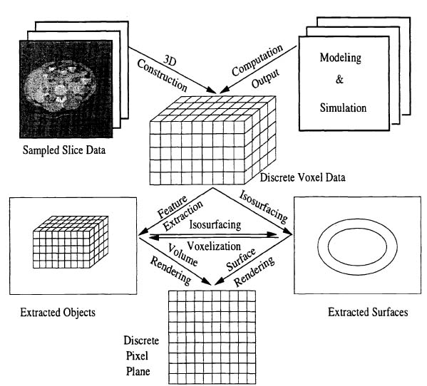
Figure 3.2. The general data flow in volume visualization

Vectorization of Visualization Tools:
Translating existing visualization modules directly onto the supercomputer generally does not take full advantage of the pipelined CPU. Optimization of the modules for the vector-parallel Cray C94A at the Alabama Supercomputing Network is required and the results are presented in the following paragraphs.

Optimization of Marching cubes algorithm:
The solution is to transform the serial algorithm into a parallel algorithm designed to exploit the potential computing power supplied by a supercomputer. The Marching Cubes algorithm involves the calculation of the positions of the intersections between the isosurface and each cube edge. Cube-by-cube processing is not well-suited for vector-parallel computation on a pipelined CPU, thus the optimization modified the execution flow first by computing the intersection points as an array of vector data.

Experiments were conducted on four sets of volume data to test the performance of the vectorized Marching Cubes method. One dataset is a three-dimensional H₂0 molecule of size 64 x 64 x 64. The other three datasets are computerized tomography images. They are a 128 x 128 x 34 image of a lobster, a 256 x 256 x 37 image of a preserved kidney and a 256 x 256 x 37 abdominal torso dataset. Figure 3.3 shows the extracted object isosurfaces based on the specified iso-values and Figure 3.4 demonstrates how the vectorized Marching Cubes algorithm exploits the underlying pipelined CPU on the vector-parallel supercomputer. The figure shows the time improvement of the vectorized version against the serial version at various threshold levels for the four datasets. The time improvement is calculated as the ratio between the computation time with the serial version and the computation with the vectorized version. All the tests were run on the Cray C94. Serial performance was measured using executables compiled without vectorizing optimization.
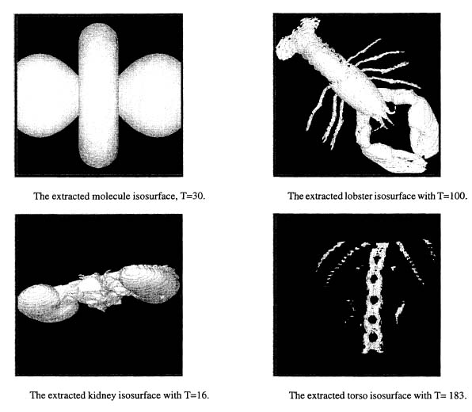
Figure 3.3. The extracted objects based on the specified iso-value.

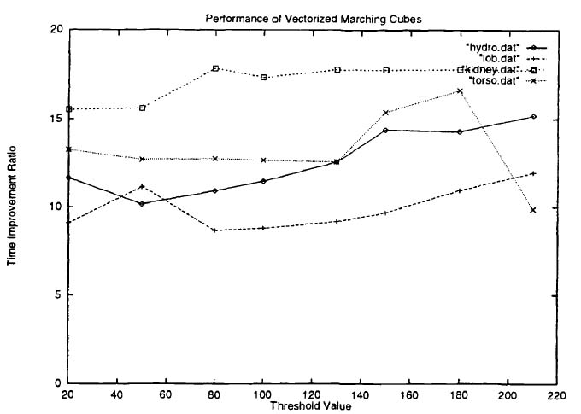
Figure 3.4. Time improvement of vectorized MC on several datasets.

Optimization of Surface Ray Tracing:
Figure 3.5 shows the ray-tracing model with view, objects, and light sources. The view includes a viewpoint and a view plane (or an image plane) composed of pixels at regular grid points. A ray (the primary ray) is traced from the viewpoint, passing through each pixel in the view plane, intersecting with objects in the scene and continuing along the reflected direction. The reflected ray is traced according to the principles of basic geometric optics. Typically, the user specifies the maximum number of reflections for the ray tracing.
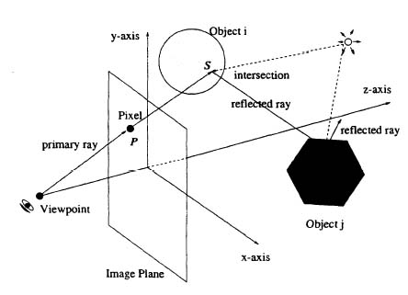
Figure 3.5. Surface ray-tracing principle.

The intensity at each pixel is determined by tracing the ray passing through it. We can imagine, at each intersection point, only the light from the light sources and the light from the next intersection point along the tracing direction will proceed along the inverse direction of the tracing ray, be attenuated at each of the former intersection points, and reach the pixel. Figure 3.6 describes the relations between all the rays. It uses the Phong optical model for determining intensity where the surface normal is computed using the central different method.
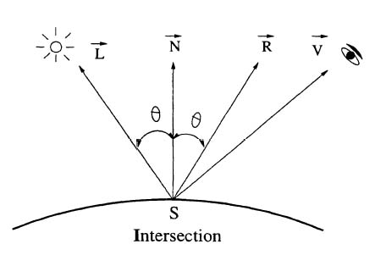
Figure 3.6. Surface ray-tracing model.

Most existing algorithms are executed ray-by-ray. For each pixel in the image plane, a single ray is emitted and traced until termination. However, this conventional ray-by-ray execution cannot exploit vector pipelining. Therefore, the design in this application employs a different execution flow and traces all the rays in parallel. The rays are viewed as a vector of input operands and pumped through the pipeline. In this way, all the rays form a vector data input and the same operations are executed on the vector data one by one. The length of the vector is proportional to the number of rays (i.e., the image size). The new execution flow exploits the underlying hardware structure for better performance.
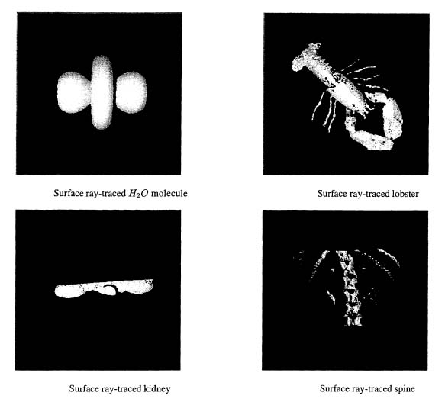
Figure 3.7. Surface Ray-trayed Objects.

Figures 3.7 shows the renderings of isosurfaces extracted from the H₂0 molecule, the lobster, the preserved kidney CT, and the lower torso CT datasets. Isosurfaces were first extracted using vectorized Marching Cubes and represented as polyhedra with triangular facets. Then they were surface rendered. To test the time improvement of vectorization of the surface ray-tracing algorithm, the rendering on the Cray was performed using executables compiled with a vectorization option and compared this to a non-vectorized version of the same algorithm. Because the surface ray-tracing is extremely time-consuming, the non-vectorized algorithm were tested with several small datasets (artificially created objects with 200, 1000, and 2000 triangular facets) and with one isosurface extracted from a lower torso CT dataset. Table 3.1 shows that even with different datasets, time improvement of 5 to 8 times has been achieved for the vectorized algorithms over the non-vectorized one. The vectorized ray-tracing does make it much easier and faster to render high resolution images.

Table 3.1. The time improvement for vectorized surface ray-tracing (CPU time in seconds).
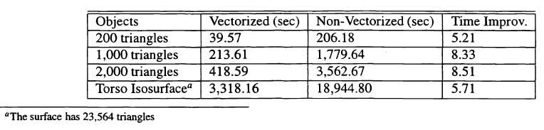

Optimization of Volume Ray Casting:
Volume ray casting combines feature extraction and image rendering. Many conventional approaches to visualizing volumes capitalize on surface-based computer graphics techniques. However, materials such as soft tissues do not always have a well defined boundary. Overlaying isosurfaces also do not depict good inter-relation and transition between such objects clearly, either. Volume rendering techniques render the data directly from voxel data without an explicit eometric surface modeling.

One of the often used volume rendering algorithm for the production of high-quality images is volumetric ray casting. Figure 3.8 describes a typical setup of volume ray casting. Similar to surface ray tracing, a ray is cast through each pixel in the image plane and its intensity is dependent on the optical effect along the ray. However, several differences exist here. Instead of using 3D surfaces, the original voxel data at discrete grid points are used. Furthermore, rays are projected in parallel into the scene instead of perspectively from one viewpoint. In face, perspective projection could also be applied in volume ray casting. Parallel projection is preferred because its view volume has the same form as the data volume and this may simplify some computations.
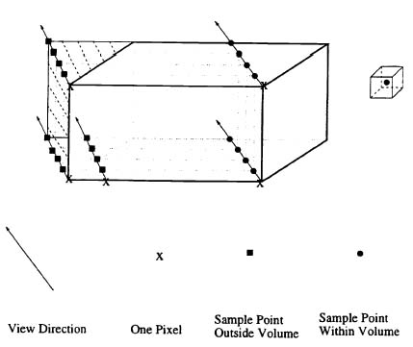
Figure 3.8. Volumetric ray casting

As show in Figure 3.8, sample points are taken along each ray and Phong optical model is applied at all the sample points. However, different from surface ray tracing, the vector optimization of placing all rays in a vector did not work here. Irregular memory accesses and conditional branching are caused by the sampled points lying inside or outside the data volume in a pattern depending on the view setup. This is a serious obstacle for vector parallel computation.

The irregular memory accesses and conditional branchings were observed to be caused by our image-plane based traversal mode; traversal starts at ordered pixels in the image plane but then proceeds to irregular positions (i.e., between sampled voxels) in the data volume. Considering the requirements for vector optimization, it is more appropriate to start from ordered voxels and cast the rays back toward an extended image plane. As shown in Figure 3.9, the solution is to view each voxel as a sample point that emits a ray back to the image plane. The amount of light hit on the image plane is proportionally divided into four neighboring pixels. An extended image that size is determined by original image plane is used and the view direction so that all rays just hit the inside of the extended image. This modified volume ray casting method support pipelined operation on a vector formed by all the voxels.

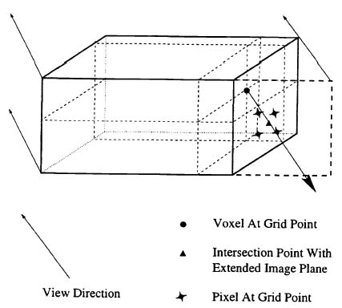
Figure 3.9. Modified ray casting

Table 3.2 shows the performance of our vectorized volume ray casting on the datasets. The rendered output image size is fixed at 300 x 300. An average time improvement of about 10 has been achieved. The time improvement is very promising. It is efficiently vectorized on the pipelined supercomputer. Figures 3.10 show renderings of several images.

Table 3.2. The time improvement for vectorized volume ray casting (CPU time in seconds)
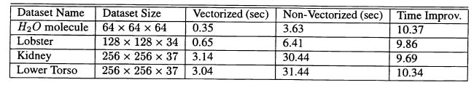
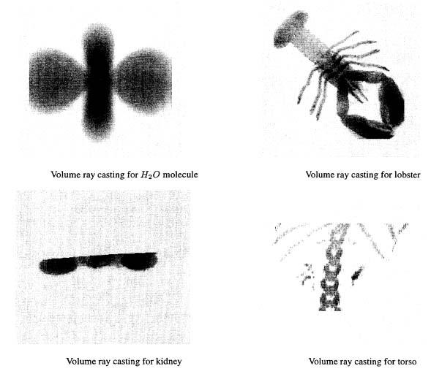
Figure 3.10. Volume ray casting for the various objects.

