M6528 MIRV Assignment #3
Name: Yeoh Wee Soon, Matrix No.: G0201890F

Task 1: Rendering of a Human Brain

1. Link to the data set you have used:
http://www.siggraph.org/education/materials/vol-viz/volume_visualization_data_sets.htm

2. A short summary of the data set:
A 109-slice MRI data set of a head with skull partially removed to reveal brain.
Dimensions: Z=109 Y=256 X=256

3. The visualization software used: 3D Doctor
Steps required for reading in raw data:
1) File->Raw Image File Import->Single File.
2) Then, under the "Image File Name" dialogue box, click "Browse" to specify the input raw data file "MRbrain.raw" and set its data format as:
# of Columns (X): 256
# of Rows (Y): 256
# of Slices(Z): 109
# Bits Per Pixel(8/16): 16
3) Click "OK" will create a header file "MRbrain.hdr" for future use, i.e., in future, we can simply read in the raw data via this header file without the need to repeat the above procedure.

4. A short description on what you intend to visualize:
Interactively examine the brain of a dead patient to understand the caused of dead using volume rendering option of the software.

5. Algorithm: Volume Rendering
The procedures and options leading to best visual result are written as follows:
- Click “3D Rendering”-> Volume Rendering\Smooth Rendering: Option: Grayscale (mode) and Transparent (voxel type). This will generate the rendered volume which shows in a newly popped up “VolumeView”.
- In the “VolumeView”, hold down left mouse button to rotate the rendered object to your interest view of angle (ROI). You may now use the zoom-in/out option in the main menu to get a close view of the ROI as shown in Figure 1-1.
- Click “View”->”Contrast” to adjust the contrast interactively so as different features can reveal or highlighted while performing visual examination. Pseudo color may also be added via “View”->“Pseudo color” but the author prefers grayscale. The final result is depicted in Figure 1-2.
- The author has also tried using "Direct Volume Rendering" with the various available modes such as "Maximum Intensity (MIP)", "Transparent" and "Opaque" but failed to get comparable visual result.

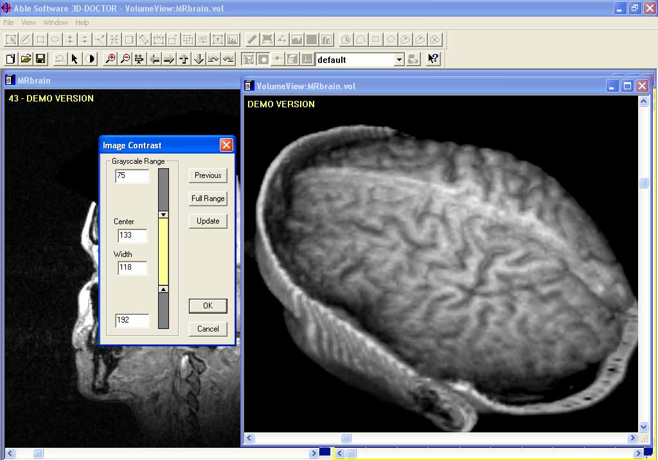
Figure 1-1. Screen capture of the Rendered Brain. The contrast is interactively adjusted to reveal different features while in the process of examination.

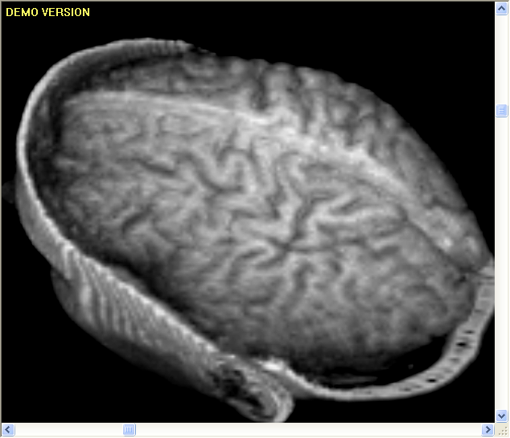
Figure 1-2. Screen capture of the final Volume Rendered Brain.

Task 2: Rendering of a Normal Liver

1. Link to the data set you have used:
http://radiology.uiowa.edu/downloads/

2. A short summary of the data set:
A 58-slice MRI data set of a normal liver from a female patient of age 38.
Voxel Dimensions (mm): 1.45 x 1.45 x 5
Volume Size (pixels, x, y, z): 256 x 256 x 58

3. The visualization software used: VolView 2.0
Input files: MR_LIVE0.hdr (header file) and MR_LIVE0.img (image data file).

4. A short description on what you intend to visualize:
Interactively examine the liver based on the enabled option of the demo software.

5. Algorithm: Volume Rendering
At any point during the setting of the parameters:
- Hold down the right mouse bottom and dragged to zoom-in/out to get a close inspection of the quality of the rendered liver.
- Hold down the left mouse bottom and dragged to rotate the angle of view.

- Choose composite blending function and maximum super sampling via "View/Volume Display".
- Choose linear interpolation via "View/Appearance".
- Projection type may be set to either "Parallel Projection" or "Perspective Projection" via "View/Views & Lights".

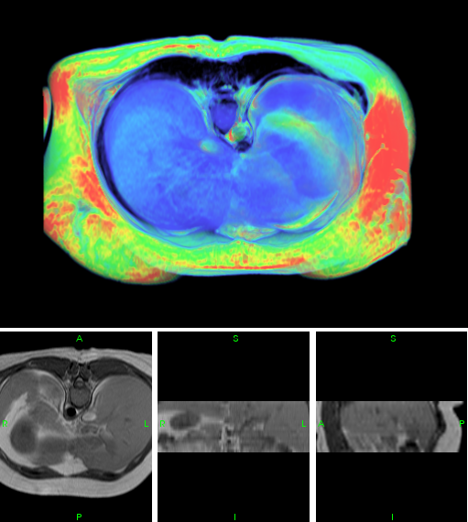
Figure 2-1. Rendered Volume of a Normal Liver (Top) and different views: (Bottom-left) Axial, (Bottom-center) Frontal, and (Bottom-right) Sagittal.
Task 3: Rendering of a Human Face

1. Link to the data set you have used:
Downloaded from the course website, i.e., head.slc

2. A short summary of the data set:
File Type: Slice File
Data Size: 59 x 133 x 133 voxels
Voxel Size: 2.064000 x 1.376000 x 1.376000 millimeters, 8 bits per voxel
Data Origin: Voxelized Function File
Data Modification: Original Data
Data Compression: Run Length Encoding

3. The visualization software used: VolVis
4. A short description on what you intend to visualize and Algorithm:

1) 3D Surface Rendering using Ray Tracing:
1) File I/O->Load->Locate the file in the directory and click “Accept”, then close all the dialogue boxes.
2) Now, we examine the visual results of different settings of Ray tracing:
3-1) Click “RENDERER”-> “Setup” to select the following settings:
Computer Shadows: On
Level Of Reflection: 1
Level Of Transmission: 1
Image Accuracy: High
PARC: On
4) Click "Close" to close the dialogue box. Them, click "Project". Noted that there are three different views available via the setting in the pulldown menu of "Active View", i.e., "Nav View 1" to "Nav View 3", but only the front view (Nav View 1) is presented for simplicity. Besides, for those views created, the users can always revisit via “IMAGE CONTROL”-> select “Active Image” and click “Display”. The resultant display is shown in Figure 3-1.

Observation:
With the setting in 3-1) takes 2.86sec for rendering.

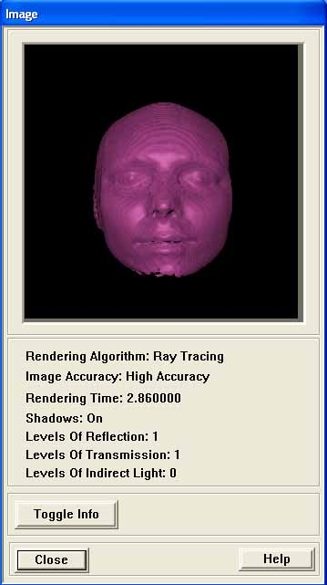
Figure 3-1. Ray Tracing Test One.

3-2) Now, we repeat the same procedure as before but the settings in 3-1) are changed to:
Computer Shadows: Off
Level Of Reflection: 0
Level Of Transmission: 0
Image Accuracy: Progress
PARC: Off

4) Repeat the same steps as before gives Figure 3-2.
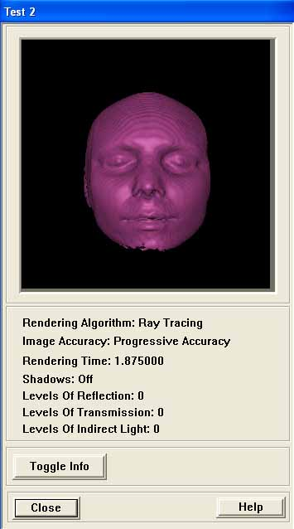
Figure 3-2. Ray Tracing Test Two.

Observation:
With the setting in 3-2) takes 1.875sec for rendering.

2) 3D Surface Rendering using Marching Cubes:
1) File I/O->Load->Locate the file in the directory and click “Accept”, then close all the dialogue boxes.
2) Now, we click “NAVIGATOR”-> “Projection 1” and use "Manipulation: Fly" to get an enlarged view as shown in Figure 3-3.

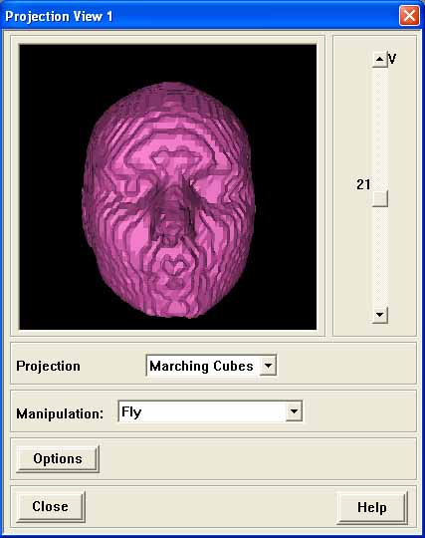
Figure 3-3. Surface Rendering using Marching Cubes.

Task 4: Rendering of a Lobster

1. Link to the data set you have used:
http://www.gris.uni-tuebingen.de/areas/scivis/volren/datasets/new.html (New data set：March 21, 2005)
http://www.gris.uni-tuebingen.de/areas/scivis/volren/datasets/datasets.html (older data set)

2. A short summary of the data set:
CT scan of a lobster contained in a block of resin. This data file is preferred because of its smaller in size which facilitates the many different tests possible (due to faster in computations).
Dimensions: 301 x 324 x 56

3. The visualization software used: 3D Doctor
Steps required for reading in raw data:
1) File->Raw Image File Import->Single File.
2) Then, under the "Image File Name" dialogue box, click "Browse" to specify the input raw data file “lobster.raw” and set its data format as:
# of Columns (X): 301
# of Rows (Y): 324
# of Slices(Z): 56
# Bits Per Pixel(8/16): 8
3) Click "OK" will create a header file "lobster.hdr" for future use, i.e., in future, we can simply read in the raw data via this header file without the need to repeat the above procedure.

4. A short description on what you intend to visualize and Algorithm:
1) First, we look at the visual results with the various options of direct volume rendering. Click “3D Rendering”->”Volume Rendering”->”Direct Volume”->
i) Maximum Intensity (MIP) as shown in Figure 4-1 (left).
ii) Transparent as in Figure 4-1 (right).
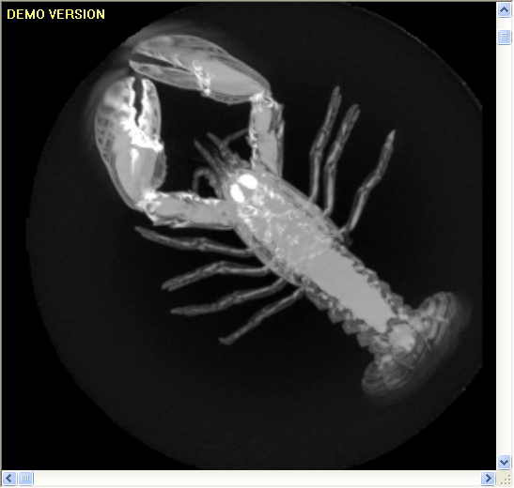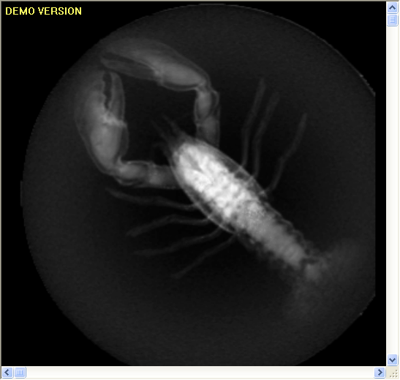
Figure 4-1. Direct Volume Rendering. (a) MIP, and (b) Transparent.

2) Then, we look at the visual result using volume smooth rendering. Click “3D Rendering”->”Volume Rendering”->” Smooth Rendering”-> Rendering Mode: Color, Voxel Type:Transparent. This result is shown in Figure 4-2.

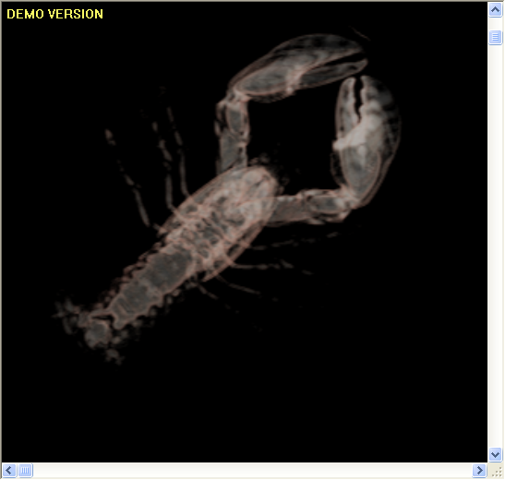
Figure 4-2. Volume Smooth Rendering.

3) Now, we are interested to perform 3D surface rendering via clicking “3D Rendering”->”Auto Segment”->”Segment”.
3-1) After all the slices have been segmented, we click “3D Rendering”-> “Surface Rendering”-> “Complex Surface” to give Figure 4-3.
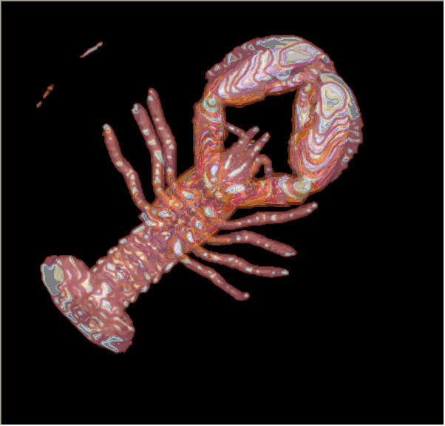
Figure 4-3. 3D Surface Rendering.

3-2) Object Volume and Surface Area calculations can be seen via "Tool"->"Calculate volumes" which are shown below:
Obj9 781.299827 cubic voxel 1209.238826 square voxel (46.442905,-53.159195,24.239847)
Obj8 2776.037731 cubic voxel 4542.976294 square voxel (48.276699,-57.589710,18.258579)
Obj5 1913.270778 cubic voxel 5027.954101 square voxel (16.777935,-45.763115,18.090042)
Obj7 62693.681298 cubic voxel 24170.512126 square voxel (-5.862922,-18.559303,24.726814)
Obj6 19966.864006 cubic voxel 34488.531510 square voxel (-6.838545,-19.525522,23.427681)
Obj4 22388.184522 cubic voxel 43664.115482 square voxel (6.297127,-34.780499,21.595341)
Obj3 87908.723195 cubic voxel 110856.255273 square voxel (-8.229659,-20.568781,24.215942)
Obj2 159882.449928 cubic voxel 128172.591370 square voxel (-8.889489,-20.483120,23.039528)
Obj1 450492.184825 cubic voxel 88113.790859 square voxel (-11.451853,-20.632542,19.719215)

3-3) Likewise, the 3D surface information can be seen via "Tool"->"Surface Infor" given as follows:

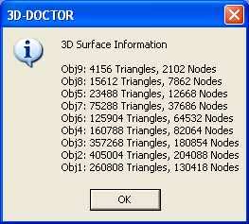
Figure 4-4. 3D Surface Information.

