A Review of Article - An Intestinal Surgery Simulator: Real-Time Collision Processing and Visualization
Yeoh Wee Soon
Nanyang Technological University

Abstract
This paper is a review on the above subject by L. Raghupathi, L. Grisoni, F. Faure, D. Marchal, M. Cani, and C. Chaillou. The paper presents the development of a VR-based trainer for colon cancer removal which enables surgeons to interactively view and manipulate the concerned virtual organs. The contributions of the paper are twofold. First, it proposes a new method for real-time animation of the small intestine and mesentery which incorporates a stochastic approach for fast collision detection in highly deformable, self-colliding objects. Second, it describes a new method based on generalized cylinders for fast rendering of the intestine. This includes an efficient curvature detection method, along with an adaptive sampling algorithm. This approach, while providing improved tessellation, also allows for high-performance rendering with a guaranteed frame rate.

Keywords: Virtual reality, physically-based modeling, animation, curve and surface representation.

I. Introduction
L
apparoscopic colectomy procedure (colon cancer removal) is difficult to master with a very flat learning curve [1]. Current training procedure involves practicing on pigs to get a feel for the organ’s behavior which is prohibitively expensive and also raises numerous ethical issues. In view of this, the VR-based simulator platform is introduced to potentially resolve these issues.
The aim of this research work is to simulate the behavior of the intestine when the surgeon is practicing in the virtual environment and it does not include the simulation of the cancer removal itself. The paper focuses on two important pedagogical problems: 1) camera positioning by allowing the trainee to visualize the relevant organs in 3D, 2) manual dexterity by letting them interactively manipulate these organs.

II. Challenges and Probable Solution
During this surgical procedure, the patient is lying on his back. Fig. 1 shows that, as a result, the small intestine is positioned just above the colon region, hiding the colon beneath. The intestine is a tubular structure, about 4 m long, constrained within a small space of the abdominal cavity, resulting in the creation of numerous folds. This is further complicated by a tissue known as the mesentery that connects the intestine to the blood vessels as depicted in Fig. 2. An important surgical task of this procedure is to displace the tissues and organs by pulling and folding them from the site of the operation. As the surgeon manipulates these organs, they deform and collide with each other. Thus, the broad challenges here are the real-time animation and visualization of these organs at an acceptable frame rate.

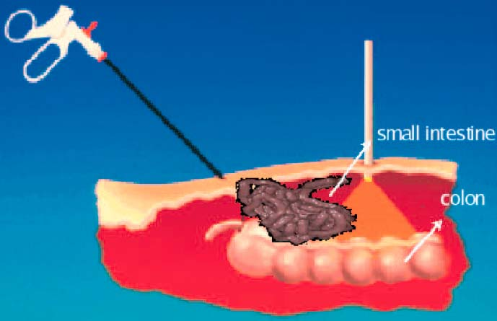
Fig. 1. Position of the intestine during the surgery.

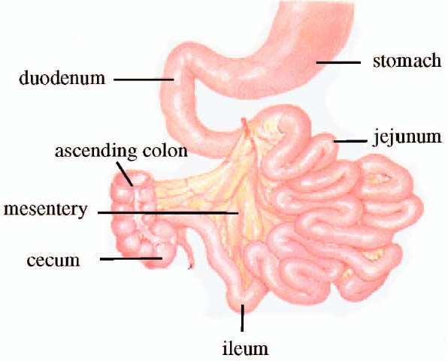
Fig. 2. Anatomy of the intestinal region.

The proposed solution is a layered model: a skeletal axis deformed using physically-based animation, rendered with a generalized cylinder-based skinning in real-time, that:
- efficiently model the intestine and the mesentery, taking into account its geometry,
- detect the collisions and self-collisions occurring in the intestinal region during animation,
- provide a fast and stable collision response.

III. Current Technique
A. Real-Time Animation of Deformable Models
In all the existing works, volumetric deformable bodies were either simulated in isolation or were interacting with a single rigid tool, enabling the use of very specific techniques for collision detection and response, such as methods based on graphics hardware [2]. These were methods required volumetric deformable model.
Alternatively, France et al. [3], [4] used a simple spline model animated by mass-spring dynamics for simulating the intestine. The detection of selfcollisions of the intestine and collisions with its environment was based on a grid-based approach. All objects were first approximated by bounding spheres, whose positions were stored, at each time step, in the 3D grid. Each time a sphere was inserted into a nonempty voxel, new collisions were checked within this voxel. Though this method achieved real-time performances when the intestine alone was used, it did not handle the simulation of the mesentery.
A well-known technique for accelerating collision detection is to approximate the objects by a bounding volume hierarchy (BVH), e.g., in [5]. Such approaches provide simple tests for fast detection of noncolliding regions. However, the large scale global deformation created prevents the BVH from being efficiently updated.

B. Intestine and Mesentery Rendering
In addition to handling the collisions, one also needs to provide a real-time, smooth rendering of the organs. Existing approach to intestine modeling uses generalized cylinders, also sometimes called sweep. Classical generalized cylinders are defined using a parameterized axis , along with a set of planar cross-section that can be represented as a continuous set depending on the same scalar value that parameterizes the axis [6]. The classical tessellation approach is as follows: The axis is sampled either uniformly or adaptively, depending on some curvature isolation. For each axis sample, section is positioned on a local frame calculated along the axis and then approximated by a polyline. Two consecutive polyline sections along the axis are then connected by a triangle stripset in order to form a local approximation of the sweeps. High curvature point detection becomes a critical step for such a process and any sharp angle is likely to be missed in the sampling.

IV. Presented Technique
A. Real-Time Animation of Deformable Models
The intestine and the mesentery are represented as a 1D and a 2D structure, respectively. The main issue is the detection and processing of the collisions and self-collisions of the intestinal system in real-time. The paper is inspired by the idea of stochastic collision detection exploiting temporal coherence where it is adapted for the processing of multiple collisions and contacts between the intestine and the mesentery folds. Collisions between convex polyhedra were detected by tracking pairs of closest vertices. These pairs were efficiently updated at each time step by propagating closest distance tests from a vertex to its neighbors. This technique was adapted for efficient detection of collisions between volumetric layered shells. Since these shells were neither convex nor rigid, a stochastic approach was used at each time step to generate new pairs of points anywhere on the two approaching objects. These pairs were made to converge to the local minima of the distance, disappearing when they reached an already detected minimum.

B. Intestine and Mesentery Rendering
The proposed solution comes from skinning which takes advantage of the OpenGL skinning feature provided by recent GPUs. The work incorporates a simple geometric transformation in homogeneous coordinates by a 4 x 4 matrix which is the composition of rotation, translation, and scaling that allows an initial mesh to be positioned anywhere within a given scene, along with simple deformations. The technique cannot be directly applied to the rendering of a folded generalized cylinder controlled by a skeleton, the intestine in this case. Extending the skinning method to this case is resolved by using high-curvature detection and adaptive sampling.

V. Other Related Works

Author/ Year | Article | Description | Relation to main article
S. Capell et al.,  2002. | Proc.  SIGGRAPH | Interactive Skeleton-Driven Dynamic Deformations | Efficient simulation of deformable models
E. Grinspun et al, 2002. | Proc. SIGGRAPH | CHARMS: A Simple- Framework for Adaptive Simulation | Another efficient simulation of deformable models
G. Debunne et al, 2001 | Proc. SIGGRAPH | Dynamic Real-time Deformations Using Space and Time Adaptive Sampling | Another efficient simulation of deformable models based on mulit-resolution
S. Cotin et al.  2000 | The Visual Computer | A Hybrid Elastic Model for Real-Time Cutting, Deformations, and Force Feedback for Surgery Training and Simulation | Deformable models for surgery Training Simulators
G. Sze´kely et al, 2000 | Medical Image Analysis | Modelling of Soft Tissue Deformation  for Laparoscopic Surgery Simulation | Modelling of Soft Tissue Deformation
M. Bro-Nielsen  1998 | Proc. IEEE | Finite Element Modeling in Surgery Simulation | Surgery simulators
M. Lin and J. Canny  1992 | Proc. Third EG Animation & Simulation Workshop | Efficient Collision Detection for Animation | Exploit temporal coherence

VI. Modeling and Animating the System
The overall aim is to develop a generic simulator which can help the surgeons to practice the gestures used to manipulate the organs. A virtual model of the intestine and the mesentery is created which will serve as the basis for the animation and rendering stages. The mechanical model needed for animating the intestinal system is then presented.

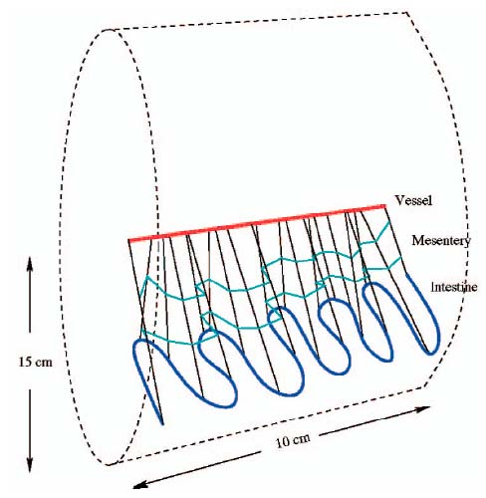
Fig. 3. Initialization of the geometry of the intestine and mesentery. The intestine is drawn on the inner surface of a small cylinder.

As the mesentery cannot be unfolded onto a plane, setting up its initial geometry free of self-intersections is quite difficult. The problem is resolved by modeling a possible rest position for the intestine as a folded sine curve lying on the inner surface of a cylinder of radius 15 cm. With the axis of the cylinder representing the main vessel, the folds are placed on the cylinder such that their total length is 4 m (Fig. 3). Then, the mesentery can be defined as the surface generated by the set of nonintersecting line segments linking the cylinder axis to the curve. When animated under the effect of gravity, these collision-free initial positions will automatically move to their correct positions. The geometry of the intestine is defined by creating a piecewise tubular surface of radius 2 cm along its skeleton curve. The thickness of the mesentery surface, parameterized based on patient-specific data, was set to 1 cm.
For animation, the mass-spring approach was derived. The designed model consists of mass points connected by damped springs. Since the mesentery has a much larger length (4 m near the intestine) than width (15 cm near the vessel), the model is sampled by four sets of 100 masses each (Fig. 4). The last set of masses requires no computation since they are attached to the main vessels, requiring only 300 masses to be integrated at each time step. In addition, no specific model is needed for the intestine since it can be simulated by adjusting the mass and stiffness values along the first bordering curve of the mesentery surface.
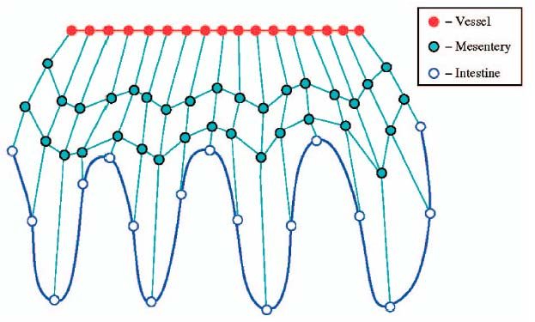
Fig. 4. Mechanical model of the organs (shown unfolded).

VII. Real-time Collision Processing
The real-time collision processing efficiently detects the colliding regions, and a response algorithm, which prevents/corrects the interpenetrations.
Collision detection between cylinders can be processed by computing the closest distance between their principal axes. The local minima of the distance between nonneighboring segments along the curve (Fig. 5) are tracked and only those satisfying a given distance threshold are considered relevant (i.e., active pairs). Each active pair is locally updated at each time step in order to track the local minima when the intestine folds move. This update requires nine distance tests (Fig. 6) and the pair of segments associated with the closest distance becomes the new active pair.
To detect new active pairs, a stochastic approach is used such that at each time step, additional random pairs of segments, uniformly distributed between the end-points, but under the distance threshold, are generated. The update of these extra active pairs is similar to the update of the existing local minima. Collision response will then be applied between these segments.
For the mesentery, the paper considers the nontrivial cases of intestine-intestine and intestine-mesentery interactions. A two-step convergence algorithm is used. Given a segment pair , the first step is to find if there exists another segment that is the closest to . Then, find a segment that is the closest to . This update requires not more than 13 distance computations. When a collision is detected, a response force is applied to the deepest penetrating segment-pair and also to the entire collision area (both for intestine and mesentery). A recursive algorithm searches the neighbors to find all the colliding pairs in the area.

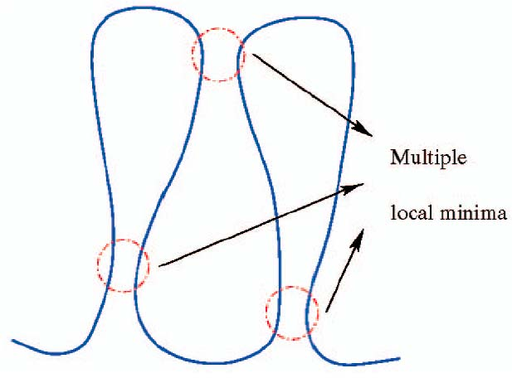
Fig. 7. Tracking the local minima of distance between nonneighboring segments.

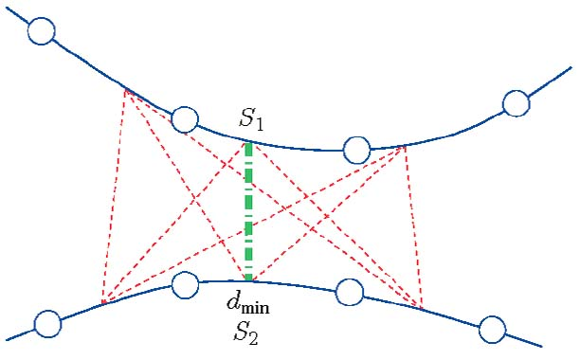
Fig. 8. Distance computation between two intestine segments.

The collision response is initiated the response once distance between the two segments is less than sum of their radii. The proposed method alters the displacements and velocities such that it instantaneously cancels the interpenetration while keeping a resting contact between the two colliding bodies with no bouncing effects.

VIII. Skinning and Rendering
The rendering adopted for intestine and mesentery is simply a triangle stripset whose points are the intestine mechanical sampling points and the mesentery root.
The mechanical sampling points of the intestine axis are converted into a cardinal spline approximation to remove undesirable oscillations. The sampling algorithm consists of two steps. The first pass fixes the sampling points to the local spline curvature. The second pass positions the additional sampling points in the high curvature segments in order to get a more stable tessellation. This proposal takes advantage of the regularity property of spline to capture the high curvature segments while assuring stability. The resulting curve segments, as shown in Fig. 9, are displayed using a hardware-based technique.
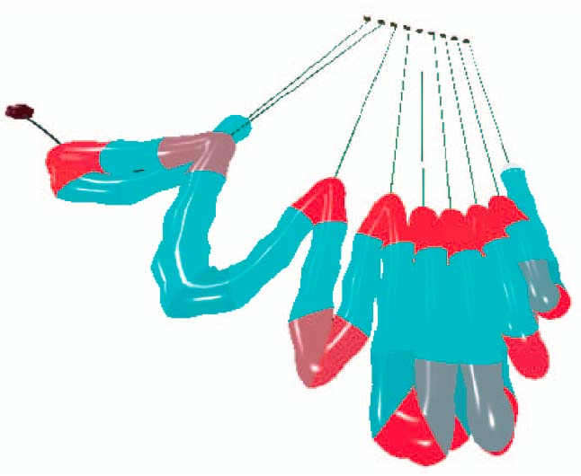
Fig. 9. Spline segment coloration to illustrate the curvature isolation process. A higher curvature will result in a smaller angle between the segments.

The sampling process gives a set of parameter intervals. For each interval generated by the sampling algorithm, two frames (one for each segment extremity) are calculated along the axis of [7]. Each frame gives the local orientation of the sweep cross-section. These frames generate the homogeneous transformation matrices and for the considered parameter interval. They are then used by the blending technique on an elementary nondeformed cylinder aligned along the z-axis which is approximated by polygons using a positive integer resolution. The higher the n value, the smoother the interpolation between the frames represented by and .
The software part of this tessellation only involves the calculation of the geometric transformations. The tessellation primitive for a given resolution n is constant over time and so it is stored in a displaylist using vertexArray technology [8] to take full advantage of the data transmission optimizations of the GPU.

IX. Conclusions and Future Work
In this paper, the presented anatomical model greatly simplifies the problem of simulating a complex deformable organ in real time. The collision model efficiently determines all the active colliding regions and provides a realistic and stable response. The rendering technique quickly generates high-quality image sequences with no tessellation artifacts.
The paper claimed that their contributions when integrated into a surgical simulator can be used as a generic trainer that can mimic the real-time behavior of the organs very well, thus have potential of replacing the practice on animals.
Further developments are to include triangle tests for more robust collision detection, and the adaptation of the continuous collision detection techniques for handling of fast motion of thin objects such as membranes, vessels, etc. Moreover, suggestions from surgeons are addressed and currently working on to incorporate them into the system.

References
[1]. S. Sgambati and G. Ballantyne, “Minimally Invasive Surgery for Diseases of the Colon and Rectum: The Legacy of an Ancient Tradition,” Laparoscopic Colectomy, R. Jager and S. Wexner, eds., pp. 13-23, New York: Churchill & Livingstone, 1995.
[2]. J.C. Lombardo, M.-P. Cani, and F. Neyret, “Real-Time Collision Detection for Virtual Surgery,” Proc. Computer Animation ’99, pp. 82-91, 1999.
[3]. L. France, A. Angelidis, P. Meseure, M.-P. Cani, J. Lenoir, F. Faure, and C. Chaillou, “Implicit Representations of the Human Intestines for Surgery Simulation,” Proc. Modeling & Simulation for Computer Aided Medicine & Surgery (ESAIM), M. Thiriet, ed., pp. 42-47, 2002.
[4]. L. France, J. Lenoir, P. Meseure, and C. Chaillou, “Simulation of a Minimally Invasive Surgery of Intestines,” Proc. Fourth Virtual Reality Int’l Conf., June 2002.
[5]. J. Klosowski, M. Held, J. Mitchell, H. Sowizral, and K. Zikan, “Efficient Collision Detection Using Bounding Volume Hierarchies of k-DOPs,” IEEE Trans. Visualization and Computr Graphics, vol. 4, no. 1, pp. 21-36, Jan.-Mar. 1998.
[6]. G. Agin and T. Binford, “Representation and Description of Curved Objects,” IEEE Trans. Computers, vol. 25, no. 4, pp. 439-449, Apr. 1976.
[7]. J. Bloomenthal, “Calculation of Reference Frames along a Space Curve,” Graphics Gems, A. Glassner, ed., pp. 567-71, New York: Academic Press, 1990.
[8]. OpenGL Vertex Weighting, NVIDIA Corp., 2004, http://developer.nvidia.com/object/GL_EXT_vertex_demo.html.

