Aquarians – The Merfolk  By John DeCocq  Special Thanks to Tony Newton  The graceful spirits of the water played peacefully beneath the waves, oblivious to the chaos and horror that gripped the land. From the coral reefs to the open expanses of white sand, these spirits drifted on the currents without a care.  Then the corrupt Sauhaugin appeared and the waters turned vile and murky, poisoned by the very presence of these despicable creatures. The water spirits looked for help, but none was to be found. Only the scattered rays of light that filtered down through the clouded waters gave them any comfort. They flocked to the light and were thankful for its warmth.  The overspirit of the oceans saw the strength the light gave her charges and she called to the master of light to help them further. He was unable to intervene directly, but happy to help them help themselves…  The Merfolk are beings made of Light and Water. Light is a new element and is represented by white. |  |  |  |  |  |  |  | Aquarian Special Abilities:  Healing: Being creatures of Light, they have the ability to bring dead units back to light just by being in an army. After a turn, the owner with at least 1 health worth of Light hybrid still in their army rolls his dead units. Up to three health worth of units rolling ID faces are immediately brought back to the player’s Reserves. All other rolled units that did not roll an ID icon are immediately buried.  Magic Use: Merfolk may cast all basic Green and White spells, as well as the unique Green and White spells included in these rules. Additionally, Merfolk may cast basic spells that match the colors of the terrain where they are located. Merfolk may never cast Black spells, regardless of the circumstances.  Ocean Natives: Merfolk double all maneuvers rolled when at a Coastland terrain.  Missile Use: The Merfolk have not developed missile weapons. There are no missile faces on any Merfolk units. Their IDs may be used as missile results, as appropriate.
Creature Descriptions:  All of the Merfolk have humanoid torsos with lower bodies resembling fish tails, crustacean tails or a set of tentacles.  Common Units:  Clawer: Their crab-like claws crush opponent’s weapons.  Gripper: These creatures make up the bulk of the Merfolk shock troops.  Slammer: Lightweight troops who attack in overwhelming number to defeat foes.  Burster: These swift soldiers break through enemy lines.  Whirlpooler: Minor magic-users that are highly effective en masse.  Uncommon Units:  Crusher: These large crustaceans can take enormous amounts of punishment.  Grabber: These fighters grapple their foes to allow their allies to strike more easily.  Basher: Strike force warriors that often take the point in combat raids.  Rupturer: Quick movement and devastating melee power makes these soldiers formidable.  Waterspouter: These spell-weavers ride into the fray atop huge columns of brine. |  |  |  |  |  |  |  | Rare Units:  Spiker: Nearly impossible to kill, they use their body spikes as wards against damage.  Entangler: Soldiers with incredible melee skill, they can decimate enemy regimes with ease.  Impaler: These skirmishers have a second melee weapon built into their faces.  Breacher: The irrestable force that has run many opponents into the ground.  Typhooner: Masters of water magic, they can even bring huge storms ashore to wipe out their enemies.  Monster Units:  Nymph: Graceful and alluring water spirits.  Storm Giant: Massive humanoids who wield the powers of nature in combat.  Reef Guardian: Huge orbs with massive claws that are rumored to be related to beholders.  Hippocampus: Couriers of the Merfolk, they are never used as common steeds but sometimes carry their allies away from harm.  Dragon Turtle: Their potent breath wreaks havoc on enemy forces.
Merfolk Icons |  |  |  |  |  |  |  | Normal Action Icons |  | Special Action Icons
 | Common |  | Uncommon |  |  | Rare
Heavy Troop | 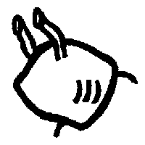 |  | 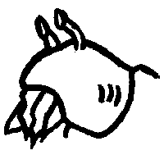 |  |  | 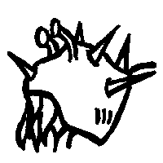 |  | 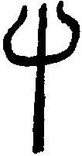 | 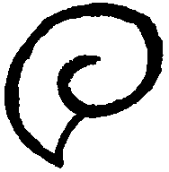 | 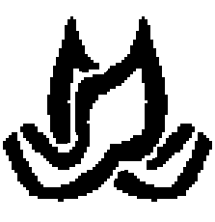 | 
 | Clawer |  | Crusher |  |  | Spiker |  | Melee | Magic | Hug | Cantrip
Light Troop | 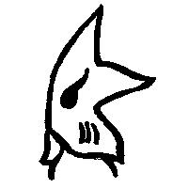 |  | 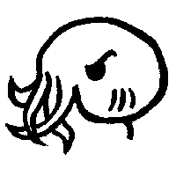 |  |  | 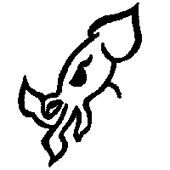 |  | 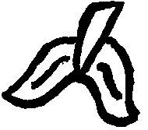 |  | 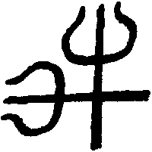 | 
 | Gripper |  | Grabber |  |  | Entangler |  | Maneuver | Save | Counter | Trample
Skirmishers | 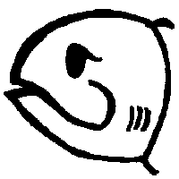 |  | 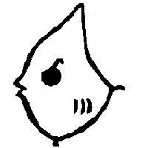 |  |  | 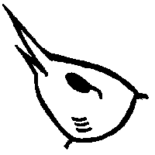 |  |  |  | 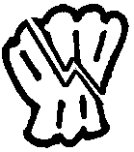
 | Slammer |  | Basher |  |  | Impaler |  |  |  | Smite
Calvary | 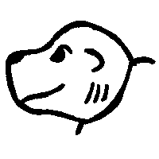 |  | 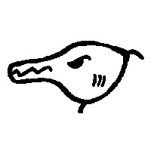 |  |  | 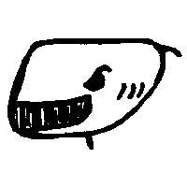
 | Burster |  | Rupturer |  |  | Breacher
Magic | 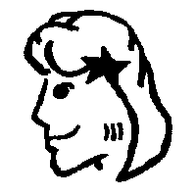 |  | 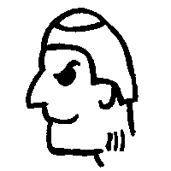 |  |  | 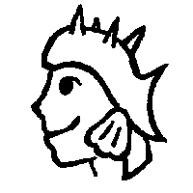
 | Whirlpooler |  | Waterspouter |  |  | Typhooner
Merfolk Monster Icons |  |  |  |  |  |  |  | Special Action Icons:  The following SAIs appear on Merfolk and have the standard effect:  Cantrip, Charm, Counter, Dispel Magic, Ferry, Smite, Swallow, Trample  The following are new SAIs that appear on the Merfolk units:  Lightning Strike: During melee or missile the owner of this die targets a single unit in the opposing army. That unit rolls to save as if it had been struck by the spell “Lightning Bolt”  Steam Breath: During melee attack rolls, inflict 4 points of melee on the opposing army. During counter-maneuver rolls, subtract 4 from the opponent’s maneuver results.
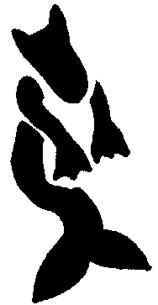 |  | 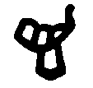
Hippocampus |  | Ferry |  |  | Counter
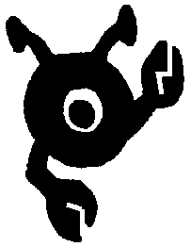 |  |  |  |  |  |  | 
Reef Guardian |  | Dispel Magic |  | Stone |  |  | Illusion
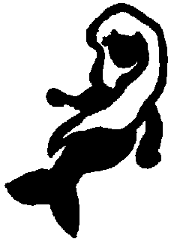 |  | 
Nymph |  | Charm |  |  | Cantrip
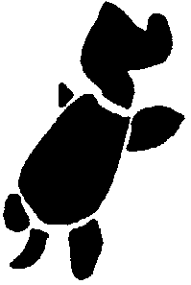 |  | 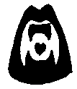 |  |  | 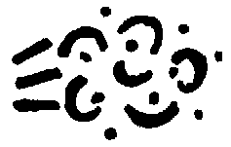
Dragon Turtle |  | Swallow |  |  | Steam Breath
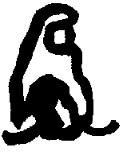 |  | 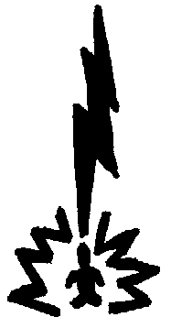
Storm Giant |  | Lighting Strike |  |  | Trample
Life (White) Spells: This is the basic white spell list, useable by all creatures of light.  Cost Spell  3 Healing Touch: Restores one unit of health from the dead area. Multiple castings may bring back multiple units, or units of higher health values as the caster chooses.  4 Saving Grace: Creates a vortex that moves all one-health units to the owner’s reserve area unless a maneuver is rolled per unit. The entire army is rolled and the number of maneuvers rolled is the number of one health units that can remain at the terrain. Multiple castings only affect the remaining one health units at the terrain, never units of higher health.  5 Recruit: Opens a conduit to the Life-Force of Nature. Allows caster to promote up to 3 Life Units in target army by trading in for units one health higher from the dead area. 3 health units may be promoted to monsters.  6 Warmth Of Light: One health of the target army (your choice) has all of its rolls doubled until the end of the owner’s next turn. Multiple casting affect multiple targets, allows larger units to be affected or both.  7 Summon White Dragon: Send any White Dragon to any terrain |  |  |  |  |  |  |  | Light (White) Spells (Merfolk Only):  3 Smite Evil: Target any enemy unit in play that has the Death or Shadow aspect. Target unit is rolled for an individual save. If it fails the unit is killed and is removed immediately from play.  4 Halo: Target any army in play at any terrain. Target army may not contain any units with the Death or Shadow aspect. Target army gains 3 automatic saves until the end of the caster’s next turn.  Water (Green) Spells (Merfolk Only):  4 Quicksand: Target any swampland terrain in play. All armies at the target terrain subtract 4 from all maneuver results until the start of the caster’s next turn.  10 Hurricane: Target any coastland terrain in play and note the current face of the target die. The coastland terrain die is rolled twice by the caster, and these results added together. Inflict that amount of damage on each army at the target terrain. All armies roll for saves individually. All SAI’s that do not specifically count as saves are negated, including Cantrip. The coastland die is then put back into play one face lower than its starting face. This spell may not target a terrain that is currently at its 8th face.
Additional New Items and Creatures:

Light (White) Dragon: May be drakes or wyrms.

Breath Weapon: Laser Light: Five health worth of units are killed in the target army. The target army’s owner then rerolls the slain units. All units that roll ID faces may be promoted. 3 health units may not be promoted to monsters in this way, but may be promoted to Champions. If no Champions are available the 3 health units are lost instead.

