Aberations  By John DeCocq and Tony Newton  After a very short while, Death grew tired of defeat. He did not like it's bitter taste one bit. He connived to steal the secret of Light for himself. Ether saw this and was worried, for even though he came from beyond, he was now an inextricable part of the war on Esfah and saw the folly of Death's machinations. He cried to his half-partner that only destruction could result from this foolhardy venture. But Death was foolish, blind to the truth with defeat in his eyes and he paid no heed to Ether. He went ahead and tried to combine the two eternal opposites of Light & Death never guessing what was to transpire.  Esfah shook and shuddered under the mighty conflagration. The firmament was torn asunder as destruction ravaged the world. When the dust and debris had settled it was discovered that the two opposing forces had indeed combined in a most remarkable and unforeseen way creating a mysterious and chaotic new race to fight for Death...the Aberations strode into a new chapter in the war for Esfah!  The Aberations are composed of Death and Light. Light is a new element and is represented by white. The red ink color has nothing to do with the element fire. It just looks cool. |  |  |  |  |  | Aberation Special Abilities:  Healing: All Light Hybrids have the ability to heal their own kind. At the end of a player’s turn, after the reserve phase, he may roll all light hybrid units in his dead unit are. Up to three health-worth of units rolling IDs are retunred to that player’s reserve area. An equal number of light units that did not roll IDs must be buried  Death Throes: When killed Kaos Kreatures have the ability to lash out one final time. During melee, any Aberation that is chosen as a casualty is rolled again. If the ID is rolled the unit inflicts that amount of melee damage on the opposing army, no saves possible. Any units not rolling IDs are placed in the Dead Unit Area. Any unit rolling its ID is then rolled a second time. If a save or ID is rolled the unit moves to its owner’s Dead Unit Area. Any other result indicates the unit is buried.  Magic Use: Since they are from outside Nature, Aberations do not double White magic points when ID icons are rolled. Black magic points are doubled as per the normal rules. They may cast spells from the Basic White Spell list, as well as the spells from the Basic Black Spell list. They may also cast White and Black Spells from the expanded lists of unique Kaos spells, also included herein.
Creature Descriptions:  The Kaos Kreatures come in all shapes and sizes and are all abominations of nature:  Common Units:  Dergoloth: Nearly mindless, they crave only the sheer joy of wanton destruction.  Hydroloth: Sub-aquatic horrors that crawl ashore to wreak havoc.  Nikkor: Flaming darts fly from their fingertips.  Minordling: These beasts overrun their enemies en masse.  Green Slaad: Their gaping maws mutter mystical words.  Uncommon Units:  Yagoloth: Thickly-muscled warriors that are perfect combat machines.  Aseoloth: Their tentacled mouths repulse even hardy opponents.  Splitor: Short and squat, these yeoman are excellent marksmen.  Majordling: These lumbering bulks take time to get moving but are nearly unstoppable once they do.  Red Slaad: The opposing forces of light and death crackle in the air around them. |  |  |  |  |  | Rare Units:  Ultraloth: Towering over the lesser Aberations they hold a broadsword in each hand and rain blows upon their foes.  Mezzoloth: A thick hide repels blows and their speed makes short work of their opponents.  Shator: Their bows dwarf the largest balista.  Greatordling: Claws to catch their enemies unaware, wings to escape at a moment’s notice.  Grey Slaad: These huge frog-like monstrosities wield death as a sword and light as a shield.  Monster Units:  Archaeri: Four-legged birds that run down enemy forces quickly.  Astral Dreadnaught: Disembodied heads with huge sharp-toothed mouths that are capable of swallowing other creatures whole.  Bebelith: Warped mockeries of the preying mantis, they kill with a single blow of their serrated pinchers.  Malephant: These diminutive elephantine horrors stomp on enemy soldiers.  Vaporighu: These creatures use their bulk as a weapon to crush the life out of any who oppose them.
Kaos Kreature Icons |  |  |  |  |  | Special Action Icons |  | Special Action Icons
 | Common |  | Uncommon |  | Rare
Greater Yugoloth  (Heavy Troop) | 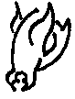 |  | 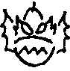 |  | 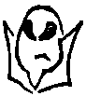 | 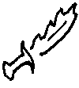 | 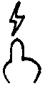 |  | 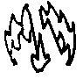
 | Dergoloth |  | Yagaloth |  | Ultraloth | Melee | Magic | Bullseye | Smite
Lesser Yugoloth (Light Troop) | 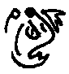 |  | 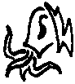 |  | 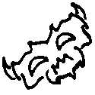 | 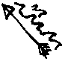 | 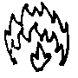 | 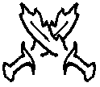 | 
 | Hydroloth |  | Aseoloth |  | Mezzoloth | Missile | Save | Counter | Cantrip
Gehreleth (Missile) | 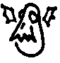 |  | 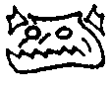 |  | 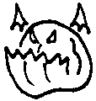 | 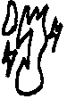 |  | 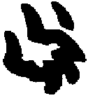 | 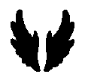
 | Nikkor |  | Splitor |  | Shator | Maneuver |  | Rend | Fly
Hoardlings (Calvary) | 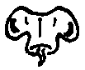 |  | 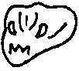 |  | 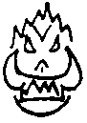
 | Minordling |  | Majordling |  | Greatordling
Sladdi (Magic) | 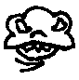 |  | 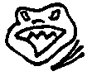 |  | 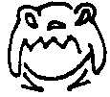
 | Green Slaad |  | Red Slaad |  | Grey Slaad
Kaos Kreatures Monster Icons |  |  |  |  |  | Special Action Icons:  The following SAIs appear on the Aberation units and monsters. All follow the Standard rules for the SAIs as listed in the DCM, or most recent rule revision.  Bullseye, Cantrip, Coil, Counter, Fly, Hug, Poison, Rend, Roar, Screech, Slay, Smite, Smother, Trample, Trumpet.
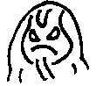 |  | 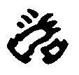 |  | 
Vaporighu |  | Hug |  | Smother
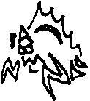 |  | 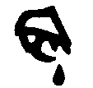 |  | 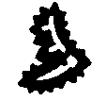
Bebelith |  | Poison |  | Slay
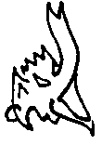 |  |  |  | 
Malephant |  | Trumpet |  | Trample
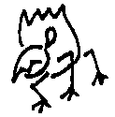 |  | 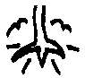 |  | 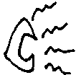
Archaeri |  | Trample |  | Screech
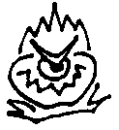 |  | 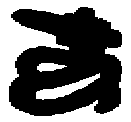 |  | 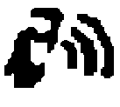
Astral Dreadnaught |  | Coil |  | Roar
Life (White) Spells: This is the basic white spell list, useable by all creatures of light.  Cost Spell  3 Healing Touch: Restores one unit of health from the dead area. Multiple castings may bring back multiple units, or units of higher health values as the caster chooses.  4 Saving Grace: Creates a vortex that moves all one-health units to the owner’s reserve area unless a maneuver is rolled per unit. The entire army is rolled and the number of maneuvers rolled is the number of one health units that can remain at the terrain. Multiple castings only affect the remaining one health units at the terrain, never units of higher health.  5 Recruit: Opens a conduit to the Life-Force of Nature. Allows caster to promote up to 3 Life Units in target army by trading in for units one health higher from the dead area. 3 health units may be promoted to monsters.  6 Warmth Of Light: One health of the target army (your choice) has all of its rolls doubled until the end of the owner’s next turn. Multiple casting affect multiple targets, allows larger units to be affected or both.  7 Summon White Dragon: Send any White Dragon to any terrain |  |  |  |  |  | Death (Black) Spells (Aberation Only):  3 Dark Heart: Trade any non-Aberation unit into the owner’s Dead Unit Area and replace with an Aberation unit of the same health from the Dead Unit Area. Cannot be cast unless an appropriate Aberation unit is already in the Dead Unit Area when spell is cast.  10 Reaper’s Touch: Target any army. Count the number of common units in target army and inflict that amount of damage on target army, up to a maximum of 10 points of damage. Army may make a single save roll against damage. Casualties must be chosen from common units first. Multiple castings must target another army in play.  Light (White) Spells (Aberation Only):  3 Sear: Inflict one point of damage on target army. May be multiplied to target the same or another army. Each Army is allowed a single save roll against total damage from Sear regardless of how much damage is caused  6 Blind: Target any army. All save rolls are halved until start of the caster’s next turn.
Additional New Items and Creatures:

Light (White) Dragon: May be drakes or wyrms.

Breath Weapon: Laser Light: Five health worth of units are killed in the target army. The target army’s owner then rerolls the slain units. All units that roll ID faces may be promoted. 3 health units may not be promoted to monsters in this way, but may be promoted to Champions. If no Champions are available the 3 health units are lost instead.

