Tuskers: The Orcs  The Lizardmen were ferocious in battle, but were unable to stop the advancement of the legions of Death across the face of Esfah. Nature again turned to Ether for help. This time they built a sturdier race of Ether and Earth, hoping that hearts of stone would temper the spirit of chaos.  These warriors marched tirelessly in their effort to stop the Netherwolrders and their allies. Whether they will fight for Nature of their own ends remains to be seen!  Creatures of Ether and Earth, the Orcs are prepared to meet any foe! |  |  |  |  |  | Orc Special Abilities  Magic Use: Since they are from outside Nature, Orcs do not double magic points when ID icons are rolled unless they use the Ether Bridge spell. They may cast spells from the Basic Gold and Basic Purple Spell lists. They may also cast Gold and Purple Spells from the expanded lists of unique Orc spells, also included herein.  Flatland Advantage: Orcs are particularly fast in the flatlands and double all maneuver rolls while in the flatland.  Sturdy Build: Orcs are very hardy warriors. When attacking during a charge, they are able to use their save results to reduce damage done by the defending army.  Missile Use: Orc hand axes have limited range. Even when in possession of a tower Orcs may only attack with missiles at their current terrain or an adjacent terrain. All missile attacks at an adjacent terrain are halved. This is cumulative with all other penalties and bonuses.  Reinforcements: Orcs, and all other ether hybrid races, can summon other members of their races during the course of the game. There are two ways to have this occur. The Gate SAI, found on rare magic-users and some monsters and the Reinforce spell. A summoning pool is created at the beginning of the game. This pool consists of one-fourth the number of ether hybrids initially put into play. The forces in the pool may be of any race brought to play and must be in proportion to the units in play. Once the pool is empty, no more troop summoning many occur.
Creature Descriptions  Common Units:  Pugilist: These lesser warriors often rely on their fists in battle.  Goon: Minor fighters that attack only in numbers.  Pitcher: Missile troops with minor melee abilities as well.  Stomper: These foot troops forge paths ahead regardless of resistance.  Dirt Minder: Minor craftworkers that know only rudimentary spells.  Uncommon Units:  Ruffian: Larger and stronger than pugilists they favor hammers as weapons.  Strongarm: These uncommon troops bring bulk to the battlefield.  Hurler: These missile bearers pelt enemy armies with axes, forcing retreat.  Trampler: Larger than the stompers these orcs often roll over other armies in pursuit of conquest.  Loam Adept: These medium powered magicians are fast and tough. |  |  |  |  |  | Rare Units:  Barbarian: Fearless and powerful, their hammers shatter the shields of their foes.  Enforcer: Enemies are maimed by the blows of these warriors.  Cleaver: Masters of the throwing axe, they turn these weapons to melee when pressed.  Bull Rider: Atop huge black bulls these creatures slash paths for their allies to follow.  Earth Tamer: Major spell crafter that have mastered the mighty ether spells.  Monsters:  Basalisk: A six-legged lizard with razor claws and a gaze that petrifies.  Brain Mole: These tiny creatures invade the minds of their enemies and turn them against their own forces.  Ettin Hound: Two-headed dogs that tear opponents to pieces with their massive jaws.  Gahlen Duhr: The Vagha named these creatures “land shark” from their burrowing attack and dorsal fin.  Minotaur: Hideous creatures with the body of an orc, the head and feet of a black bull.
Orc Icons |  |  |  |  |  | Normal Action Icons |  | Special Action Icons
 | Common |  | Uncommon |  | Rare
Heavy Troop | 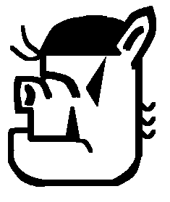 |  | 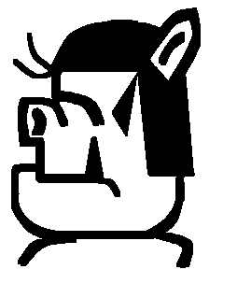 |  | 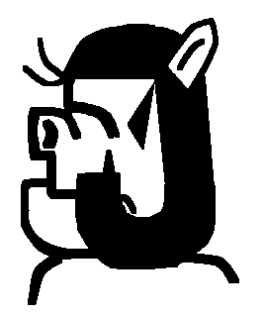 | 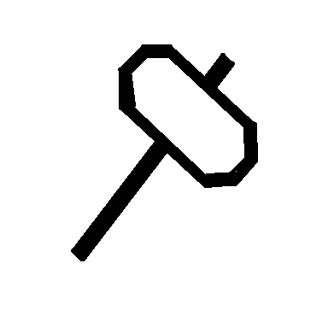 | 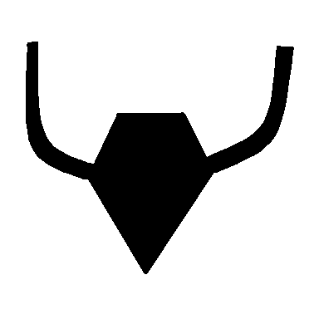 | 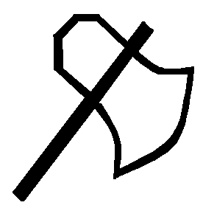 | 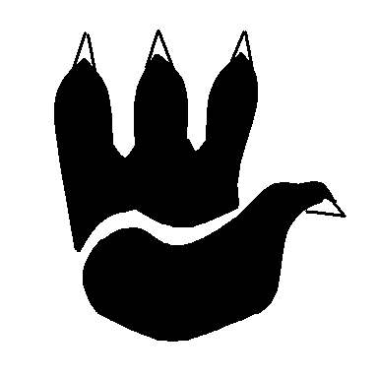
 | Pugilist |  | Ruffian |  | Barbarian | Melee | Magic | Point Blank | Cantrip
Light Troop | 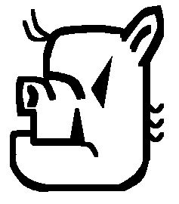 |  | 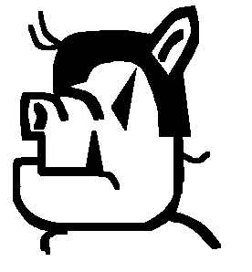 |  | 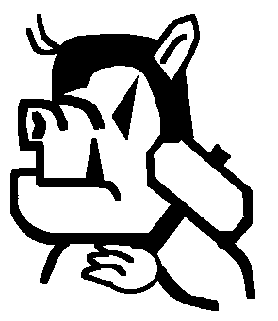 | 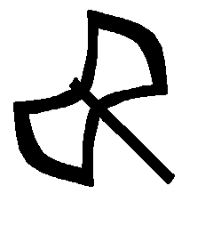 | 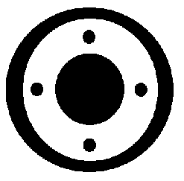 | 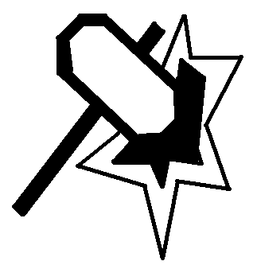 | 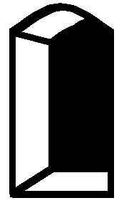
 | Goon |  | Strongarm |  | Enforcer | Missile | Save | Maul | Gate
Missile | 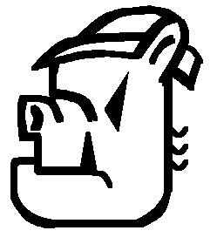 |  | 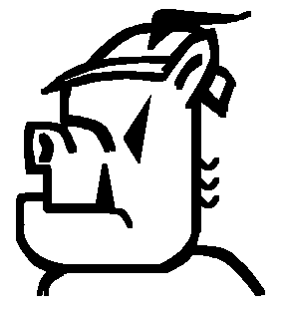 |  | 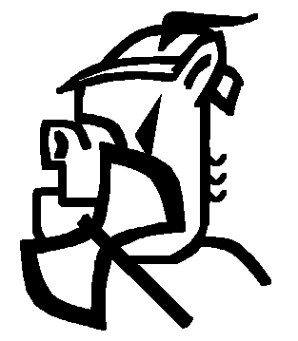 | 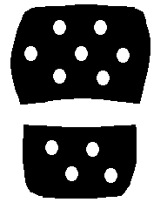 |  | 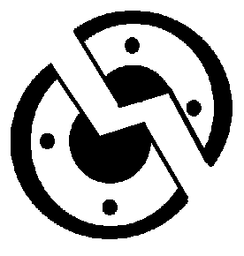 | 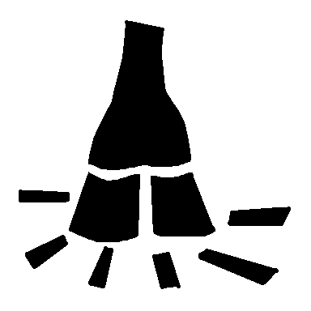
 | Pitcher |  | Hurler |  | Cleaver | Maneuver |  | Smite | Trample
Calvary | 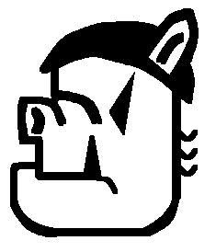 |  | 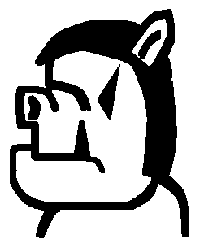 |  | 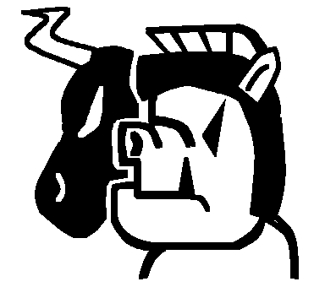
 | Stomper |  | Trampler |  | Bull-Rider
Magic | 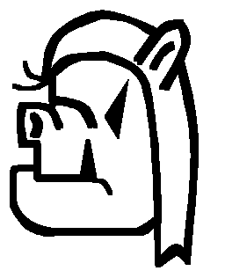 |  | 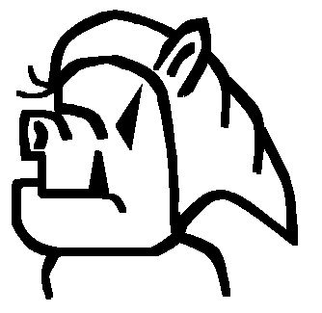 |  | 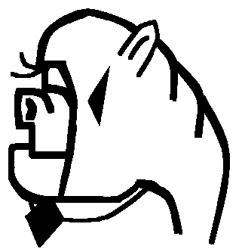
 | Dirt Minder |  | Loam Adept |  | Earth Tamer
Orc Monster Icons |  |  |  |  |  | Special Action Icons:  Bullseye: During a missile action, this attack targets a unit of the acting player’s choice. Only the target rolls to save. If it does not save it is removed to the dead area before the army rolls for saves against any other missile damage.  Cantrip: During a magic action, the cantrip counts as normal magic. During any other action, including rolls for saves, it can be used to purchase immediate spells.  Counter: During a melee attack, the counter acts as a normal hit. During a roll for saves during melee, it counts as both a save and an immediate hit upon the attacking army, which cannot save against it. Counter never causes a rout.  Gate: During a magic action, Gate icons count as normal magic. During maneuver rolls Gate icons are negated. During any other action, they allow the caster to summon a unit from the ether hybrid pool. Any opposing army at the same terrain as the casting army may attempt to counter the Gate effect by making a roll for magic. Only magic icons are counted, the highest opposing magic roll is retained and one gate icon is negated for every two magic ions rolled (rounded down). A single Dispel Magic negates all Gate icons. Only one unit may be summoned per unit rolling Gate icons and this unit must have health equal to or less than the adjusted number of Gate icons rolled.  Smite: During a skirmish attack, no saves count against these hits. Units killed by the smite are removed before the defending army rolls for saves.
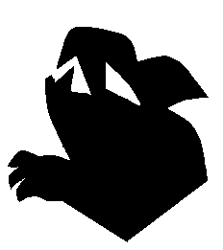 |  | 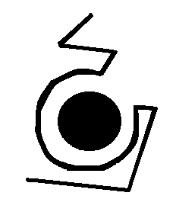 |  | 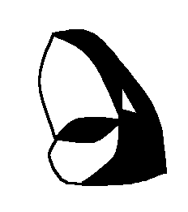
Gahlen Duhr |  | Surprise |  | Swallow
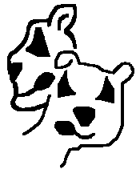 |  | 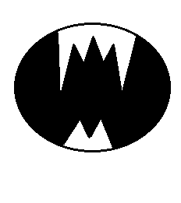 |  | 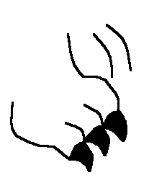
Ettin Hound |  | Bite |  | Rend
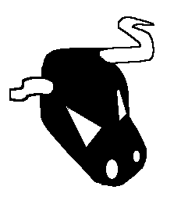 |  | 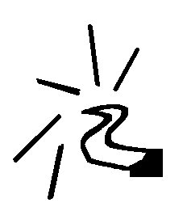
Minotaur |  | Gore |  | Trample
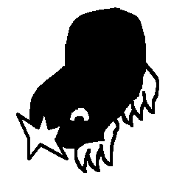 |  | 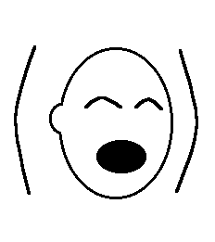
Brain Mole |  | Mind Control
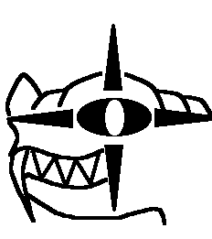 |  | 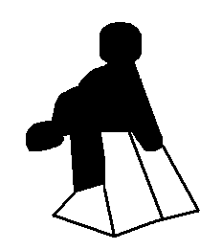
Basalisk |  | Stone |  | Rend
Rules for Monster Units:  • All standard Monster rules apply.  Monster Special Action Icons:  Charm: During melee, four health worth of opposing units, attacker’s choice, add their rolls to yours. Units must be chosen before their rolls are made.  Mind Control: Causes four health units in the opponent’s army to roll a skirmish attack against their own army. The remainder of the army can roll to defend, and counter or smite results must be applied. When rolled during a Dragon attack, choose one unit in any other army at the terrain to add their roll to yours against the Dragon.  Mind Drain: Kills two health points of the enemy, owner’s choice, no save possible. Counts as two points damage during a Dragon attack.  Paralysis: Four health worth of opposing units, owner’s choice, can only roll for saves until the end of the owner’s next turn.  Psychic Blast: When rolled during missile or melee, this power targets four health worth of the opponent’s army. Defender chooses units, those that do not roll individual saves are killed and buried. However, if all the defending units roll ID icons the attack is reflected upon the Mind Flayer, who must save against its own attack. For purposes of this save only, the Psychic Blast icon functions as saves. Counts as four points of damage during a dragon attack.  Rend: During maneuver, counts as four maneuvers, during melee, counts as four points of damage and unit is rerolled for additional effect. |  |  |  |  |  | New Spells: The following spells are useable by all beings of Ether. This is the basic spell list for Ether spells.  Ether (Purple) Spells:  Cost Spell  3 Portal: Restores one unit of health from the dead area. Multiple castings may bring back multiple units, or units of higher health values as the caster chooses.  4 Vortex: Creates an Ether vortex that moves all one health units to the owner’s reserve area unless a maneuver is rolled per unit. The entire army is rolled and the number of maneuvers rolled is the number of one health units that can remain at the terrain. Multiple castings only affect the remaining one health units at the terrain, never units of higher health.  5 Ether Bridge: When cast, this spell enhances the flow of magic from the Ether at the affected terrain. All ID icons rolled during a magic phase can be doubled if used for purple magic. This effect applies to all armies at the terrain, and lasts until the end of the caster’s next turn. This cannot be cast on an army in reserve.  6 Reinforce: Opens a gate to the Ether. Allows caster to promote up to 3 Ether Units in target army by trading in for units one health higher from the dead area. 3 health units may be promoted to monsters.  7 Summon Purple Dragon: Send a Purple Dragon to any terrain.
Ether (Purple) Spells (Tusker Only):  4 Dispel Magic: Negates the effect of any one spell currently in play. May only be cast  once per magic action.  8 Displacement: Casting army may make an attempt to maneuver any terrain in play. This maneuver attempt occurs outside the normal turn sequence and may be countered as normal by any other army at the chosen terrain, if desired. After completion of this maneuver roll all units in the casting army are returned to their initial terrain.  Earth (Gold) Spells (Tusker Only):  4 Wall of Stone: Until the beginning of the caster’s next turn the target army may not move any units into or out of the reserve area. This affects the results of a Revolt disaster face, forcing all units to remain at the terrain. The minor terrain rolling the Revolt is removed from play as normal. This spell does not affect the following SAI’s or spells: Path, Ferry, Rise From the Ashes or Open Grave. It also does not affect the abilities of Firewalkers or Lizardmen to move between terrains without passing through the reserve area first.  6 Entrench: Target any terrain die currently in play. Until the beginning of the caster’s next turn the target terrain may not be maneuvered. This effect may be countered by any army stationed at the target terrain by immediately rolling eight or more maneuvers. This spell cannot target a terrain currently at the eight face. This may only be cast once per magic action. (see Mire) |  |  |  |  |  | Earth (Gold) Spells (Tusker Only):  7 Tremor: Target any army at a terrain, reserve armies may not be targeted. The target army rolls and all units with ID results are stunned (as the SAI Stun) until the beginning of the caster’s next turn. These units may take part in any action that requires no rolls, but may not be rolled in any action until the effects of the stun wear off.  Additional New Items and Creatures:  Ether Dragon: May be a Drake or a Wyrm. Identical to other Drakes and Wyrms except for its breath weapon.  Breath Weapon: Psychic Shriek: Kills 5 units in target army. During the counter attack on the dragon all units rolling ID ignore these results when figuring save, melee and missile results. Additionally these units are Stunned (per the SAI) until the start of their owner's next turn.  Note: This is a substantial change from the original Psychic Shriek I created. The revised Black Dragon breath now has an effect essentially identical to the initial Psychic Shriek so this revision was needed.

