Spawn – The Demons  By John DeCocq  Her reach extended everywhere and her curiosity knew no bounds as she swept across the surface of the planet. She shriveled the flora, devoured the fauna, spoiled the waters and even defiled the air.  She felt the air around her, sniffed it and found that even her pollutants left it too fresh to be palatable. She grasped a handful of the stuff and prodded it, but it drifted away from her. Infuriated she used her mystic might to capture the air and bind it to shadow. The hideous shapes that appeared delighted her and she watched them struggle and rend each other, then she scattered them far and wide across Esfah. Her final gift to this race was the ability to call each other from any distance when help was needed.  Demons of air and darkness had arrived.  The Spawn are composed of Shadow and Air. Shadow is a new element and is represented by grey. |  |  |  |  |  | Spawn Special Abilities:  Infiltration: During melee actions Spawn may opt to use Infiltration. See the full description below.  Magic Use: Since they are from outside Nature, Spawn do not double magic points when ID icons are rolled. They may cast spells from the Basic Blue Spell list and the Basic Grey Spell list, included here. They may also cast Blue and Grey Spells from the expanded lists of unique Tannari spells, also included herein.  Summoning: During any action roll an army containing Spawn may forgo the usual action phase of a march and instead, use the ID results of all Spawn in the acting army to summon additional Spawn. All IDs must be used for this purpose, they may not be divided between summoning and the needed result. Divide the number of ID face results by 2, round down and return that number of health of Spawn from the acting player’s dead unit area to the acting army. These summoned Spawn are not rolled during the current action phase.  Fearless: The Spawn have no save icons anywhere on their faces, only ID results may be used to generate saves. However their ID results are discounted when determining a rout. An army composed entirely of Spawn is, therefore, immune to routing. If other units are present in the army and the army is routed, all Spawn are routed as well.
Creature Descriptions:  The Spawn are basically humanoid but have unusual heads, arms and other appendages:  Common Units:  Glabarezu: Small demons with tough hides, they fall upon their foes in waves.  Manes: Shock troops that burst into nothingness when hit, then reform just as quickly.  Quasit: These minor Tannari are all nails, claws, teeth and horns.  Chasme: They run like bats out of the Abyss.  Dretch: Shriveled and disfigured these spell-weavers work well in groups.  Uncommon Units:  Marilith: Powerful soldiers who repel invasions.  Nalfanshee: Striking without warning these Spawn capture most enemies alive.  Vrock: These fighters attack continuously, wave after wave.  Uridezu: Rat-demons with all the speed and stealth of rodents.  Incubus: Unworldly handsome and charming, these demons smooth-talk their potential victims. |  |  |  |  |  | Rare Units:  Balor: Generals in the Spawn armies, they wield their power mercilessly  Bebelith: Viscious melee fighters they delight in shattering foes defenses.  Hezrou: Leaders of small strike forces, they often sneak attack opponents camps.  Armanite: Demonic centaurs with razor-edged hooves  Sucubus: Irresistable seductresses with only vestigal horns, they have devoured countless mortal souls.  Monster Units:  Retreiver: Roughly arachnid in form, they carry out their master’s bidding by bringing the enemy back alive.  Dire Wolves: Packs of these ferocious beasts tear the enemy limb from limb.  Chupacabara: Foul beasts that raid livestock for food.  Larvae: Immature souls that need training to become full-fledged demons. They are strong when they attack in force.  Impaler: Malformed and covered in spines. They throw themselves upon their foes in order to slay them quickly.
Spawn Icons |  |  |  |  |  | Normal Action Icons |  | Special Action Icons
 | Common |  | Uncommon |  | Rare
Heavy Troop | 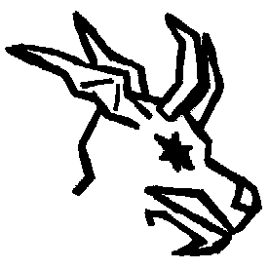 |  | 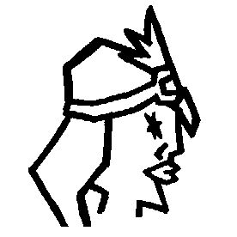 |  | 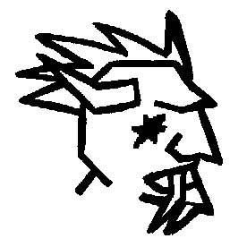 | 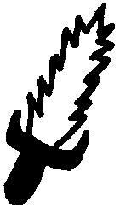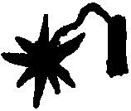  Melee  Magic |  | 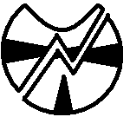 | 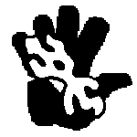
 | Glabrezu |  | Marilith |  | Balor | Melee |  | Smite | Psyphon
Light Troop | 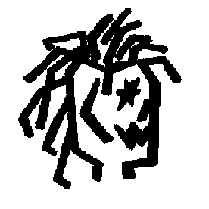 |  | 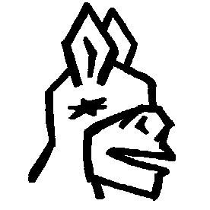 |  | 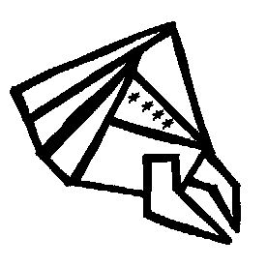 | 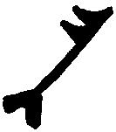 |  | 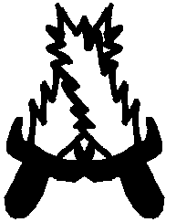 | 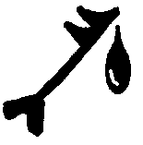
 | Manes |  | Nalfanshee |  | Bebelith | Missile | Maneuver | Counter | Poison Arrow
Skirmisher | 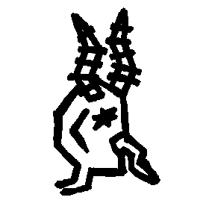 |  | 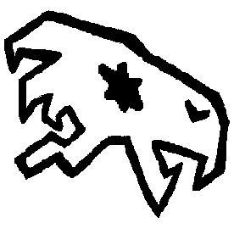 |  | 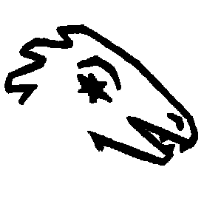 | 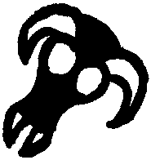 |  | 
 | Quasit |  | Vrock |  | Hezrou | Magic |  | Trample
Calvary | 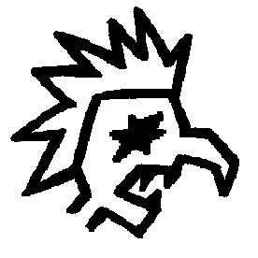 |  | 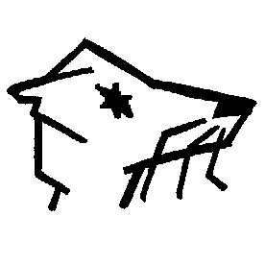 |  | 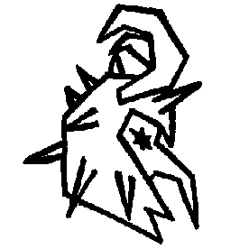
 | Chasme |  | Uridezu |  | Armanite
Magic | 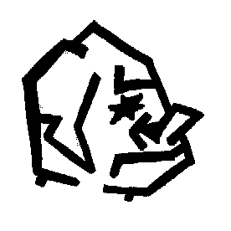 |  | 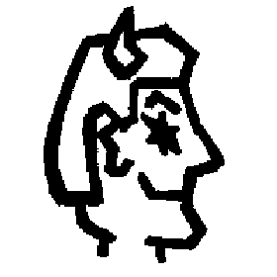 |  | 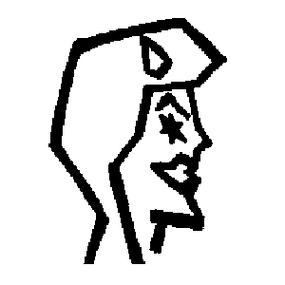
 | Dretch |  | Incubus |  | Succubus
Spawn Monster Icons |  |  |  |  |  | Special Monster Rules: The Larvae Swarm and the Dire Wolves are group monster units and all group monster unit rules apply.  Special Action Icons: The following SAIs appear on the Spawn units and monsters. All follow the Standard rules for the SAIs as listed in the DCM, or most recent rule revision. On Monsters each has its normal effect. On six-sided units reduce to one point of effect per icon.  Counter, Convert, Double Strike, Fly, Plague, Rend, Smite, Trample.
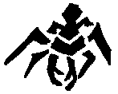 |  | 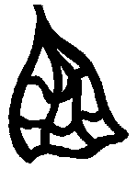 |  | 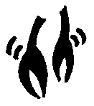
Retreiver |  | Capture |  | Double Strike
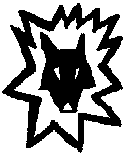 |  | 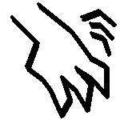 |  | 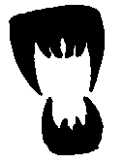
Dire Wolves |  | Rend |  | Bite
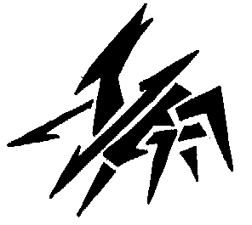 |  | 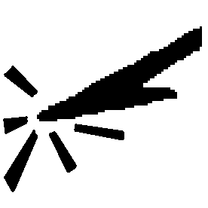 |  | 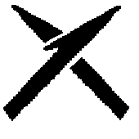
Impaler |  | Impale |  | Counter
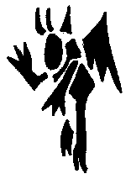 |  |  |  | 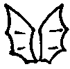
Chupacabara |  | Rend |  | Fly
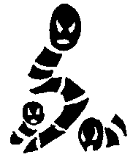 |  |  |  | 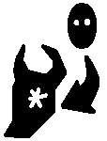
Larvae Swarm |  | Plague |  | Convert
New SAIs:  Bite: Target a single unit in the opposing army. Inflict two points of melee damage on the target unit and roll the biting unit again, applying the next result to the target unit as well if it is a melee result. The target unit may then roll to save against the total melee damage inflicted.  Capture: During a melee attack choose one unit in the opposing army. Target unit may not make any rolls. At the start of the Capturing unit owner’s next turn the target unit is rolled. If a save result is generated the unit returns to its army. On any other result the target unit is killed and the owner of the capturing unit may return one unit of equal or lesser health to the capturing unit’s army.  Poison Arrow: During missile target a number of 6-sided units in the defending army equal to or less than the number of Poison Arrow icons rolled. Each Poison Arrow icon inflicts 1 point of damage and the target units are rolled individually for saves. Any failing to save are rolled again. Any unit generating an ID result is killed and buried.  Psyphon: During magic actions target one health worth of units in the defending army. The owner of the targeted units may roll to save. Units are treated individually for purposes of saving. If a unit rolls a non-ID save there is no effect on the unit. Any other result kills the unit and allows acting army to cast a Cantrip using the target’s life force as the needed energy. The cantrip points may be used to cast any spell normally castable by the acting army or target unit, even if that spell is not normally available to the acting army. The number of points of cantrip gained are equal to the number of health worth of units killed. If any unit rolls its ID during the save roll the number of Cantrip points it generates is doubled. |  |  |  |  |  | Shadow (Grey) Spells: This is the basic grey spell list, useable by all creatures of Ether.  Cost Spell  2 Hide in Shadows: One health worth of units are hidden and cannot be targeted by melee or missile attacks until the start of the caster’s next turn. Multiple castings target multiple units, larger units or both.  4 Darkness: Target any terrain in play. All missile fire into or out of or at the target terrain is halved. All melee, save and maneuver rolls at the target terrain are halved.  5 Silence: Target any army in play. The target army cannot cast spells until the end of the army owner’s next turn.  6 Insect Swarm: Target any army in play. All units in that army roll. Up to four-health worth of units rolling Ids are chosen by the caster. Those units are rolled again for individual saves. Any units failing to save are killed.  7 Summon Grey Dragon: Send any Grey Dragon to any terrain
Shadow (Grey) Spells (Spawn Only):  3 Smite Good: Target any single unit in any opposing army that does not contain either the Black or Grey aspect. The target unit rolls for an individual save. If it fails it is killed.  10 Overrun: Target any friendly army in play that contains Spawn units, including the owner’s reserves. Roll the Spawn units from the target army in a melee attack against an opposing army in play at any terrain. Double all maneuvers generated by the Spawn units and convert to melee results. The opposing army may roll for saves. Any normal melee results generated during the save roll count as damage on the attacking army, with no saves possible.  Air (Blue) Spells (Spawn Only):  4 Shockwave: Target any opposing army at the same terrain as the casting army. The army’s owner chooses 5 health worth of units and Stuns them, per the SAI.  8 Abyssal Vortex: Target any opposing player’s DUA. All units in the target DUA are rolled. Any failing to roll an ID result are immediately buried. |  |  |  |  |  | New Action:  Infiltration: When chosen all Shadow units in the infiltrating army are rolled. All Stealth SAIs are counted, then added to the number (not value) of ID icons rolled. The opposing army then rolls all of its units. The number of ID icons (not value) rolled by the opposing army are compared to the number of Stealth icons and ID icons rolled by the acting army. If the opposing army’s ID icons equal or exceed the number of Stealth and ID icons rolled by the acting army then the acting army is caught and the opposing army rolls a skirmish attack against the infiltrating units. Only the infiltrating units roll for saves against the attack and they cannot make a counter attack. After this the current action ends the surviving infiltrating units are returned to the acting army. If Stealth icons exceed ID icons then the infiltration is successful and the targeted army cannot be used in any type of action during the owner’s next turn. The infiltrating units may then opt to make a single skirmish attack on the infiltrated army, who may not make a counter attack. During this attack all melee icons and stealth SAI icons count as damage, all Backstab SAIs count as double damage.  Additional New Items and Creatures:  Shadow (Grey) Dragon: May be drakes or wyrms.  Breath Weapon: Shadowfire: Kills 5 health worth of units in the target army. All missile attacks on the target army are doubled until the start of the owner’s next turn.

