Effort Estimation

The PRINCE Method
The PRINCE process-based approach to project management. The processes define the activities to be carried out during the project.

PRINCE Process Model

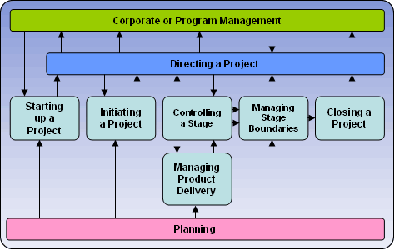

PRINCE Components
The PRINCE process model consists of the following 8 management process components:
* Business Case
* Organization
* Plan
* Control
* Risk Management
* Quality
* Configuration Management
* Change Control

Effort Estimation Guideline
The following is a list of some concerns about the resource estimation of a project:
- Scope and Functions – A management summary
- Function Description – List of Functions from functional requirement
- Team structure and responsibilities
- Organizational Structure (OBS) c.f. Organization Chart
- Work Breakdown Structure (WBS) i.e. a list of tasks to be performed
- Product Breakdown Structure (PBS) i.e. a list products to be delivered
- Context Diagram, First Level DFD and 2nd Level DFD (may be available later)
- Effort Estimation using Function Point Analysis (FPA )
  - Determine the type of function point count;
  - Identify the application boundary;
  - Determine the Unadjusted Function Point ;
  - Determine the value of the Adjustment Factor;
  - Evaluate the final Adjusted Function Point (AFP)
- Cost Model derived using COCOMO
  - Calculate the size of the system KDSI (Kilo Delivered Source Instruction) based on the FP Count;
  - Determine the effort MM (Man Month) using the appropriate formula;
  - Calculate the Effort Multiplier (EM);
  - Determine the software development time TDEV (in months).
- Resource Planning – considering different skill requirement, job categories throughout the timescale.
- Sizing and Capacity Planning
- Benefits of the system
- Duration i.e. the elapsed time of the system
- Project Plan and Stage Plan – Gantt Chart
- Project Schedule such as Network Diagram and CPM/PERT Chart from WBS
- Implementation plan

