Items students will need to bring:

- Calculator
- Two # 2 pencils
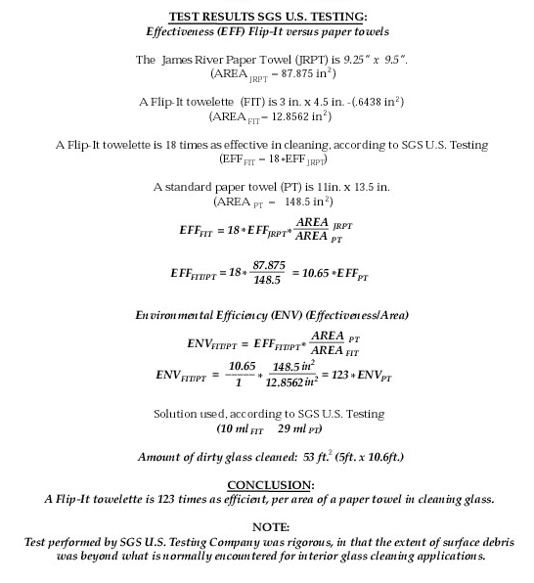
- Quiz Books
- Student ID

I, ________________ give my child ______________ permission to participate in Mr.
Palmer’s Math Tournament at Freedom Middle School on May 21st. Please return to your homeroom by May19th.

