Slater's Rules for Effective Nuclear Charge
This set of simple rules for approximating the effective nuclear charge was proposed a number of years ago by Professor John C. Slater, a former faculty member at M.I.T.
Read through the rules carefully - all of the information you need is there. Work through the examples and verify that you get the same results.
Derive the Z_{eff} for the elements Li through Ne and compare your results with the experimental ionization energies and atomic radii for these elements. Are your calculations consistent with the experimental values for ionization and with the radii?
Calculate Z_{eff} for the group IA elements. What do you find? How do you rationalize your results with the experimental ionization energies of these elements?
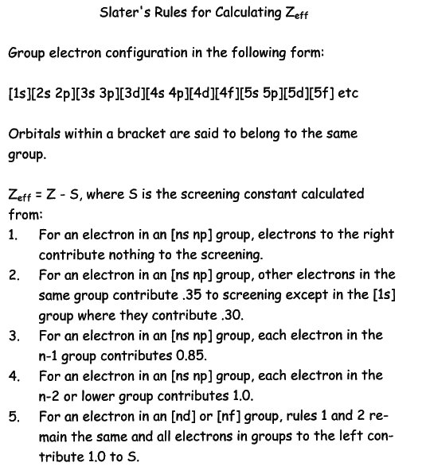
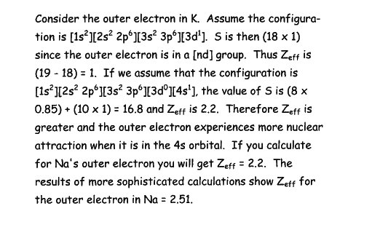
William F. Coleman wcoleman@wellesley.edu
Dept. of Chemistry, Wellesley College
Date Created: January 27, 2004
Last Modified: January 27, 2004
Expires: September 15, 2014
Copyright 2004 by William F. Coleman

