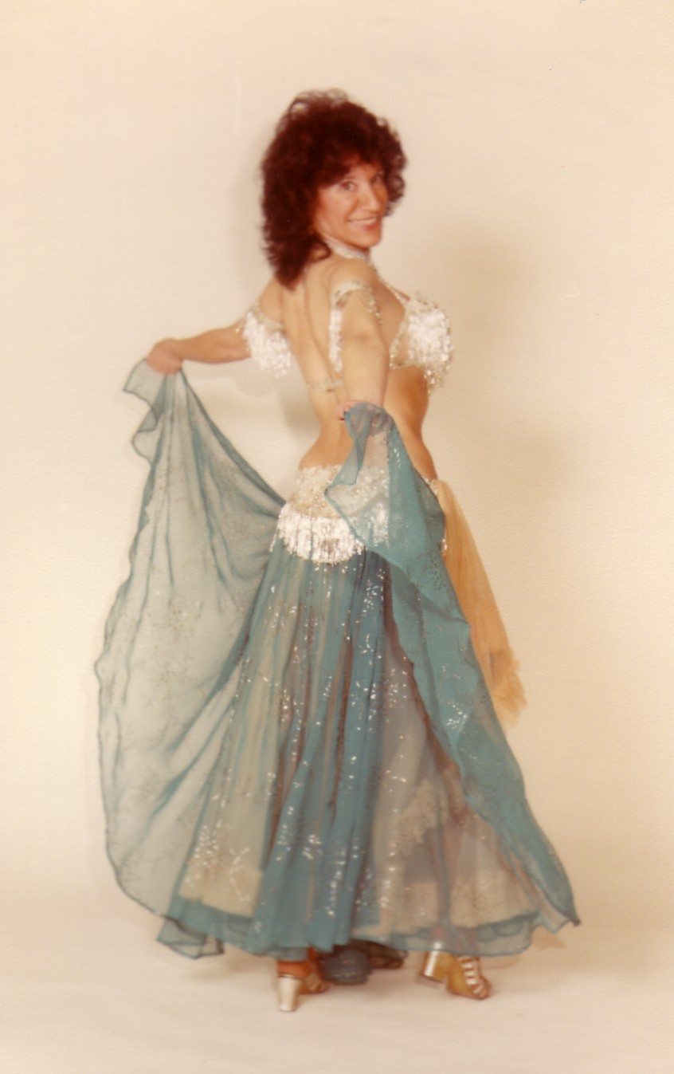

Mideastern

dance classes

All ability levels welcome!

To beginners/continuing and/or

Show-Time Class student dancers

~~ Need prior ME Dance experience ~~
Tina Saroli Jablonski
Performer / Choreographer
Since 1972

All Classes are held on Wednesdays

(7, 45-minute sessions)

Please note: These classes are for adults.
For children, please call Tina direct at 586-264-0159
for children’s location for their lessons.

This class is conducted through the Sterling Heights Parks and Recreation Department.
You may register in person at the Parks and Recreation Department or online at
www.sterling-heights.net
Classes are held at the Sterling Heights Senior Center, 40200 Utica Rd.
Dodge Park and Utica Road in Sterling Heights.
Please register early.

Beginner/Continuing Beginner Class

Meets on: Wednesdays from 7:00-7:45 p.m.

Class Agenda: Beginners will learn all the basic steps through choreographed routines, which make the learning process so much more fun. Continuing students will review the beginner steps and continue on with the more complicated steps.

Cost: $40 for Sterling Heights Residents
$47 for non-Sterling Heights Residents

Show-Time Class

Meets on: Wednesdays from 6:15 until 7 p.m.

Class Agenda: Advanced “Show-Time” Students will work on advanced chorography and show-time routines along with attention on various movements for your solo numbers for the May 18, 2006 Show. Special attention will be paid to veils and zills as well.

Cost: $40 for Sterling Heights Residents
$47 for non-Sterling Heights Residents

For more information regarding classes, please call Tina at 586-264-0159
or visit my website at www.geocities.com/tinajablonski/
or the City’s website at www.sterling-heights.net.
Sterling Heights Parks & Recreation – 586-446-2700

