Spectroscopy
Spectroscopy is the analysis of the ways in which matter emits and absorbs radiation. One early spectroscopist, the German physicist Gustav Kirchhoff (1824-1887), in 1859, summarised the observed relationships between 3 types of spectra:
- continuous
- emission line
- absorption line

 Origins and its colours explained
The 3 rules governing the formation of spectra are:
- A luminous solid or liquid, or a sufficiently dense gas, emits light of all wavelengths and so produces a continuous spectrum of radiation.

- A low-density, hot gas emits light whose spectrum consists of a series of bright emission lines. These lines are characteristic of the chemical composition of the gas.

- A cool, thin gas absorbs certain wavelengths from a continuous spectrum, leaving dark absorption lines in their place, superimposed on the continuous spectrum. Once again these lines are characteristic of the composition of the intervening gas – they occur precisely the same wavelengths as the emission lines produced by that gas at higher temperature.

A spectroscope is a device for splitting a beam of radiation into its component frequencies and delivering them to a screen or detector for detailed study.

The emission and absorption lines produced by each element are unique – they provide a ‘fingerprint’ of that element in the light it emits or absorbs. The study of spectral lines produced by different substances is called spectroscopy.

 Read between the light
Astronomers apply the laws of spectroscopy in analysing radiation from beyond Earth. Several mechanisms can broaden the spectral line. The most important is the Doppler effect, which occurs because stars are hot and their atoms are in motion or because the object being studied is rotating or in turbulent motion.

Since we know that each element has a it’s own set of spectral lines, astronomers can find out the chemical composition of stars and galaxies just by analysing the light received from the source.
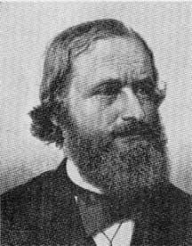
Gustav Kirchhoff (1824-1887)

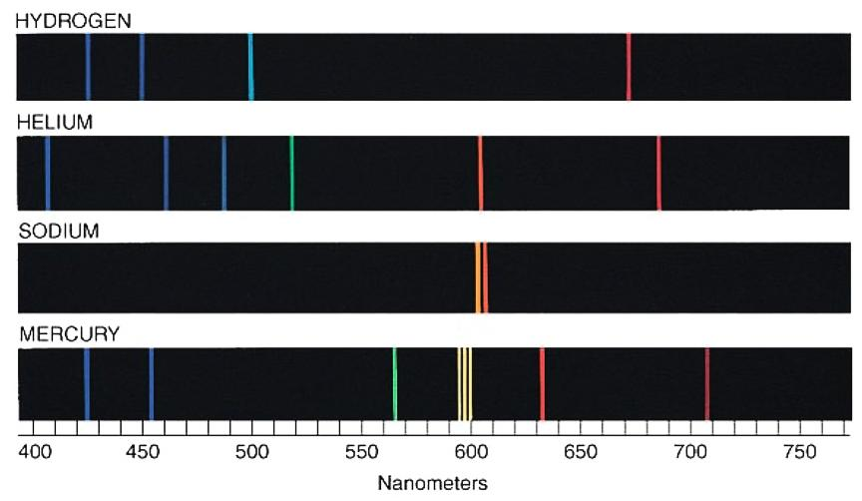
Spectral Lines

