JAMAICA

TAEKWON-DO

ASSOCIATION

TOURNAMENT
RULES & REGULATIONS

Revised January 2002

Jamaica Taekwon-Do Association Belt System
- White Belt
- Yellow Belt
- Green Belt
- Blue Belt
- Red Belt
- Black Belt

Referees, Judges, Timekeepers & Recorders
- Each ring will consist of a Referee, four (4) Judges, a Timekeeper and a Recorder.
- The Referee will be in control of the ring at all times.
- Judges for the pattern competition will be seated in a line facing the competition.
- Judges for sparring will be seated at the four- (4) corners of the ring. They will give points accordance with their judgement.
- Timekeeper will be seated at the ringside to check and indicate the beginning, end and continuation of each match.
- The Recorder will be seated at ringside to keep match records.

Safety Equipment & Protective Gear
Competitors must wear:
- Safety equipment of an approved type on their head, hands and feet.
- Groin guard protectors (when worn they must be inside the dobok trousers.)

Competitors may optionally wear the following:
- Padded shin protectors.
- Padded forearm protectors.
- Breast protectors (female only.)
- Mouth guards.

These all being of approved type consisting of elasticated material with sponge or rubber type padding and containing no metal, bone or hard plastic or similar hard material whatsoever, nor involving the use of zip, lace or stud fasteners.
- No other protective or safety equipment may be worn.
- No jewelry, watches or other adornments may be worn, hair may be kept in place using material of a soft elastic nature only, no grips or slides are allowed.

System of Tournament
- Competition will be decided by the pyramid tournament system as far as pattern, sparring and team sparring are concerned.

Target Area
- Head and neck area at the front and sides but not at the back (Adult Division Only.)
- Trunk of the body from neck to navel vertically and from a drawn from the armpit vertically down to the waist on each side (that is frontal area excluding the back.)

Point Awards (scoring)
One point will be awarded for:
- Hand attack (punch) directly to mid or high section of body.
- Foot attack directed to mid section.

Two points will be awarded for:
- Foot attack directed to high section.
- Hand attack while in air (both feet must be off the ground.)
- Jumping or flying kick to mid section.

Three points will be awarded for:
- Jumping or flying kick directed to high section.

No contact is allowed but points will be given only for correctly delivered techniques, which are within 2cm of the section under the following conditions:
- Proper distance.
- Correct posture.
- Appropriate tool to the section.
- Forceful delivery.

No punching to the face for peewees and juniors.

Legal Techniques
- Punch.
- Backfist.
- All standing / jumping kicks.
- Reverse knife hand (Black Belts only.)

Illegal Techniques
- Knife hand strikes.
- Elbow strikes.
- Knee strikes.
- Fingertip thrusts.
- Open hand slapping.
- Headbutts.
- Chokes.
- Throws of any kind (takedowns.)
- Holds of any kind.
- Blind techniques.
- Hitting below the belt.
- Sweeps.

Fouls
When a center referee feels that a foul has been committed, he/she will break the fighters and signify to the scorekeeper a “warning” or “minus” point to the appropriate fighter. He/she will then immediately restart the bout, if the fighters can continue (time continues unless the center referee stops time.)
When both fighters commit a foul, the center referee will signify to the scorekeeper the appropriate deduction. Remember, a fighter who fouls in association with a point cannot earn a point.

A fighter who is assessed three (3) minus points via warnings or fouls will be automatically disqualified. The center referee can disqualify a fighter for any foul if he/she feels the foul was malicious, intentional and/or because of the result of the foul.

If a fighter commits a foul and the fouled fighter cannot continue the fight, the guilty fighter will be disqualified immediately. The fouled fighter will advance to the next round. If he/she has recovered prior to their next match, they can continue…if not, he/she must withdraw from the tournament.

If both fighters are injured simultaneously through no fault of either fighter, the center referee will give both fighters a reasonable time to recover. If no fouls occurred and the bout can continue, the center referee will restart time when appropriate. If neither fighter can continue, the scores would be added up at that time and a winner declared.

If a fighter is injured through his/her own fault and through no fault of the other fighter, the center referee will give the injured fighter a reasonable time to recover. The fight must then continue, or the injured fighter must withdraw and the other fighter must be declared winner.

If either or both fighters commits fouls and neither can continue the center referee will disqualify both fighters.

A fighter who is disqualified at any point in the bracket despite whether this occurs in a preliminary or finals match will not receive any award. This position will remain open in the bracket sheets. (E.g., if there is a disqualification in the 1st –2nd place match, only 1st place award will be made, no 2nd place. The 3rd and 4th place awards will remain in their respective spots.

Determing a Foul
The center referee should use Severity, Intent and Result (S.I.R) as basic criterions to decide on appropriate deduction such as whether a warning should be given to a fighter or if the severity of the infraction should result in a “minus point” or disqualification.

Severity: If the severity of the foul is a serious disregard for the rules, it could be declared a foul despite the fighters intent or the result of the infraction (E.g., when a fighter continuously throws blind techniques that were capable of serious injury, even though intent or result are not present.)

Intent: If the fighter intentionally commits an infraction that could cause an injury, yet it did not result in an injury, the center referee may find it to be malicious and deduct a minus point (E.g., intentional headbutting.)

Result: Any infraction that results in an injury should result in minus point. If because of the infraction, the injured fighter is put in a disadvantage for the remainder of the match, the center referee may deduct a minus point (E.g., thigh bruises, hard groin kicks and high sweeps.)

A combination of severity, intent and result must be weighed by the center referee in making the decision for a minus point, warning or disqualification. The center referee should be consistent and honest in his/her judgement. The center referee can ask for the opinion of the judges, but the final decision is his/hers.

Warnings (minor fouls)
When a minor foul occurs, the center referee warns the fighter and notifies the scorekeeper to mark a warning on the score sheet for the appropriate fighter. When three (3) warnings are accumulated, the scorekeeper will circle the three warnings – making them equivalent to a “minus point”. The center referee should assess warnings with consistency since these warnings are an integral part of the score.

Types of Fouls (f: foul, 1 minus point, d: disqualification, w: warning, 3 warnings = 1 minus point.)
- Headbutting. (d)
- Striking with elbow or ungloved portion of arm. (d)
- Striking or punching below the waist. (f)
- Attacks with the knee. (f)
- Attacks to the spine. (f)
- Kicking to the legs while they are below the belt. (f)
- Hitting a downed fighter (if any part of the fighter is touching the ground other than his/her feet. He/she is considered down.) (f)
- Pushing, shoving or wrestling. (w)
- Attacking after the “break”. (w)
- Holding and hitting. (w)
- Grabbing or holding onto the opponent’s leg. (w)
- Leg checking – extending the leg to stop an opponent from kicking. (w)
- Refusing to fight or evading contact. (w)
- Abusing language in the ring. (d)
- Clinching – holding on to the other fighter. (w)
- Going out of bounds. (w)
- Blinding techniques. (f)
- Unsportsmanlike conduct. (w)
- Not following the instructions of the center referee. (w)

The Center Referee’s Power to Stop the Match
The center referee can stop a match at any stage if he/she decides that the safety of the fighters is in question. The center referee may call time out for equipment repairs, to explain an infraction, or to clarify disputes.

If the match is too one-sided or the fighters are out of condition or improperly trained, the center referee may stop the bout. The center referee may also stop the bout for a disqualification or an injury.

The center referee may call timeout at any time to summon a medic or physician into the ring to check the condition of the fighter(s). The center referee may consult with any of the following to decide whether or not to stop the match:
- Tournament Medical Staff.
- The Competitor’s Instructor.
- The Competitor’s Family Member.
- The Competitor.
- The Tournament Director.

Any of these may withdraw the competitor from the match, but only the physician/medic or the center referee has the power to render the decision in the event the match is ended.

Disqualification’s
The center referee can disqualify a fighter for a foul if it is deemed that it was committed with malice and intent or if the result of the foul calls for such action.

Disqualification will result without question if there is:

- A major sign of disrespect or Unsportsmanlike conduct.
- Any knockout, or
- Contact resulting in blood drawn as a direct result of a foul (sometimes a fighter is hurt in a previous bout and blood is drawn again in a subsequent match.) Blood being drawn is defined as an uncontrollable flow, not an abrasion. The center referee should explain this fact, give the fighter time to recover and resume the match if possible.

A fighter can be disqualified if he/she is not available when his/her match is called. In this case, the center referee will allow a reasonable time to pass (including moving on to the next bout and then returning to the previous scheduled bout.)

A fighter will be disqualified if he/she receives “three minus points” during the bout via warnings or fouls.

A fighter will be disqualified if he/she is injured through no fault of the other fighter and cannot resume the match.

Sparring Competition
The sparring competition will consist of three types:
- Point Sparring.
- Continuous Sparring.
- Team Sparring.
Target areas, warnings, disqualification, fouls and point allocations are the same for the three types of sparring. Time is stopped during a match only for injury, judges and referee consultation or safety equipment adjustment. The total points accumulated at the end of each bout will determine the winner and they will go on to the next round.

1. Point Sparring Competition
Each fight will have duration of two (2) minutes. The referee stops the fight when a point is scored. The referee or a judge may call for a decision on a point to be made. (A referee may decline the call for a point if he/she saw that no point was made, e.g. attack delivered on the guard, low or out of range. In this case the referee must publicly give reason for his/her decision.) The referee must name the technique and target area for every point that is scored. If he/she is unaware of the target area then he/she must ask the judges. When a majority of judges indicate the same target area then the corresponding points are awarded. If the judges indicate different target areas then the lower score is used.

In the Event of a tie
The referee will announce that a tie has occurred and the bout will be continued one (1) minute. If there is a tie at the end of overtime then the referee asks each judge to make an instant decision regarding the winner of the fight. The judges will simultaneously indicate by raising the flag of the winner. In this case the referee will also vote at the same time.

Judging for point sparring competitions
Each judge possesses a blue flag and a red flag. The judges will be required to indicate their observation as follows:

When a point is seen: Raise flag of corresponding competitor.

RED BLUE

If the technique was blocked: Cross both flags in front of chest.

If the technique was not seen: Point edge of flags to each other in front of
eyes “can’t see”.

Please note: “can’t see” refers to visual obstruction by either referee being in line of sight or the competitor’s back is turned towards a judge. Absolutely no score should be awarded if technique is not clearly seen, e.g., if blue (or white in this case) kicks to red’s middle section and red’s back is turned to a judge and the judge cannot see whether red’s hand and body was kicked, no score can be awarded by that judge. No score should be awarded based solely on sound of impact or result of impact, e.g. being pushed by a technique.

The following is an outline of referee rulings based on judges’ decisions

Judge1 | Judge2 | Judge3 | Judge4 | Result
 |  |  |  | Point-Red
 |  |  |  | Point-Red
 |  |  |  | No Point
 |  |  |  | No Point
 |  |  |  | Point-Red
 |  |  |  | No Point
 |  |  |  | No Point

2. Continuous sparring competition
Each fight will have a duration of two (2) minutes. The fight is not stopped to award points. Each judge will possess score sheets on which all points are recorded. The referee will interrupt a match only if warnings or fouls are to be given. At the end of two minutes, the referee will collect the score sheets and hand them to the recorder who examines them and informs the referee of the winner.

In the event of a tie
The referee will announce that a tie has occurred and the bout will be continued one (1) minute. If there is a tie at the end of overtime, the jury will decide the winner by evaluating the score sheets and determine the winner by the following criteria:
- The number of warnings i.e. the competitor with the least number of warnings win or.
- The number of difficult techniques scored i.e. the competitor whom scores using more difficult technique wins.
Note: the second option is used only if the number of warnings is equal.

3. Team sparring competition (continuous)
Each school may enter as many teams as they wish. Each team consists of five (5) members. A team must win three (3) out of five (5) fights to advance to the next round. Each fight will last two (2) minutes and the rules for each fight are the same as the continuous sparring competition.
Note: Only adult male black belts are allowed to enter the team competition.

Patterns (forms) competition
Only traditional forms are allowed (i.e., forms that are done for each individual style’s testing requirements.) A panel of five (5) black belts will judge each ring.

The recorder will call two competitors according to the bracketing sheet. The most senior judge in the panel will give the following commands:

“Ready Position”
“Begin”

Both competitors will begin at the same time. When the competitors have completed their patterns, the senior judge will then instruct the judges to score by saying:

“Judges Score”

The judge’s score simultaneously by raising the flag of the competitor whom he/she thinks has won. The winner is the competitor with the majority of votes and will go on to the next round. If the competitor has to begin the pattern again, he automatically loses the bout.

Note: Competitors must not introduce themselves or the pattern they intend to do.

Breaking competition

A. Technique Breaking
This consists of three (3) aerial breaks:

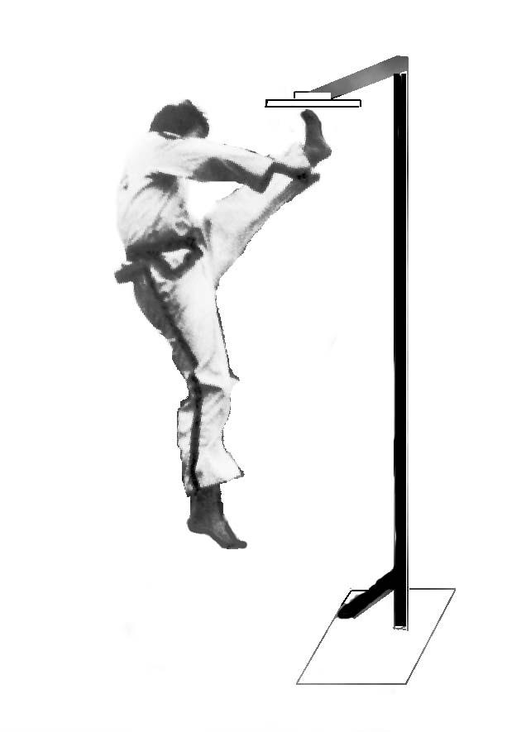
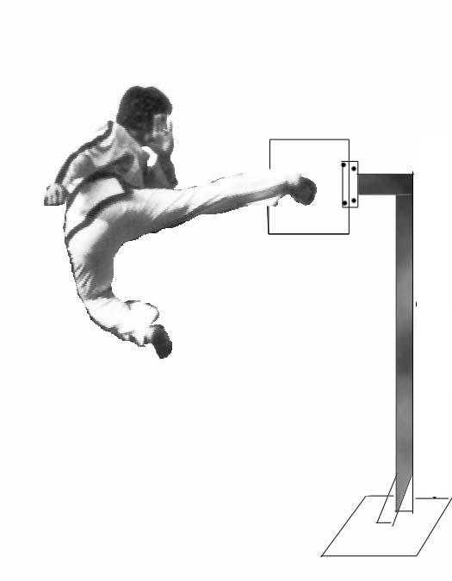
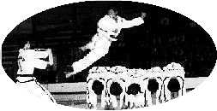
1. Flying Front Kick 2. Flying Turning Kick 3. Flying Side Kick
Each competitor should attempt all three breaks.
Technique | Black Belt Male | Black Belt Female
Flying Front Kick | 260 cm – 8 ½ ft | 210 cm – 6 ft 8 inches
Flying Turning Kick | 230 cm – 7 ½ ft | 190 cm – 6 ft 2 inches
Flying Side Kick | 210 cm – 6 ft 8 inches | 150 cm – 5 ft

Points are accumulated as follows:
1 Point: Each broken board (clean break.)
½ Point: Each cracked board (able to be broken with a tap or finger pressure.)

In the event that a second round is necessary, the flying front kick and the flying sidekick are used. The flying front kick will be raised 15cm (6 inches) and the flying sidekick extended by 30cm (1 foot).

If a third round is necessary, only the flying front kick will be used and the height will be increased by another 30cm (1 foot).

If a fourth round is necessary, the flying front kick will again be used and increased another 15cm (6 inches).

In the event of a tie in the fourth round, the first place is shared.

Note: If no competitor scores in the third or fourth round, each is allowed another attempt. If there is still no score, a tie is declared.

B. Power Breaking
This consists of both foot and hand breaking.

Each competitor will attempt a minimum of the following number of boards and tiles:

Rank | Number of Boards & Tiles
Black Belt Male | 4
Black Belt Female | 2

Foot Breaking
The following kicks are allowed: sidekick, turning kick and back kick.

Points are accumulated as follows:
1 Point: Each broken board (clean break.)
½ Point: Each cracked board (able to be broken with a tap or finger pressure.)

Hand Breaking
The following tools are allowed: forefist punch, knifehand strike and reverse knifehand (ridge hand) strike, sidefist strike (hammer fist), backfist strike and open palm strike.

Points are awarded as follows:

Technique | Points Awarded
Sidefist Strike (hammer fist) | 1.0
Open Palm Strike | 1.1
Knifehand Strike | 1.2
Forefist Punch | 1.3
Reverse Knifehand (Ridgehand) Strike | 1.4
Backfist Strike | 1.4

If a tap or finger pressure by the judge breaks the tiles, then half the number of points will be awarded.

Note: A competitor may request more boards or tiles for the power breaking. Spacers are not used between the breaking materials.

The winners of each breaking competition will be the competitors who accumulate the most points.

