COM3191 Internet Programming

Lab 3

Exercise 1
Develop a web page using frames as follows:

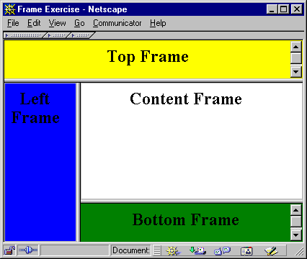

Exercise 2
Develop a web page using a client-side imagemap as follows:

