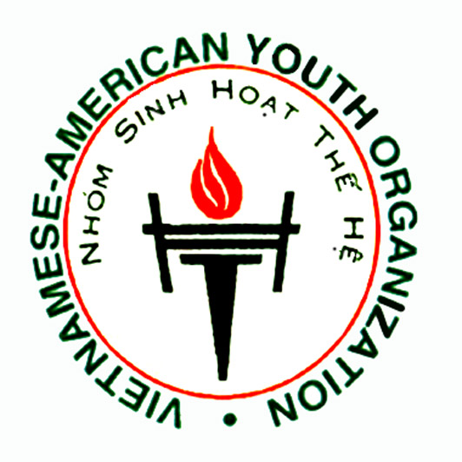
A little about us …

The Vietnamese American Youth Organization (VAYO) is a nonprofit organization that consists of young professionals and college students who are working toward the improvement and development of the Vietnamese community. Through our cultural and social activities, we hope to foster understanding and appreciation of our culture in hopes that it may enhance the Greater Houston Community.

Our involvement initially began in 1986 when a group of college students introduced a monthly magazine called "The He" ("Our Generation”). This magazine expressed the concerns and activities of young Vietnamese of this generation and provided a forum, through which the students could exchange ideas and feelings about themselves and their community. In 1990, due to the success of this magazine, which brought overwhelming interest in our movement and increasing recognition from the community, this modest involvement evolved into a more formal organization, the present Vietnamese American Youth Organization (VAYO).

Since then, VAYO has remained active within the community in many diverse ways. Our successful efforts to promote culturally important events, such as the Tet Festival, to not only the Vietnamese but also the Greater Houston Community.

Some of our activities include:

- VAYO scholarship fund for Texas-resident Vietnamese-American students who will pursue or presently pursuing a college degree from a Texas university
- Organizing the Trung Thu, a “Harvest Moon Festival”, for local children under the care of the YMCA International Services and the Lutheran Social Services

- Humanitarian projects such as raising funds for the American Red Cross to assist Midwest Flood, California Fire Disasters, and Fund for Refugees

- Participating in other community projects that are organized by larger organizations/corporations

