Directions to HORS’N AROUND STABLES:
19032 St Andrews Rd Caledon, Ontario, Canada L7K 2C7 Problems? Call Maggie at 519-927-3296

-Highway #401 to Highway #410 North
-#410 ends at 'Mayfield Rd'-- Turn LEFT (west) onto 'Mayfield Rd'.
-Turn RIGHT (north) onto 'Hurontario St' (which is also called ‘Highway #10’).
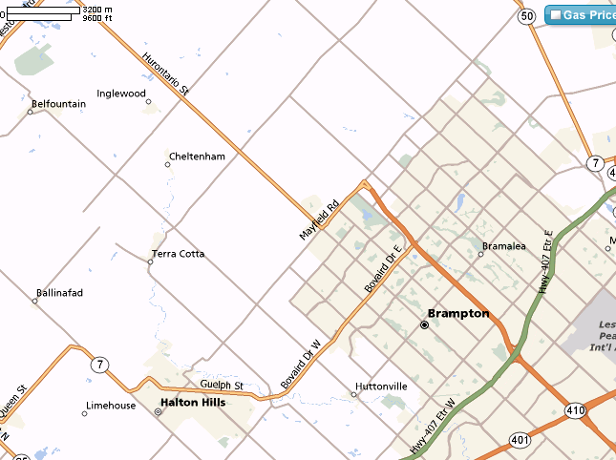
-Turn RIGHT (east) from ‘Hurontario St’ onto ‘Charleston Sideroad’
-Turn LEFT (north) from ‘Charleston Sdrd’ onto ‘St. Andrews Rd’
-We are the first farm on the LEFT--#19032. There is a large yellow sign that says “Hors’n Around”.
