
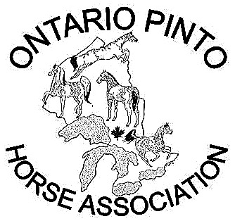

The Ontario Pinto Horse Association Presents:
HORS'N AROUND SCHOOLING SHOW
VICTORIA DAY-MAY 18, 2009 AT 10:00AM

ALL HORSE BREEDS, COLOURS, SHAPES AND SIZES WELCOME!
ALL PROCEEDS TO BENEFIT THE ONTARIO PINTO HORSE ASSOCIATION

ENTRY FEES: $5.00 per class or $25.00 for the Whole Day!

YOUTH: Rider under 18 years as of January 1st. OPEN: Rider of any age Beginner: Riders any age that are not ready to Canter/Lope.

Class List:
- Open Halter - Judged strictly on the horse's confirmation.
- Youth Showmanship (English/Western) - Judged on the safe handling & presentation of the horse.
- Open Showmanship - see class #2 for description

- Minute Break

- Youth English Pleasure - Judged as a pleasure horse on performance and manners.
- Open English Pleasure - see class #6 for description.
- Open English Equitation - Judged on the rider's equitation while executing a pattern.
- Open Hunter Under Saddle – Judged at a walk, trot, canter and hand gallop.
- Open English Discipline Rail - Judged on the prompt response to the judge’s commands.
- Open Hunter Hack - Two fences to be jumped 2' maximum. Cross rails may be requested.
- Open Hunter Over Fences 2’3” – Two fences to be jumped. Cross rails may be requested.

LUNCH BREAK

- Lead Line – Age limit 11 years old and under / 55 yrs or older. An experienced handler must lead.
- Open Trail – (English/Western) Judged on the ability to negotiate obstacles in a pattern.
- Beginner Walk/Jog/Trot Trail – Judges on the ability to negotiate obstacles in a pattern.
- Beginner Walk, Jog/Trot (English or Western) - For riders any age who are not ready to Canter/Lope. Young riders may be lead.
- Beginner Walk/Jog/Trot/ Pattern - Judged on the rider’s equitation while executing a pattern.
- Youth Western Pleasure - Judged as a pleasure horse on performance and manners.
- Open Western Pleasure - see class #11 for description.
- Open Pairs Pattern (English/Western) - Judged on riders executing a pattern in sync with each other.
- Open Western Discipline Rail - Judged on the prompt response to the judge’s commands.
- Open Barrel Race - Triangle barrel pattern. Fastest time wins.
- Open Flag Race - Rider must retrieve and deposit a flag from a barrel. Fastest time wins.
- Open Pole Bending - Weaving through poles pattern. Fastest time wins.

Hors'n Around is located at 19032 St. Andrews Rd. South of Orangeville, North of Brampton, West of Caledon East and East of Caledon Village. RAINING?? No Problem! We have a very large Indoor Arena.
WEB SITE: www.ontariopinto.com

QUESTIONS??? CALL MAGGIE AT (519) 927-3296 OR Email: margaret.meehan@dpcdsb.org
All-Breed classes are approved for the Paint Alternative Competition program (PAC) http://www.apha.com/pac/index.html

