Journeyman Formsetter/Framer
206 992 9374 tombronson@yahoo.com
Tom Bronson UBC# U-2922-3710 SSN 563-80-2417 Idaho DL RA362025E
Cards: Rigging Scaffold Erection C-Stop Lift Truck TWIC Fall Safety
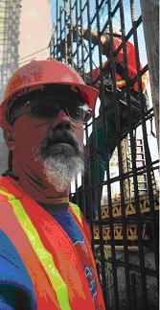  23 years in construction--56 years old in excellent health | 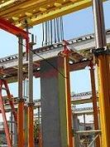  Peri & Skydeck | 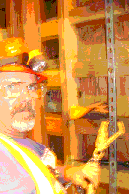  Fall Safety Card
 | 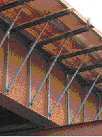  Bridge Brackets & Deck | 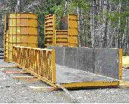  EFCO forms
 | 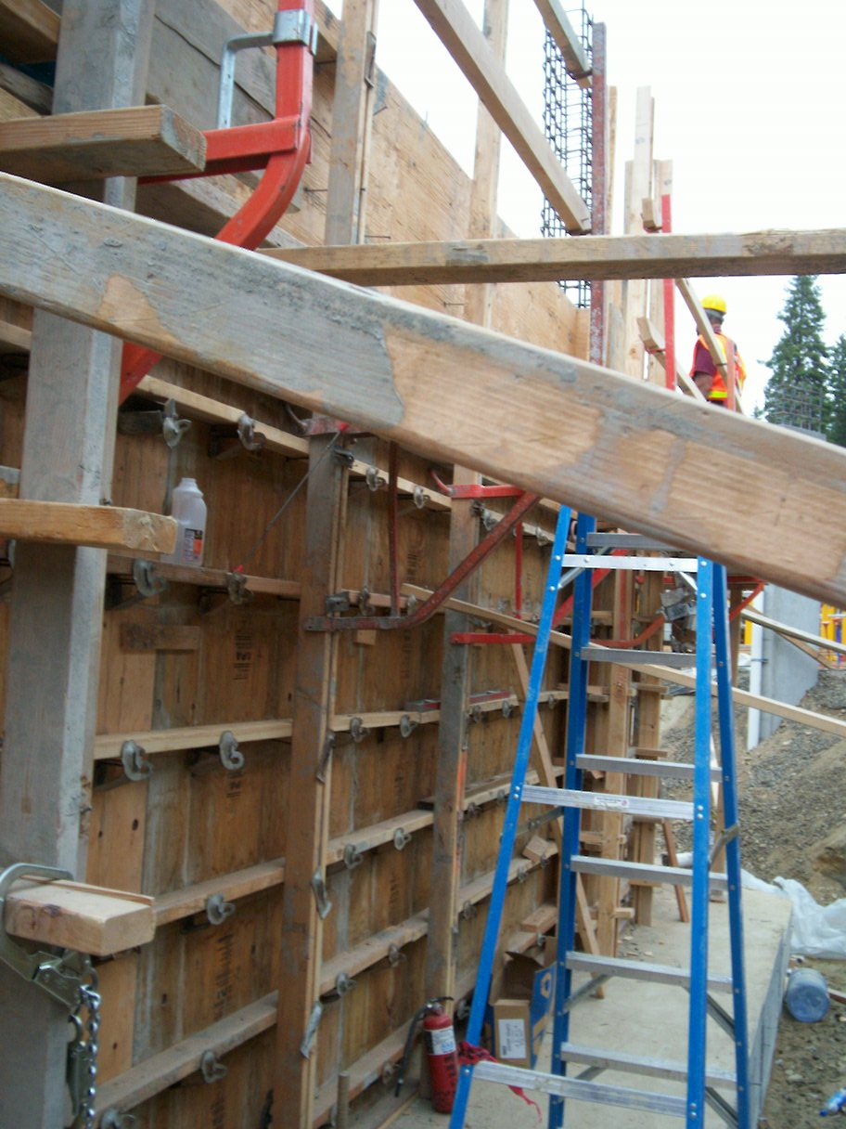  Gang Forms | 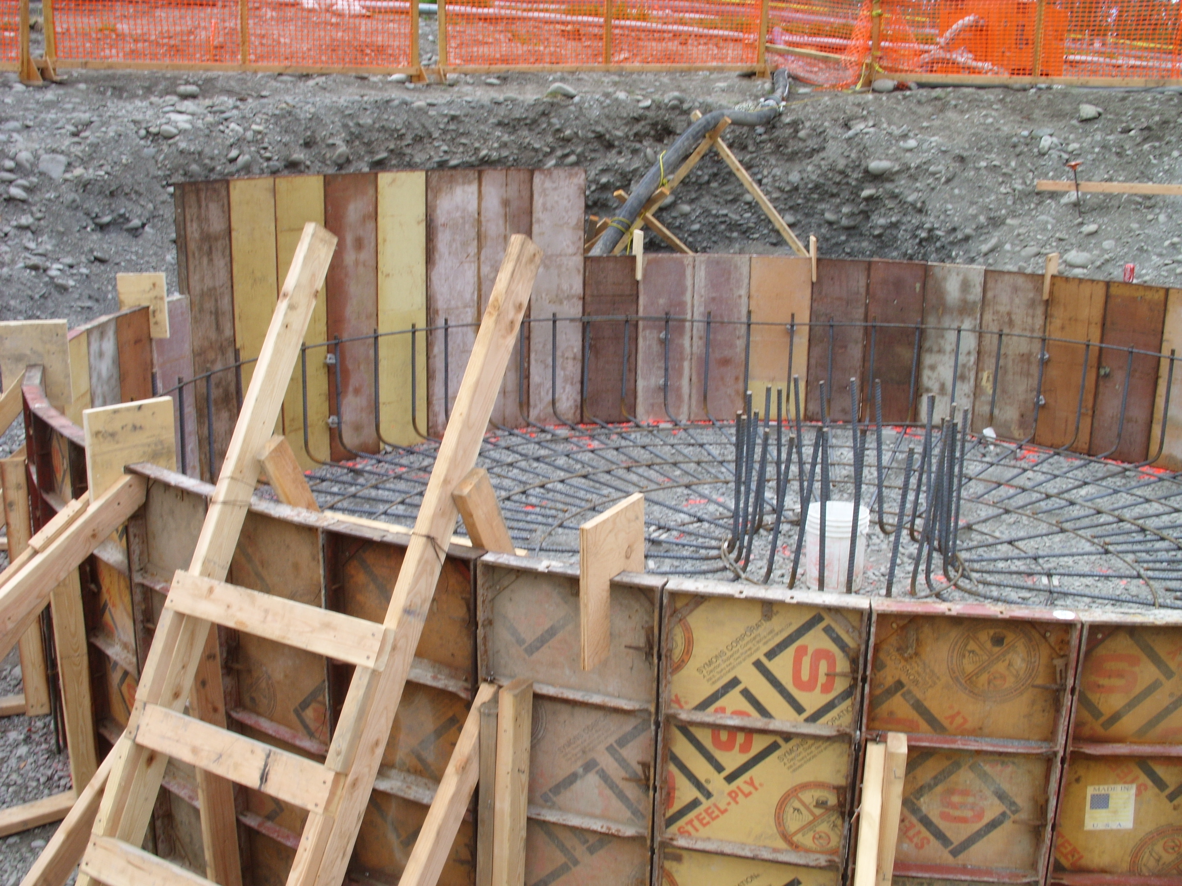  Steel Forms
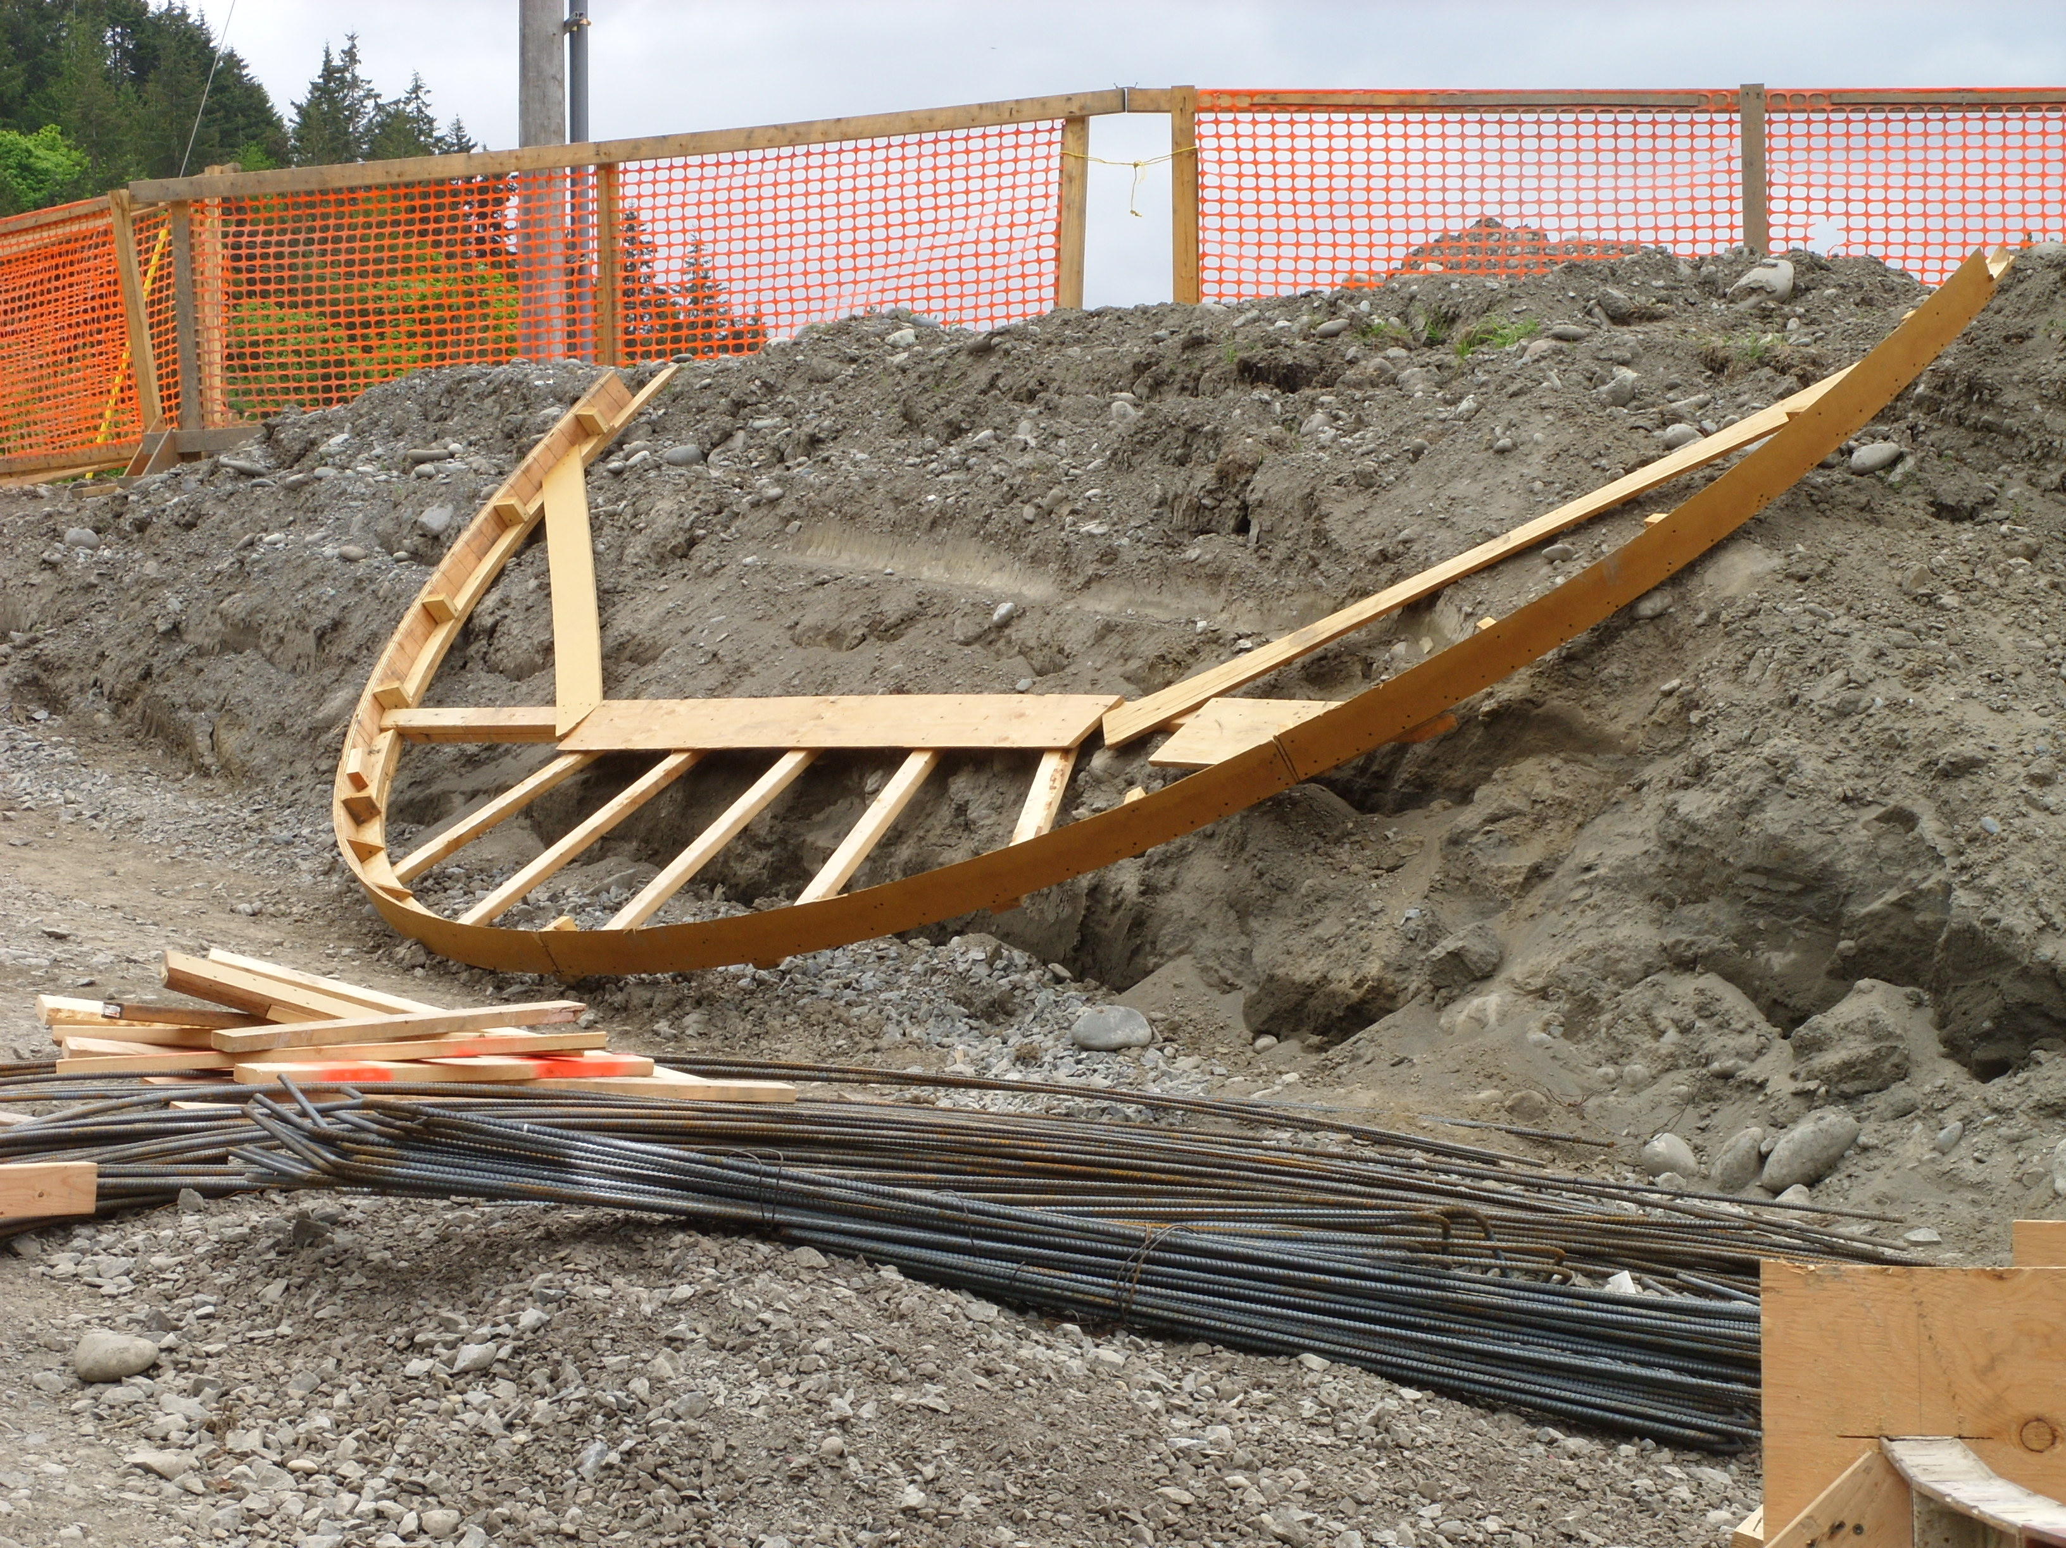
Curved Wood Forms

