A BIRD IN THE HAND IS
BETTER THAN TWO

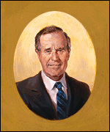 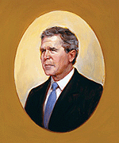’s

IN
THE WHITE HOUSE

