Quantitative Analysis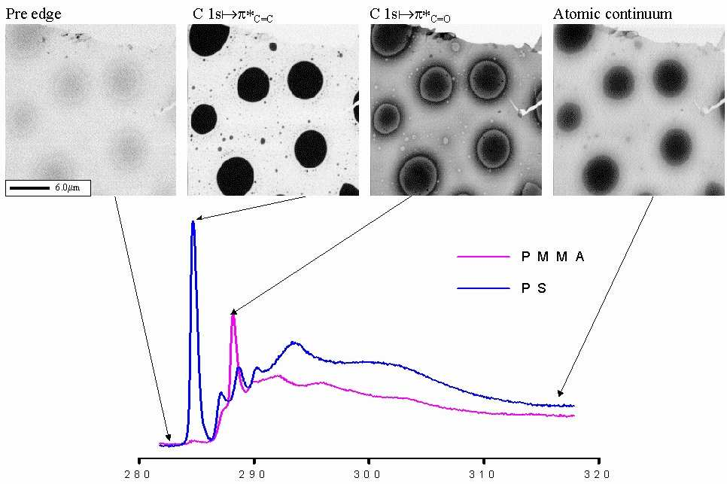

Tony Liang
Jan 10.06

