Hot air Balloons History
- The First Hot-Air Balloon
- Balloons in Australia 1850-1900
- Ballooning - Glossary of Terms
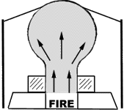
PROCEDURE:
1. Seal any openings and tears in the upper end of the bag with a minimum of cellophane tape.
2. Attach several paper clips to the plastic around the lower opening. The number of paper clips to attach is determined by experimentation.
3. If using sterno or some other open flame heat source, prepare the heat duct by drilling several holes around the base to allow air to flow in.
4. Turn on the blow dryer (or light the Sterno or stove and then set the heat duct over it) Spread the bag opening wide to capture the rising hot air while supporting the upper end with your hand. It is best to have assistance in keeping the bag open so that it does not melt.
5. When the bag is inflated with hot air, test its buoyancy by letting it go for a moment. If it rises quickly, stand back and let it fly otherwise continue heating it for a little while longer.
6. If the bag tips over and spills its hot air before it reaches the ceiling, add a few more paper clips to weigh down the bottom slightly. If the bag will not rise at all, remove a few clips.
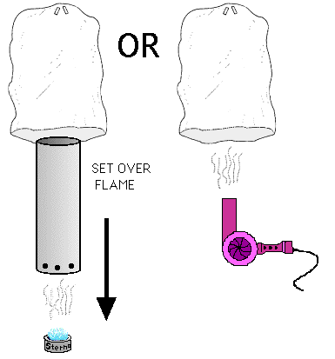
CAUTION: Be careful not to brush clothes or fingers into the flames or touch the metal heat duct. Keep a fire extinguisher handy if you use flames. If the bag starts to crumple and melt from the heat, set the blow dryer on a lower setting or hold the bag farther from the heat source.
DISCUSSION:
Hot air is less dense than cold air. Heat accelerates the motion of the air molecules causing fewer molecules to occupy the same space as a much greater number of molecules do at a lower temperature. With fewer molecules, the hot air has less mass, and therefore is buoyant than an equal volume of colder air.
Placing the dry cleaner bag over the heat source captures the hot air and forces out the cooler air in the bag. The bag becomes a mass of low-density air which floats up-
ward in the higher denser air surrounding it. The paper clips are placed at the bottom of the bag to keep the open end downward in flight to prevent it from prematurely spilling the hot air and terminating the flight.

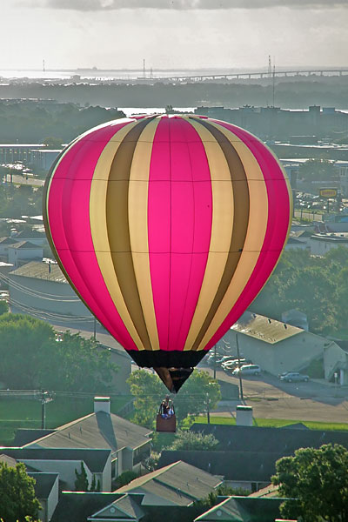

Most members of Balloons Over Britain have been operating passenger balloon rides for over ten years, some for twice as long.
This gives us an unparalleled wealth of operational experience that we share across the network to ensure the highest operating standards. From this experience have come many of the procedures that are now incorporated into industry standards via our regulatory body, the Civil Aviation Authority (CAA), through which all BOB members receive their Air Operators Certificates. This certification is granted to fare-paying-passenger carrying organisations that satisfy the organisational and safety requirements required by the CAA.

