Home Made Posi-Lock // Get Rid of Your Failing 4x4 Vacuum System

Here are the Materials You Are Going to Need:

- Bicycle cable or cable kit from Wal-Mart / 6-8 ft in length (the longer the better) ($5)
- 2 ¾ in compression spring (Lowe’s or Home Depot) Also, this spring needs to compress to around ½”.($4)
- Small amount of Lithium Grease
- 2 adjusting screws from a Bicycle shop(look at picture) ($1)
- Throttle lever from Parts Store of Small Engine Shop ($5)
- Cable Ties
- Drill w/ Drill Bits

The Process:
MAKE SURE YOU READ THROUGH ALL THE DIRECTIONS BEFORE YOU BEGIN. THIS WILL HELP YOU UNDERSTAND EXACTLY WHAT YOU ARE GOING TO BE DOING BEFORE YOU START.

- Jack up the passenger side of your jeep. This will move the majority of your fluids to the driver side. When you crawl under it, your vacuum actuator is going to be on the backside of the axle on the passenger side.
- First, disconnect the vacuum hoses from the actuator. There is a multi-connect dual hose coming in the top and one in the side. There will be three all together.
- Put a pan to collect the fluid that does leak out under the actuator. Then take out the four bolts that hold the actuator in. The actuator is now completely separate from the Jeep.
- On the top of the actuator, there is a plastic piece that the vacuum hoses connected to. You are going to have to take this off by prying the metal holding the plastic piece up and then pulling off the plastic piece. Look at picture A.
- Once the plastic cover is removed, you will pull off the rubber grommet to expose the metal piece that is going to have to be removed. Otherwise, it could damage your axle shaft. Take a screwdriver and pry it up until it comes off. Look at Picture B to see the metal piece.
- Now replace the plastic cover and use a hammer to bend the metal back around it to hold it in.
- There are going to be 3 E-clips holding the fork in. Remove these clips and make sure the fork slides back and forth. Then pull the top of the actuator (the one with the plastic piece) until the bar that the fork is attached to comes out.
- Then you are going to have to drill a hole in the fork just wide enough for the metal wire of your brake cable to go through. This should not be very big. Look at picture C to place exactly where to drill.
- Now take the black casing holding the fork and drill the hole for the bike brake adjuster to go through. Look at picture D to place exactly where to drill.
- If you drill the hole just right, you can thread the hole with the adjuster or if not, you can bolt the adjuster to the casing.
- Now, you want to make sure you wash everything good to get all metal shavings and dirt out from inside the casing and off the fork.
- Take the fork, making sure it is pointing the right way (Picture E) and reinsert the bar to hold it in. Now, you will only put two of the E-clips back on. These will be the closest ones to the top (the piece you just inserted). You need to leave the e-clip (3rd one) that is on the side by itself off so that the fork will slide back and forth on the bar.
- Now you want to insert the spring and the bicycle cable after taking the black sheath off the cable. It should just pull right off after you cut the smaller end of the cable. Make sure the bicycle cable runs through the spring. Look at Pictures F & G for completed assembly. Also, notice which side of the bicycle cable not to cut.
- Lube up the bicycle cable sparingly. Reinsert the metal part of the cable back into the black sheath that holds it. Now you are ready to re-install the actuator.
- I would suggest dripping some gear oil to the bar holding the fork in and make sure the fork moves moderately smooth. Take the vacuum actuator and reinstall it to your axle. The gasket should be fine. Re-use it.
- Now, you have two options. You can drill a hole through the firewall and worm your line through there. Or, you can drill a hole by your shifter(above the transmission) and worm it through there. Make sure that you use the cable ties to tie the line off and keep it away from the muffler pipe. Also, do not tighten the cable too much because you want to leave some room for the axle to articulate or move.
- Now, you are going to take your throttle lever and manipulate it a little bit. You need to attach the other adjusting screw to one side of the lever. Now, run your cable through there and attach. Look at Pictures H & I.
- Attach the cable to where there will be no slack in the cable and when you pull the lever, it will have enough room to pull the cable. Now, you should establish where you want your lever. Right in front the four-wheel drive lever looked the best to me. Drill into the plastic and screw the lever to it. Also, Picture I. Now, you are finished with the install.
- To engage your front axle, you have to use the lever to pull the cable. You have to be slowly moving in 2wd to do this. I would suggest around 5 mph. You can feel it kick in.
- Enjoy your newfound reliable 4-wheel drive. If you have any questions or comments, please email me at Bigchevyman24@aol.com Thanks

PICTURES

A. 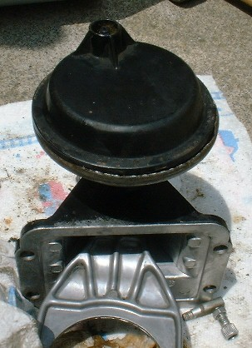

B. 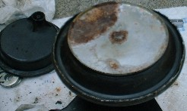

C. 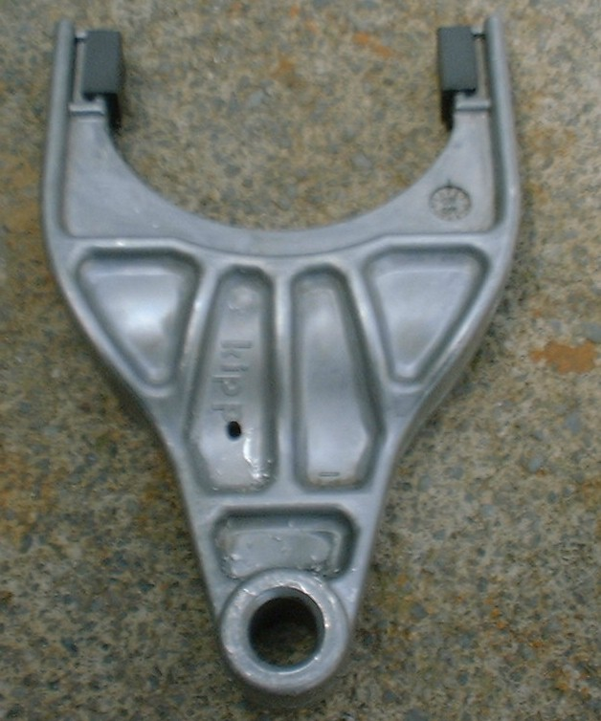

D. 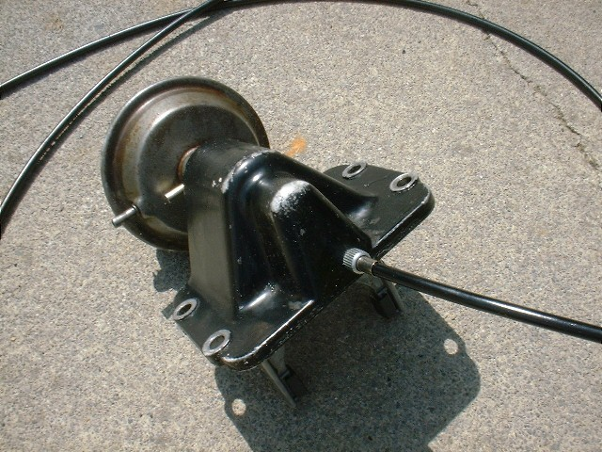

E. 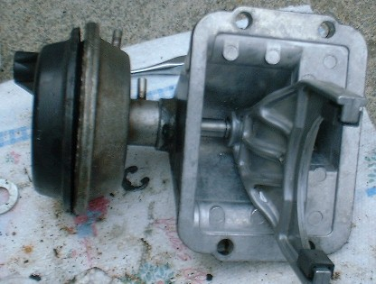

F. 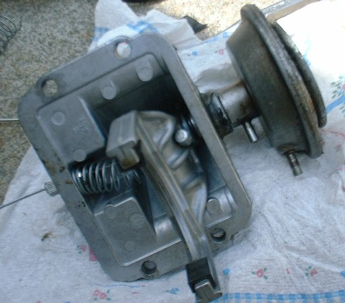

G. 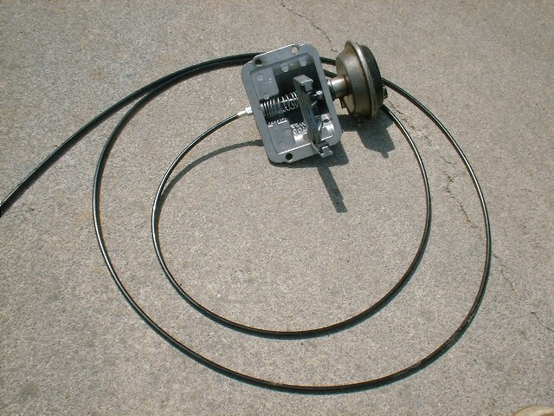

H. 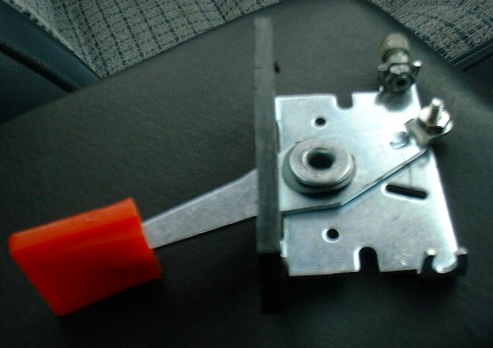

I. 