Project #2: Food Packaging (clear plastic)

RATIONALE:  In my chicharon packaging, I decided to focus more on the class A and class B consumers, although class C may also appeal to this kind of packaging.  The overall effect that I wanted to create in my packaging leans more toward the look of elegance, which we rarely see in chicharon packaging. I believe that this would appeal to class A and B men – it looks clean, new and expensive. It goes against the image of chicharon, which is sold in market places, buses, etc. The same goes for class C consumers – consumers who would usually go for the average chicharon products would see the packaging on this one and think, “Wow, iba ang itsura, mukhang mamahalin.” Its elegance, cleanliness and new treatment to the product would be what attracts the buyer to my packaging. Such would also spark their interest, which would in turn, cause them to try out this product.  The colors I used were really based on the flavor of the product, which is vinegar flavor. I opted for red and green since vinegar is usually mixed with other spices that are also colored red and green.  I used a subtle patterned background and such fonts to reinforce the elegance that the packaging wants to capture. In the image at the bottom part of the label, I used bottles that looked elegant also for the same reason.  In the image, there are vinegar bottles to support the flavor of the product. The garlic and onion in the image serves the same purpose.  I do believe that class A, B and C men would want to try out this product because of its contrast from other chicharon packaging. The classiness that the packaging exudes makes the buyer think differently, in such a way that he doesn’t think that he is going to get drunk and have chicharon as pulutan. Instead, he is going to drink and socialize while eating a Filipino delicacy. | 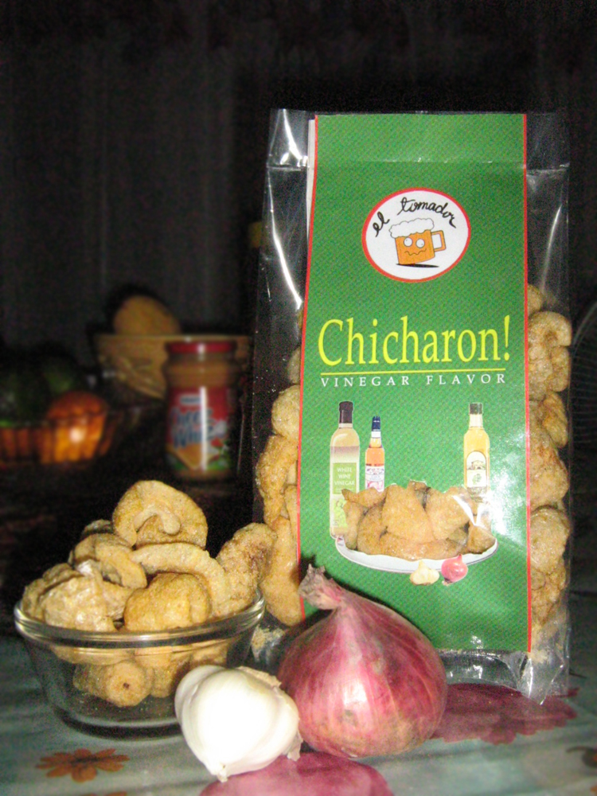

IBANEZ, Patricia D. August 13, 2007

