Court of Honor
Troop 323 Advancements
May 21, 2000

Joseph D
Tenderfoot
Space Exploration MB
Communications MB

Erik P
Space Exploration MB
Computers MB

Benjamin B
Space Exploration MB
Computers MB

Kerry B
Space Exploration MB
Communications MB
Computers MB

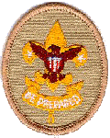

Christopher M. P
Space Exploration MB
Communications MB
Computers MB

Stephen P. P
1st Class
Space Exploration MB
Communications MB
Computers MB

