San Francisco Bay Area Council Boy Scouts of America

Tres Ranchos District

Unsung Hero Award Nomination

Each Pack, Troop, Team, and Crew is encouraged to nominate one individual who is not registered in a leadership position, (i.e. a parent, but not a Scoutmaster, Assistant Scoutmaster or a Committee Member) who has given strong and continued support to the success of the unit’s program. One recommendation from each unit, please. Those submitted will be recognized at the District Annual Recognition Dinner on May 10, 2008. Please do your best to be sure they are in attendance.

PACK TROOP TEAM CREW (Circle One) #__________

Nominates the following individual for the Unsung Hero Award:

FULL NAME OF NOMINEE ___________________________________________________

ADDRESS_____________________________CITY____________________ZIP_________

AGE_______ OCCUPATION (if known)__________________________________________

REASON WHY HE/SHE IS OUR UNIT’S UNSUNG HERO:
_______________________________________________________________
_______________________________________________________________
_______________________________________________________________
_______________________________________________________________

SIGNATURES:

__________________________________ ______________________________

Cubmaster, Scoutmaster, Advisor, or Varsity Coach Unit Committee Chair

________________________________ ______________________________
Printed Name of Signer Printed Name of Signer

________________________________ ______________________________
Contact Person Phone #

E-Mail Address of Contact Person: _____________________________________

Nomination forms must be received at the Council Office No Later Than
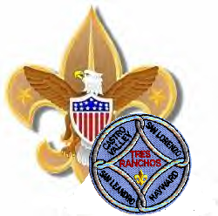
Friday April 4, 2008 by 4pm.

Tres Ranchos Recognition Dinner
c/o Linda Gentile (510) 537-6135

San Francisco Bay Area Council, BSA
1001 Davis Street ~ San Leandro, CA 94577-1514
Council FAX: (510) 577-9002

