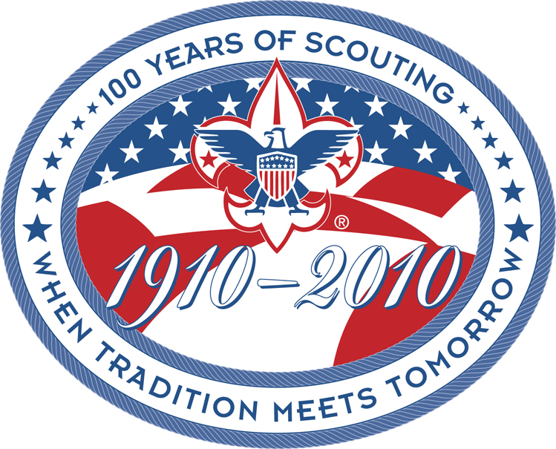
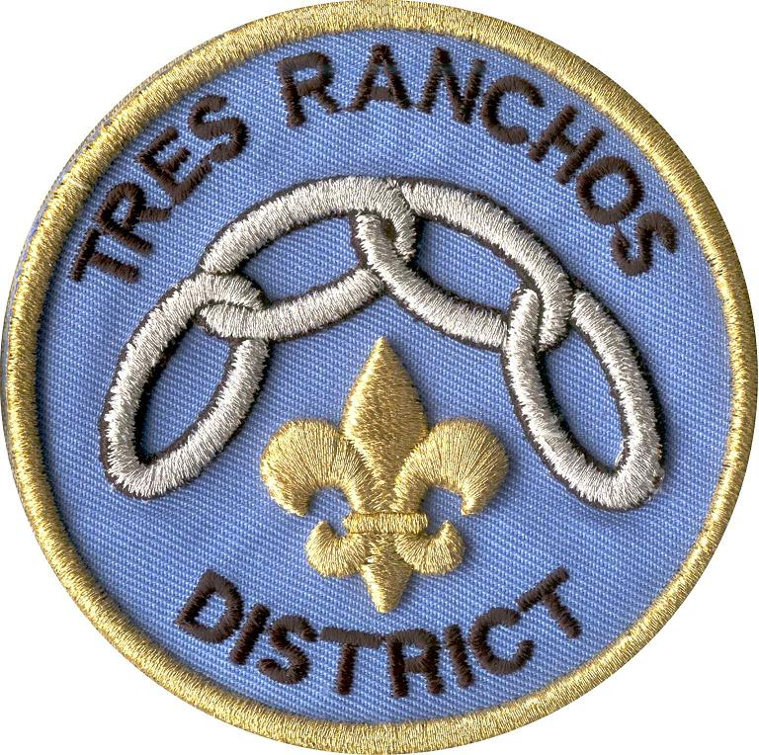
Boy Scouts of America / SFBAC / Tres Ranchos District
Rocket Jamboree

When: Sunday October 7, 2007 at 9:00am – registered Cub Scouts and their guests

Where: Camp Parks, Dublin, CA

Who: All registered Cub Scouts and their guests on Sunday

COST: $5.00 - Contact Mike Gentile for latest information and registration forms (Mike Gentile 510-537-6135)

This is a FULL UNIFORM event! Use this as a recruiting opportunity!

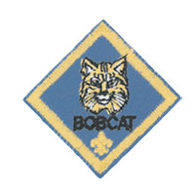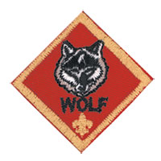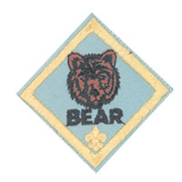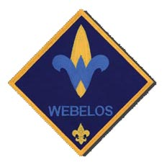

SUNDAY 10/7/07
9am – Cub Scouts and guests register
9:45am – Presentation of Colors
10am – 2pm Launch small rockets up to size "D".

You provide the rocket, motor, and igniter,
we’ll provide the launch pad and airspace.

Don’t Forget – Camp Chair, Jacket, Water, and money for food and snacks. SUPPORT THE SNACK STAND – GOOD FOOD & SCOUT PRICES. Some families/units bring an umbrella, or gazebo, or dinning canopy for sun protection.

Please stay Sunday and help us take it all down and put it away for next year!

