13.4 Blood

blood functions in maintaining homeostasis
- transport to and from capillaries
- blood clotting at injuries
- guard against microbes
- help regulate body temperature

components - 55% plasma (liquid portion of blood)
- 45% formed elements
- mostly red blood cells (RBC)
- white blood cells (WBC)
- platelets (less than 1%)

plasma - mostly water (90-92%)
- plasma proteins (7-8%)
- inorganic materials
- salts (osmosis, pH, metabolism)
- gases (O₂, CO₂)
- nutrients (glucose, fats, amino acids)
- hormones, enzymes

plasma protein - assist in transporting large organic molecules
- albumin: (60%) important blood buffer & transports bilirubin
- globulins: (36%) lipoproteins transport cholesterol, ions,
vitamins
- some have specific functions
- immunoglobulins fight infection
- fibrinogen and prothrombin clot blood
- important in maintaining blood volume by creating an osmotic
pressure inward
- proteins too large to exit capillaries
- less water concentration than tissues
formed elements - all produced from same undifferentiated (unformed) multipotent stem
cells
- stem cells are unspecialized cells with the potential to form
different cell types

multipotent stem - unspecialized stem cells that produce 2 types of blood forming stem cells cells - myeloid stem cells: most cell types
- lymphoid stem cells: immunity WBC
- blood cells form in red bone marrow of reticular connective tissue fibers
- most bones in children
- in adults chiefly spongy (porous) bones of skull, sternum
(breastbone), ribs, clavicle (collarbone), pelvic bones, spinal
vertebrae, and long bone ends
myeloid stem - differentiate into other stem cells that produce most formed elements
cells - erthrocytes: red blood cells (RBC)
- thrombocytes: platelets
- leukocytes: white blood cells (WBC)
- basophil
- eosinophil
- neutrophil
- monocyte

lymphoid stem - differentiate directly into formed elements
cells - leukocytes: white blood cells (WBC)
- B lymphocytes (processed in bone marrow)
- T lymphocytes (processed in thymus)
(FIG 13.12)

erythrocytes - biconcave disk, 4-6 million/mm
(RBC) (moore’s RBC pics)

- erythropoiesis (RBC making) at 2 million/second, “mature in 3 phases in
5-7 days
- immature erythrocytes with numerous ribosomes from hemoglobin
- nucleus and most organelles ejected
- cell collapses to biconcave shape
- vitamin B₁₂ essential to RBC formation
- erythropoiesis stimulated by erythropoetin hormone in kidneys at low
O₂ levels
- contain 250 million hemoglobin molecules
(moore’s RBC formation pic)

hemoglobin - red respiratory pigment transports O₂
- RBC anaerobic and do not consume their own O₂
- globin part made in liver has 4 polypeptide chains (2_{a} chains, 2_{B} chains)
- each polypeptide has an iron-containing heme group at its center
- 1 O₂ molecule can attach to each of 4 heme groups
- iron portion acquires O₂ in lungs and gives up in tissues
- can increase blood cell O₂ capacity by 60X
- oxyhemoglobin (HbO₂): bright red
- reduced (deoxy-) hemoglobin (HHb): dark purple
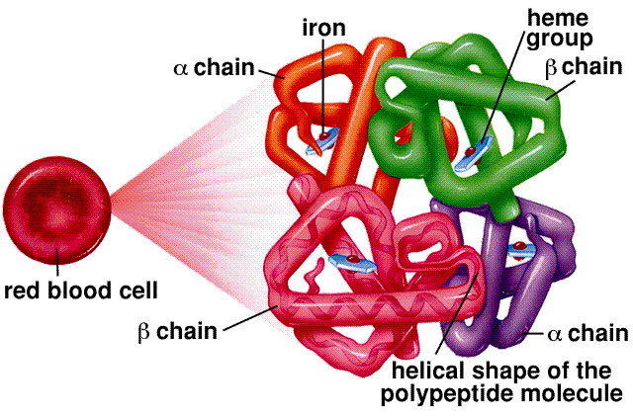

erythroprotein - stimulates erythrocyte stem cells in red bone marrow
- increase of RBC wherever arterial blood carriers reduced amount
of O₂

RBC breakdown - erthrocytes last only 120 days
- without nucleus no protein synthesis or repair of cell parts can
occur
- broken down in liver and spleen
- engulfed by large phagocytic cells (macrophages)
- spleen called the RBC “graveyard”
- RBC breakdown releases hemoglobin
- iron returned to bone marrow
- heme degraded & excreted by liver as bile pigments bilirubin &
biliverdin

RBC disease - anemia: insufficient RBC or hemoglobin leading to tired, “run-down
feeling”
- iron-deficiency anemia: diet
- pemicious anemia: digestive tract not absorbing sufficient vitamin B₁₂
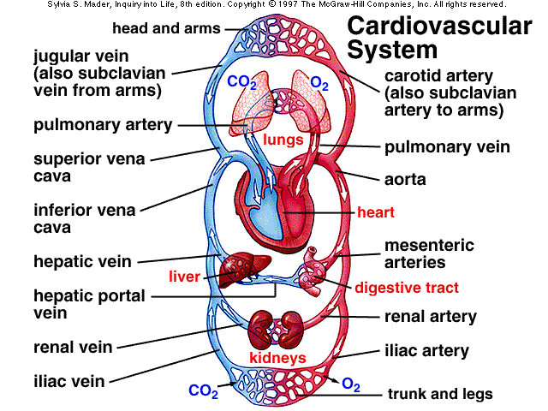
function of - enclosed in RBCs
hemoglobin - a protein containing iron in a heme group
- carries 97% of the O₂ blood (3% dissolves)
- deoxyhemoglobin (HHb) combines with O₂ to form oxyhemoglobin
(HbO₂) and releases a H⁺ ion
lungs →
HHb + O₂ ←→ HbO₂ + H⁺
← tissues
- some (24%) CO₂ is carried on amino acids in carbaminohemoglobin
- binds amino groups
- doesn’t not compete with Fe-O₂ heme
CO₂ + Hb → HbCO₂
- takes up O₂ in cool, neutral lungs and give it up in warm, acidic tissues

transport by - structure has unusual ability to react with CO₂ and H⁺, as well as O₂
hemoglobin - increasing O₂ drives off CO₂ and H⁺ (lungs)
- increasing CO₂ and H⁺ drives off O₂ (tissues)

CO₂ transport - passive, non-energy (as for O₂)
- 9% in solution, 25% combined with Hb
- 64% reacts with water and transported as bicarbonate and H⁺
carbonic anhydrase → tissue →
CO₂ + H₂O ←→ H₂CO₃ ←→ HCO₃⁻ + H⁺
HIGH → carbonic acid bicarbonate
- accumulation of H⁺ is acidic and slows uptake of CO₂

Hb buffer - Hb is important buffer that takes up H⁺
H⁺ + HbO₂⁻ → HHb + O₂
HIGH →

coupled reaction - Hb and bicarbonate reactions occur together in H⁺ uptake and release
- increasing concentration of 1 substance “pushes” reaction in the other
direction

in tissues - high concentration of CO₂ drives the bicarbonate reaction right
- high concentration of H⁺ and low O₂ (lost to the cells) drives the Hb
reaction right

in lungs - where O₂ concentration is high & CO₂ is low (exhaled) the reverse occurs
O₂ + HHb → HbO₂⁻ + H⁺
-----------------------------
H⁺ + HCO₃⁻ → H₂CO₃ → H₂O + CO₂
- H⁺ never accumulates in the free state because it is passed back & forth
between Hb & bicarbonate

leukocytes - larger and fewer (5-11,000 million/mm)
(WBC) - only formed elements that are complete cells (nuclei, organelles)
- lack hemoglobin
- appear translucent
- WBC function to fight infection
- 2 types based on granular structure
- granular leukocytes (many granules)
- agranular leukocytes (few granules)
- granules are lysosomes with enzymes and antibiotics that fight microbes

granular - develop and last only a few days
leukocytes - all “granulocytes” are phagocytes
- basophilis: inflammation at injuries
- eosinophilis: parasitic worms, allergies
- neutrophilis: bacteria, fungi
- have various enzymes & antibiotisc like proteins to help defend the body
- neutrophilis, most numerous WBC, have multi-lobed nucleus
(polymorphonuclear)

agranular leukocytes - “agranulocytes” are spherical or kidney shape
- monocytes: largest WBC
- lymphocytes
- monocytes in tissues swell into even larger macrophages
- develop in a few days, last months
- phagocytize microbes, old cells, debris
- stimulate other WBC production
- lymphocytes form B lymphocytes and T lymphocytes (B-cells, T-cells)
- develop days-weeks, last hours-years
- body immune system defense by antibodies (B or direct attack (T)

WBC diseases - leukemia (cancer)
- abnormal production WBCs of 1 or more types
- infectious mononucleosis: caused by Epstein-Barr virus with
excessive number of lymphocytes of the B type
- AIDS: caused by HIV infection with low number of lymphocytes
of T type

GM-CSF - a growth factor for white blood cells

blood clotting - stop blood leaks at damaged vessels
- 3 chief clotting factors (of 12 or more)
- thrombocytes (platelets)
- 2 plasma proteins made in the liver: fibrinogen & prothrombin
- vitamin K (intestinal bacteria) required for prothrombin production
- lack of vitamin K leads to hemorrhagic disorders (internal bleeding)

thrombocytes - made 2 billion a day, 150-300,000 million/mm
- platelets form by fragmentation of large cells in red bone marrow
- broken pieces of cell without nuclei
- clump and partially plug site of puncture
- platelets and injured tissue releases a clotting factor prothrombin activator
- converts prothrombin to thrombin
- reaction requires Ca⁺⁺ ions present

thrombin - enzyme that cuts 2 short amino acid fragments from each fibrinogen
molecule
- fragments form long threads of fibrin into a network trapping
platelets and RBC

“clot buster” - fibrin is removed from clot by the protein digesting plasmin enzyme

(moore’s clotting pic)

body fluids - blood: formed elements and plasma
- plasma: liquid part of blood
- serum: plasma minus fibrinogen
- tissue fluid: plasma minus protein
- lymph: tissue fluid in lymphatic vessels

capillary exchange - 2 forces control exchange between blood and tissue fluid
- osmotic pressure tends to move water form tissue fluid to blood
- blood pressure tend to move water form blood to tissue fluid

osmotic pressure - constant 25 mm Hg created mainly by presence of plasma proteins & salts

arterial end - blood pressure (40 mm Hg) in capillary higher than osmotic pressure
- water, O₂, nutrients exit the capillary

mid-capillary - pressure equal, no net water movement
- solutes diffuse on concentration gradients
- nutrients, O₂ out of capillaries
- wastes molecules, CO₂ into capillaries

venous end - blood pressure (10 mm Hg) in capillary less than osmotic pressure
- water, wastes enter the capillary
(FIG. 13.15)

tissue fluid - all components of plasma except plasma proteins too large to pass through

lymph - small amount of fluid that does not return to capillaries is collected by
lymphatic capillaries

lymphatic capillaries - lie near all blood capillaries and drain tissues of excess fluid

