Power Optimisation of Embedded Wireless Networks

¹Mr.T S Pradeep Kumar, ² Mr. R. Petchimuthu, ³ Dr. V. Rhymend Uthariaraj

¹Lecturer, Department of EEE,
Sri Muthukumaran Institute of Technology,
Mangadu, Chennai 600069.

² Junior Telecom Officer, BSNL, Chennai.

³ Professor, Department of Information Technology,
Madras Institute of Technology, Anna University, Chennai
{pradeepkumarts@gmail.com, tspradeepkumar@yahoo.com}

Abstract
The embedded wireless networks having nodes which are battery powered and is crucial to reduce the power consumption. Various techniques have been proposed in this paper. A technique for reducing power consumption is to place the embedded nodes in the sleep mode and awaken whenever the client needs service. This method is called node listening. We define two node listening mechanisms server guiding mode (SGM) and client guiding mode (CGM). The SGM is preferred whenever the client arrival is below a threshold level, else the CGM is preferred. We also consider a hybrid technique whereby server nodes independently select the beaconing mode so that total power consumption is reduced over a wide range of system parameter values. The operation of the client nodes is transparent to this selection. The power consumption can be minimized when the Server only transmitting (SOT) instead of receiving.

Keywords—Server Guiding, Client Guiding, Queuing model, Hybrid CGM/SGM

INTRODUCTION
In the future, embedded wireless networking will be included in many common, everyday objects. Possible examples of such embedded networks include sensor systems which monitor and control the environment, smart toys and games, smart appliances, business and manufacturing applications. Even in IEEE 802.11 and HIPERLAN, features have already been included which explicitly sacrifice performance in favor of reduced power consumption [10].
The embedded nodes can be viewed as dense mode or sparse mode applications. In dense mode, the embedded nodes per coverage area are assumed to be large. In spare mode, the nodes are small per coverage area.
In this paper, we assume the number of nodes to be sparse mode. We will employ an Average Power (AP) criterion which enables for reduced power consumption. The technique for reduced power consumption to place the nodes in the sleep mode and awaken them occasionally to communicate with the nodes. This is called node rendezvous. There are other rendezvous mechanisms as given in [10] are service rendezvous and session rendezvous.
Service rendezvous includes the act of determining a point in time where a desired node service is available so that it can be accessed. Once this happens, the nodes involved can engage in a client/server session. The session itself could involve repeated instances of node rendezvous for the purpose of occasional information exchange. This type of rendezvous is referred to as session rendezvous. The IEEE 802.11 standard includes a session rendezvous mechanism where stations in sleep mode awaken simultaneously and listen to the channel for the duration of an ATIM time window [10].
In this paper we consider power efficient rendezvous in embedded wireless networks using the AP criterion discussed above. We first define two mechanisms Server guiding mode (SGM) and Client guiding mode (CGM). The SGM mode is preferred whenever the client arrival rate is below a threshold level; else the CGM mode is preferred for lower power consumption. A hybrid technique is also defined whereby the server adopts either the SGM or CGM depending on the client arrival rate. We also define one more mechanism where the server is only transmitting as there are some applications like temperature sensors, etc. The clients are assumed only to receive the information given by the server. Although this method has some disadvantages, it still works fine for reduced power consumption for some typical applications like sensors and transmitters. In systems of this kind, guiding is a term used to describe a packet broadcast which is used by an awakening node to advertise or solicit an interaction between two or more nodes.

Embedded Server System Model
In fig.1 we show the Embedded system model used in this paper. Fig.1 shows the wireless network with activated and inactivated embedded nodes. We will assume a sparse mode situation where the coverage area of the server nodes does not overlap significantly with that of other server nodes. As discussed in the introduction, we assume that an arriving client is externally activated at some point after entering the wireless coverage area of the server.

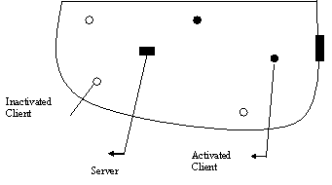
Fig.1 Embedded Wireless Network

Once the client node makes contact with the server, they engage in a client/server interaction session. Following this exchange, the client node powers down and leave the system.

Preliminaries and problem statement
The problem in this paper is that the mean power consumed by the wireless network during the interaction between the client and server nodes. The assumption is that the client and server nodes are in a sparse mode (number of nodes per coverage area is small). The client can arrival at the coverage area in a random manner with Poisson distribution and the service rate is assumed to be in exponential distribution. So, this paper is analysing the mathematical model of power consumption by the embedded wireless networks.
The factors that are necessary for the mathematical modeling of Wireless network is
- The client arrival process
- Either M/G/1 Queuing model or M/M/1 model
- The type of distribution in which the client arrives (Poisson distribution or exponential distribution)
- The Service process
  - Exponential distribution
- Guiding mechanisms
- Client guiding or server guiding
- Hybrid SGM/CGM

The ATP is calculated for the above mechanisms SGM / CGM when the Client Server system is modeled as a queuing model of either M/G/1 model or M/M/1 model. The queuing models are studied and with the help of the client arrival rate and service rate by the server, the ATP is calculated with the number of client nodes arrived per unit time is taken into account.
With the above mechanisms the ATP is optimized and gives the normalized mean power consumption. These things are modeled using queuing models M/G/1 and Markovian Chain model [8].

Client And Server Guiding Mode
In this section we introduce two basic guiding mechanisms, namely, Client guiding mode (CGM), and Server guiding mode (SGM). To aid in the description, we will focus on the actions of a particular server node and the client nodes which arrive to its radio coverage area. As discussed in Section II, we consider the common case where the visiting clients are enabled through external activation after having arrived at the coverage area.

Client Guiding Mode (CGM):
Under the CGM mechanism, the server is operated so that its receiver is actively listening at all times (When the server is transmitting, its receiver is turned off, of course). Accordingly, an activated client node can immediately engage in the client/server interaction without waiting. This is shown in Fig. 2. Since the server is always available, guiding is not needed for service listening purposes. Therefore, in systems without service discovery, client nodes can engage the server immediately. It should be noted that in systems with service discovery, the server in a client guiding system may beacon for service discovery purposes. It is obvious that in this scheme the server is constantly dissipating power. For this reason, this scheme may be more appropriate when the servers have large battery resources or are connected to AC mains power. However, we will see that under some conditions, the total client node power may be much lower than that of server guiding due to a reduction in client receive power.
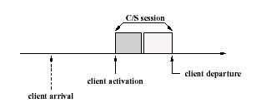
Fig .2 Client Guiding mode

Client guiding mode can be modeled as M/G/1 Queuing model.
M- Markovian Arrival Process, G- Generalised distribution of service rate, 1 represents the number of servers; here in this case it is 1.
The power for the CGM is
(1)
Upon adding the all the above power
(2)
(ηt =ηr = η =1; assuming the transmitting power and receiving energy is equal)
(3)
Where “Ps” is the mean power consumption for server guiding, Tcs and Tss are the mean transmission time for the client service and server service. W_{MG1} is the mean waiting time of the client.

Server Guiding Mode (SGM):
Under the SGM mechanism, the server sleeps and awakens periodically, every “t_{SB}” seconds. Upon awakening, the server sends a server beacon which is transmitted as a broadcast (or multicast) packet. These actions enable service listening to occur and are shown in Fig. 3. In the figure, a total of three server beacon transmissions are shown. Following each beacon, the server waits for responses from client nodes which may be waiting for service. An efficient mechanism for signaling is to include a short response window (RW) at the end of each server beacon. Awaiting clients can transmit a short carrier burst into this RW to signal the presence of one or more awaiting clients. The absence of a response in this RW will cause the server to revert to sleep mode until the next scheduled beacon time. In this case the server only dissipates power for the duration of the beacon and its associated RW. The described interaction is shown in Fig. 3.

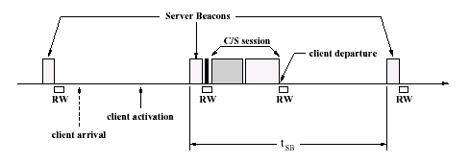
Fig.3 Server Guiding mode

Server guiding mode is modeled using M/M/1 model. Since the client and servers notifies the Reaction Window, the interaction between both the client and server is complicated and is application dependent. SGM can also be modeled using Markovian Chain with a set of boundary conditions.
M/M/1 represents, the arrival and the service rate is Markovian Process and there is only one server. The client node power is dissipated from the time the node is activated until it has finished its interaction with the server. So there is a possibility of distributed waiting of clients. In the SGM mechanism, both the client and server transmits and receive signals, so both C/S with dissipate energy. From this the power can be calculated.
The power equation under SGM is given by
(4)
Upon adding the all the above power
(5)
Where P_{SGM} is the mean power consumption for server beaconing, Tcs and Tss are the mean transmission time for the client service and server service. W_{MM1} is the mean waiting time of the client.

Fig.4 shows the normalised power consumption for various values of t_{sb}. The fig.3 also depicts the power consumption for CGM and SGM. As we can see, when λc (client arrival rate) is small P_{SGM}/P_{CGM} = τ_{sb} and thus it is P_{SGM} < P_{CGM.} But when λc is larger P_{SGM}/P_{CGM} = N_{G} / N_{MD1}. Using little’s theorem we have that N_{MD1}=N_{G} and therefore P_{SGM} > P_{CGM} under heavy conditions.

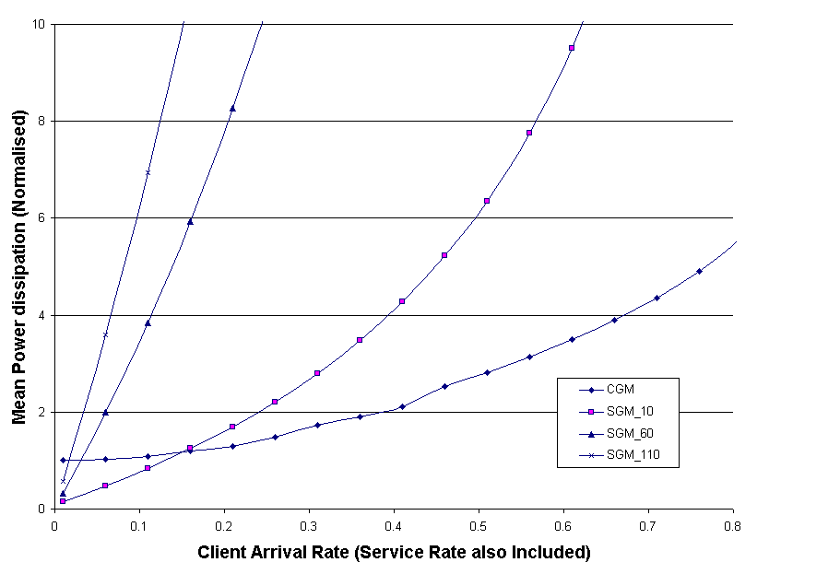
Fig.4 Server and Client Guiding mode

A more detailed comparison of the two basic schemes is an important point to make in Figure 4 is that the advantage that SGM shows under light client loading is a very important one. This is because it is expected that many embedded networks will operate under various client loading conditions. When deployed in a situation where the aggregate client loading is very low, it is highly desirable that the nodes can extend their battery life as much as possible. Operation in this region using an appropriate value for t_{sb} makes this possible.

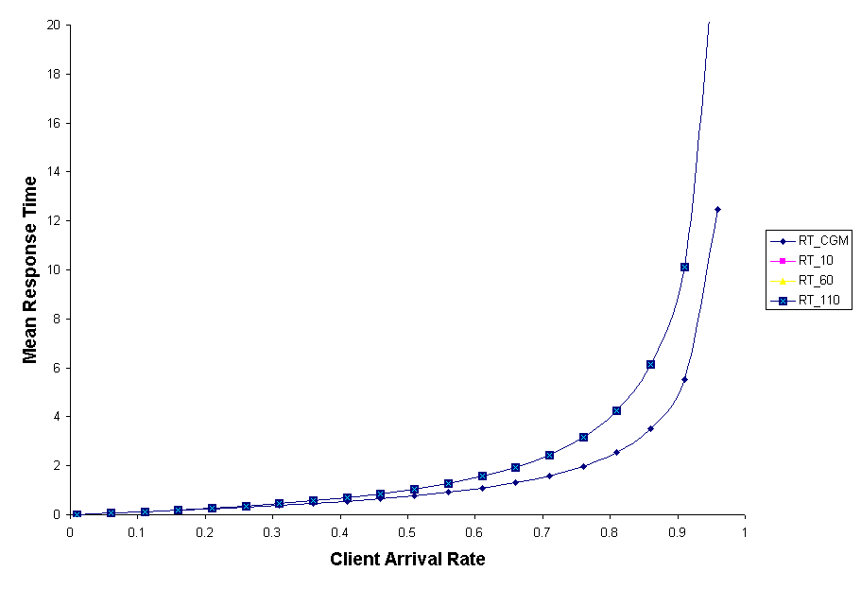
Fig.5 Response Time for CGM and SGM

Fig.5 depicts the response time between the client and server nodes of the wireless networks. As the CGM modeled as M/G/1 model, the response time is less or minimised when compared with the SGM model, as it uses M/M/1.

Hybrid CGM/SGM:
The condition of this scheme is to operate as a client guiding mode under heavy loading conditions and as a server guiding mode under light loading conditions. The server can select the mode dynamically according to the number of clients arriving at the coverage area. It is transparent to the clients. The activated client would have to know the mode of operation so that it is waiting for the server beacon packet or not. Using equations (3) and (5), the CGM and SGM intersects under light loading conditions when,
(6)
Using this approximation, a server node can select the mode of operation by making a local measure of the current client loading.

Conclusion
Power consumption has emerged as a major resource constraint in battery-operated wireless embedded systems. For real-time embedded systems such as sensor networks, power consumption must be carefully balanced with real-time responsiveness. In this paper, we have presented a power minimization scheme that uses client guiding, server guiding and hybrid mode. The Mean Response Time and the Normalised average power for the above mechanisms has been analysed. There are also other mechanism includes the AC Mains Powered Listening Server to reduce power consumption by means of sending timing information to the arriving clients so that the power dissipated in performing the service listening is minimised. This paper can be extended for minimizing power consumption for wireless sensor and transmitting devices. Since the sensors are task enabled, the power minimization can be implemented with the help of Real Time task scheduling algorithms with Dynamic Voltage Scheduling (DVS) algorithms.

References

- The Network Simulator - ns-2, URL: http://www.isi.edu/nsnam/ns/
- Kaveh Pahlavan, Prashant Krishnamurthy, “Principles of Wireless Networks” Prentice Hall of India Private Limited, 2004
- Todd, T. Bennett, F. Jones, A, “Low power rendezvous in embedded wireless networks”, Workshop on Mobile and Ad Hoc Networking and Computing, 2000.
- IEEE Computer August 2004. (Ultra Low power wireless sensor networks)
- Robert P. Dick and Niraj K. Jha, “Hardware–Software Co-synthesis of Wireless Low-Power Distributed Embedded Client–Server Systems”, IEEE Transactions on computer-aided design of integrated circuits and systems, vol. 23, No.1,January 2004
- M. Handy, D. Timmermann, “Simulation of Mobile Wireless Networks with accurate Modeling of non-linear battery effects”
- Wayne Wolf, “Computers as Components”, 2002
- Taha, “Operations Research, an Introduction”, PHI Private Limited, 1997
- Vishnu Swaminathan, Charles B. Schweizer, Krishnendu Chakrabarty and Amil A. Patel, “Experiences in Implementing an Energy-Driven Task Scheduler in RT-Linux”, Proceedings of the Eighth IEEE Real-Time and Embedded Technology and Applications Symposium (RTAS 2002).
- IEEE Standards Department. “IEEE Draft Standard - Wireless LAN”. IEEE Press, 1996
- Aravindh V. Anantaraman, Ali El-Haj Mahmoud, Ravi K. Venkatesan, Yifan Zhu and Frank Mueller “EDF-DVS Scheduling on the IBM Embedded PowerPC 405LP”

